**MINISTRY OF EDUCATION AND TRAINING**

**FPT UNIVERSITY**

Capstone Project Document

**Football Field Reservation System**

|  |  |
| --- | --- |
| **Group 03** | |
| **Group members** | Mai Minh Quý – SE61610  Trương Hữu Thành – SE61493  Phan Minh Huấn – SE61860  Phạm Trung Hiếu – SE60874 |
| **Supervisor** | Mr. Kiều Trọng Khánh |
| **Ext. Supervisor** | N/A |
| **Capstone Project code** | FFRS |

-Ho Chi Minh City, November 28th, 2017-

*This page is intentionally left blank*

# Table of Contents

Table of Contents 3

List of Tables 6

List of Figure 9

A. Report No. 1 Introduction 14

1. Project Information 14

2. Introduction 14

3. Current Situation 14

4. Problem Definition 14

5. Proposed Solution 15

5.1 Feature functions 15

5.2 Values 16

6. Functional Requirements 16

7. Role and Responsibility 17

B. Report No.2 Software Project Management Plan 18

1. Problem Definition 18

1.1 Name of this Capstone Project 18

1.2 Problem Abstract 18

1.3 Project Overview 18

2. Project organization 21

2.1 Software Process Model 21

2.2 Roles and responsibilities 22

2.3 Tools and Techniques 23

3. Project Management Plan 24

3.1 Product Backlog 24

3.2 Sprint Backlog 24

3.3 Deliverables 24

3.4 All Meeting Minutes 25

4. Coding Convention 25

4.1 Naming convention 25

4.2 Functional convention 25

C. Software Requirement Specifications 26

1. User Requirement Specification 26

1.1 Guest Requirement 26

1.2 User Requirement 26

1.3 Field Owner Requirement 26

1.4 Admin Requirement 27

1.5 Staff Requirement 27

1.6 System Requirement 27

2. Software Requirement Specification 27

2.1 External Interface Requirement 27

2.2 System Overview Use Case 29

2.3 List of Use Case 30

3. Software System Attribute 107

3.1 Usability 107

3.2 Availability 107

3.3 Security 107

3.4 Maintainability 107

3.5 Portability 108

3.6 Performance 108

4. Conceptual Diagram 108

D. Software Requirement Specifications 111

1. Design Overview 111

2. System Architectural Design 111

2.1 System Architecture Design 111

2.2 Mobile Application Architecture Design 112

2.3 Web Application Architecture Design 113

3. Component Diagram 114

4. Detailed Description 114

4.1 Class Diagram 114

4.2 Class Diagram Explanation 116

4.3 Interaction Diagram 125

5. User Interface Design 130

5.1 Mobile Application 130

5.2 Web application 149

6. Database design 161

6.1 Entity relationship diagram 161

162

7. Algorithms 163

7.1 Manage time 163

7.2 Distance 164

7.3 Matching 2 users 166

E. System implement and Test 167

1. Introduction 167

1.1 Overview 167

1.2 Test Approach 167

2. Database relationship diagram 167

2.1 Physical diagram 167

2.2 Data dictionary 170

3. Performance measures 181

3.1 Mobile Application API load speed 181

4. Test plan 183

4.3 Features to be tested 184

4.4 Features not to be tested 184

5. System testing test case 184

5.1 Communication diagram 184

5.2 Test cases 186

F. Software User’s Manual 195

1. Installation Guide 195

2. User Guide 195

2.1. Mobile Application for Customer 195

2.2. Web application 200

# List of Tables

Table 1: Roles and Responsibilities 16

Table 2: Hardware requirement for server 20

Table 3: Hardware requirement for mobile 20

Table 4: Roles and Responsibilities Details 22

Table 5: Tools and Techniques 22

Table 6: Deliverables 24

Table 7: Sign up specification 32

Table 8: Sign in specification 34

Table 9: Edit profile specification 38

Table 10: Search field specification 40

Table 11: Reserve friendly match specification 43

Table 12: Reserve tour match specification 50

Table 13: Get history specification 52

Table 14: Set favorite field specification 53

Table 15: Rate field/opponent specification 56

Table 16: Report account specification 58

Table 17: Add opponent to blacklist specification 59

Table 18: Exchange voucher specification 62

Table 19: Create matching request specification 64

Table 20: Cancel matching request specification 66

Table 21: Cancel reservation request specification 69

Table 22: Deposit specification 71

Table 23: Get match by date specification 74

Table 24: Create promotion specification 76

Table 25: Create field specification 78

Table 26: Disable field specification 80

Table 27: Create active time specification 83

Table 28: Disable time frame specification 84

Table 29: Set field for match specification 86

Table 30: Get bills by date specification 88

Table 31: Get report list specification 90

Table 32: Send lock account request specification 92

Table 33: Accept the field owner’s account creation request specification 93

Table 34: Manage price of field specification 95

Table 35: Change user’s balaces specification 97

Table 36: Calculate bonus point specification 99

Table 37: Calculate rating score specification 101

Table 38: Send notification specification 103

Table 39: Lock account specification 104

Table 40: Sign out specification 106

Table 41: Conceptual diagram data dictionary 109

Table 42: Class dictionary 115

Table 43: Account attributes 116

Table 44: Profile attributes 116

Table 45: Role attributes 117

Table 46: Promotion attributes 117

Table 47: FavoriteField attributes 118

Table 48: BlacklistOpponent attributes 118

Table 49: Voucher attributes 118

Table 50: VoucherRecord attributes 119

Table 51: Field attributes 119

Table 52: FieldType attributes 119

Table 53: TimeEnable attributes 120

Table 54: TimeSlot attributes 121

Table 55: MatchingRequest attributes 121

Table 56: TourMatch attributes 122

Table 57: FriendlyMatch attributes 122

Table 58: Bill attributes 123

Table 59: RatingOpponent attributes 123

Table 60: Report attributes 124

Table 61: TeamMember attributes 124

Table 62: <Mobile application> Register Fields 130

Table 63: <Mobile application>Register Buttons/Hyperlinks 131

Table 64: <Mobile application>Menu Field 131

Table 65: <Mobile application>Menu Buttons/Hyperlinks 132

Table 66: <Mobile application>Search field’s Field 133

Table 67: <Mobile application>Search field buttons/hyperlinks 134

Table 68: <Mobile application>Choose field’s free time Field 135

Table 69: <Mobile application>Choose field’s free time Buttons/Hyperlinks 135

Table 70: <Mobile application>View reservation details fields 137

Table 71: <Mobile application>View reservation details buttons/hyperlinks 137

Table 72: <Mobile application>Find opponent fields 139

Table 73: <Mobile application>Find opponent buttons/hyperlinks 139

Table 74: <Mobile application>Matching result fields 141

Table 75: <Mobile application>Matching result buttons/hyperlinks 141

Table 76: <Mobile application>Deposit fields 142

Table 77: <Mobile application>Deposit buttons/hyperlinks 142

Table 78: <Mobile application>Get reserved matches fields 144

Table 79: <Mobile application>Get reserved matches buttons/hyperlinks 144

Table 80: <Mobile application>Get matching request fields 145

Table 81: <Mobile application>Get matching request buttons/hyperlinks 145

Table 82: <Mobile application>Rate opponent fields 146

Table 83: <Mobile application>Rate opponent buttons/hyperlinks 147

Table 84: <Mobile application>Report opponent fields 148

Table 85: <Mobile application>Report opponent buttons/hyperlinks 148

Table 86: <Web application>Get match by date fields 149

Table 87: <Web application>Get match by date buttons/hyperlinks 149

Table 88: <Web application>Choose field for match fields 150

Table 89: <Web application>Choose field for match buttons/hyperlinks 150

Table 90: <Web application>Update time available fields 150

Table 91: <Web application>Update time available buttons/hyperlinks 151

Table 92: <Web application>Field management 151

Table 93: <Web application>Field management buttons/hyperlinks 152

Table 94: <Web application>Manage active time 152

Table 95: <Web application>Manage active time buttons/hyperlinks 152

Table 96: <Web application>Update active time 153

Table 97: <Web application>Update active time buttons/hyperlinks 154

Table 98: <Web application>Manage income 154

Table 99: <Web application>Manage income buttons/hyperlinks 154

Table 100: <Web application>Promotion management 155

Table 101: <Web application>Promotion management buttons/hyperlinks 155

Table 102: <Web application>Add promotion 156

Table 103: <Web application>Add promotion buttons/hyperlinks 157

Table 104: <Web application>User management 157

Table 105: <Web application>User management buttons/hyperlinks 158

Table 106: <Web application>View user details 158

Table 107: <Web application>View user details buttons/hyperlinks 158

Table 108: <Web application>Lock user 159

Table 109: <Web application>Lock user buttons/hyperlinks 159

Table 110: <Web application>Confirm lock account buttons/hyperlinks 160

Table 111: Describe content of all tables 169

Table 112: Data table dictionary 180

Table 113: Mobile API load speed client specification 181

Table 114: Mobile API load speed test cases 181

Table 115: Mobile API load speed test result 182

Table 117: Test case <User> Reserve field 186

Table 118: Test case <User> Create matching request 187

Table 119: Test case <User> Reserve tour match 192

Table 120: Test case <Field Owner> Create new active time 193

Table 121: <Guest> Register User UG 194

Table 122: <Guest> Login UG 195

Table 123: <Field Owner> Search field UG 195

Table 124: <User> Reserve match UG 196

Table 125: <User> find opponent UG 197

Table 126: <Field Owner> Create new matching request UG 197

Table 127: <User> Choose opponent UG 198

Table 128: <User> Deposit UG 199

Table 129: <Field Owner> Update active time UG 199

Table 130: <Field Owner> Create new promotion UG 200

Table 131: <Field Owner> Reserve match UG 201

# List of Figure

Figure 1: Scrum process 20

Figure 2: System Overview Use Case 27

Figure 3: <Guest> Overview Use Case 28

Figure 4: <Guest> Sign up 28

Figure 5: <Guest> Sign in 32

Figure 6: <User> Overview 34

Figure 7: <User> Edit profile 34

Figure 8: <User> Search field 38

Figure 9: <User> Reserve friendly match 40

Figure 10: <User> Reserve tour match 43

Figure 11: <User> Get history 49

Figure 12: <User> Set favorite field 51

Figure 13: <User> Rate field/opponent 52

Figure 14: <User> Report account 55

Figure 15: <User> Add opponent to blacklist 57

Figure 16: <User> Exchange voucher 59

Figure 17: <User> Create matching request 61

Figure 18: <User> Cancel matching request 63

Figure 19: <User> Cancel reservation request 66

Figure 20: <User> Deposit 68

Figure 21: <Field Owner> Overview 71

Figure 22: <Field Owner> Get match by date 71

Figure 23: <Field Owner> Create promotion 73

Figure 24: <Field Owner> Create field 75

Figure 25: <Field Owner> Disable field 77

Figure 26: <Field Owner> Create active time 79

Figure 27: <Field Owner> Disable time frame 82

Figure 28: <Field Owner> Set field for match 84

Figure 29: <Field Owner> Get bills by date 86

Figure 30: <Staff> Overview 87

Figure 31: <Staff> Get report list 88

Figure 32: <Staff> Send lock account request 89

Figure 33: <Staff> Accept the field owner’s account creation request 91

Figure 34: <Staff> Manage price of field 92

Figure 35: <Staff> Change user’s balaces 95

Figure 36: <System> Overview 97

Figure 37: <System> Calculate bonus point 97

Figure 38: <System> Calculate rating score 98

Figure 39: <System> Send notification 100

Figure 40: <Admin> Lock Account 102

Figure 41: <Authenticated User> Sign out 104

Figure 42: Conceptual Diagram 107

Figure 43: System Architecture Design 110

Figure 44: Mobile Application architecture design 111

Figure 45: Web Application Architecture Design 112

Figure 42: Class Diagram 113

Figure 43: Sequence Diagram Create new field 123

Figure 44: Sequence Diagram Set field for match 124

Figure 45: Sequence Diagram Set time enable 124

Figure 46: Sequence Diagram Reserve field 125

Figure 47: Activity Diagram Create matching request 125

Figure 48: Activity Diagram Reserve tour match 126

Figure 49: Activity Diagram Reserve friendly match 127

Figure 50: Activity Diagram Cancel reserve request 128

Figure 51: <Mobile Application>Register UI 129

Figure 52: <Mobile Application>Menu UI 130

Figure 53: <Mobile Application>Search Field UI 132

Figure 54: <Mobile Application>Choose field’s free time UI 133

Figure 55: <Mobile Application>View Reservation Details UI 135

Figure 56: <Mobile Application>Find Opponent UI 137

Figure 57: <Mobile Application>Matching Result UI 139

Figure 58: <Mobile Application>Deposit UI 140

Figure 59: <Mobile Application>Get reserved matches UI 142

Figure 60: <Mobile Application>Get matching request UI 143

Figure 61: <Mobile Application>Rate Opponent UI 145

Figure 62: <Mobile Application>Report Opponent UI 146

Figure 63: <Web Application>Get Matches By Date UI 147

Figure 64: <Web Application>Field For Match UI 148

Figure 65: <Web Application>Update Time Available UI 149

Figure 66: <Web Application>Field Management UI 150

Figure 67: <Web Application> Manage Active Time UI 151

Figure 68: <Web Application>Update Active Time Management UI 152

Figure 69: <Web Application>Income Management UI 153

Figure 70: <Web Application>Promotion Management UI 154

Figure 71: <Web Application>Add Promotion UI 155

Figure 72: <Web Application> User management UI 156

Figure 73: <Web Application>View User Details UI 157

Figure 74: <Web Application>Lock User UI 158

Figure 75: <Web Application>Confirm Lock Account UI 158

Figure 76: Entity Relationship Diagram 160

Figure 77: Physical Diagram 166

Figure 78: Mobile application communication diagram 183

Figure 79: Web application communication 183

Figure 80: <Guest> Register User UG 193

Figure 81: <Guest> Login UG 194

Figure 82: <User> Search field UG 194

Figure 83: <User> Reserve match UG 195

Figure 84: <User> find opponent UG 195

Figure 85: <User> Create new matching request UG 196

Figure 86: <User> Choose opponent UG 197

Figure 87: <User> Deposit UG 197

Figure 88: <Field Owner> Update active time UG 198

Figure 89: <Field Owner> Create new promotion UG 199

Figure 90: <Field Owner> Reserve match UG 199

*This page is intentionally left blank*

**Definitions, Acronyms, and Abbreviations**

|  |  |
| --- | --- |
| **Name** | **Definition** |
| CBYH | Communication by Your Hands |
| EMG | Electromyography |
| SRS | Software Requirement Specification |
| GUI | Graphic User Interface |
| EMG data format | A list with 8 numbers with byte type |
| BLE | Bluetooth less energy |

# Report No. 1 Introduction

## Project Information

* Project name: Football Field Reservation System
* Project Code: FFRS
* Product Type: **Mobile application, Web application**
* Start Date: 5/9/2017
* End Date: /12/2017

## Introduction

Football is one of the most popular sport in the world. It does not attract only professionals but also many new players and fans regardless of gender, age as well as region. As a result, thousands of soccer fields are built to provide playgrounds for everyone. Currently, people who want to reserve a football field will have to come in and set up a rental schedule with the field owner or contact via mobile phone. If the field is not available, they will usually give up because they only know a few fields that are familiar to them. And for field owners, they cannot manage field effectively and does not have environment to promote their fields to users. We build a system to help users to find suitable fields around them.

In this document, we will introduce our system as a new solution for both field owners and users to communicate faster, more convenient and easier. In particular, the main purpose of the system is to help field owners manage their fields more effective; help users reserve field online and find opponents having same level based on rating points. Rating point is calculated by users’ rating after each finished match.

## Current Situation

When users want to reserve a football field:

Case 1: If user already had enough people to play (there are 2 teams)

* 1. Reservation

Case 2: User needs to find team (there is 1 team)

1. Ask field owner to find opponent team

2. Field owner checks if time is available

3. Reservation

## Problem Definition

The disadvantages of the current situation:

Field owner:

* Field owner records reservation request on paper makes it is easier to lead to conflict and missing.
* Field owner does not usually have customers at idle hours.

User:

* It takes time to find out and reserve a suitable field at peak times.
* If there is not enough people to divide by 2 team before going, users are hard to find opponents.
* Finding and matching opponents are not suitable because the number of teams limit to one field owners.
* User have to go to the field to reserve.

## Proposed Solution

The solution we proposed is to develop a reservation system for users and field owners which allows users to search and reserve a field. It can also match users with other team having same level to play with. The field owners can manage and promote their fields efficiently by using this system.

Our system includes a web application for field owners and a mobile application for users with following functions:

### **Feature functions**

Web application:

* Provides the ability to manage field status for field owners.
* Manage field timeline for field owner.
* Manage profits for field owner.
* Manage promotions (provide users discount vouchers) for field owner.

Mobile application:

* Provide function that helps users can look for fields by field name.
* Helps users view timeline of fields, reserve field, and pay online.
* Helps users find other user to play together.

System component:

* Connect two users who want to play together.
* Suggest suitable fields for users.
* Calculate user rating score after each match.
* Manage free time of fields.
* Helps field owner optimize match at rush hour.

### Values

* Benefits:
  + Reservation transaction is proceeded online.
  + Users can find opponents with the matching system.
  + Field owner can manage timeline of field more effective, all things is record in system.
  + Field owner can attract users in idle times by setting discount price, free services for each time frame.
  + Rating function, users will be received feedback from other users about matches to make right choice.
* Drawbacks:
  + The application depends heavily on user’s behaviors. If the user does not support assess or assess incorrectly, the calculation ranking of system will be incorrect.

## Functional Requirements

The functional requirements are listed as below:

* Users component:
  + Reserve fields.
  + Manage rewards for using application.
  + View timeline of field to reserve.
  + Manage reservation requests.
  + Rate field and competitors.
  + View notifications about field reservation request, promotion of field...
* Field owners component:
  + Manage their fields: field owners can set field status, timeline and price.
  + Rate teams who have played in their fields after match.
  + Manage promotion.
  + Manage profit.
  + View notifications about reserve field status.
* System component:
  + Suggest fields for user.
  + Match teams have same level to play together.
  + Process payment between players and system; between system and field owners.
  + Calculate team and field rating score, give bonus point to user.
* Admin component:
  + Manage user’s account and profit.

## Role and Responsibility

|  |  |  |  |  |
| --- | --- | --- | --- | --- |
| **No** | **Full Name** | **Role** | **Position** | **Contact** |
| 1 | Kiều Trọng Khánh | Project Manager | Supervisor | khanhkt@fpt.edu.vn |
| 2 | Mai Minh Quý | Developer | Leader | quymmse61610@fpt.edu.vn |
| 3 | Trương Hữu Thành  Trương Hữu Thành | Developer | Member | thanhthse61493@fpt.edu.vn |
| 4 | Phan Minh Huấn  Phan Minh Huấn | Developer | Member | huanpmse61860@fpt.edu.vn |
| 5 | Phạm Trung Hiếu | Developer | Member | hieuptse60874@fpt.edu.vn |
| Table 1: Roles and Responsibilities | | | | |

# Report No.2 Software Project Management Plan

## Problem Definition

### Name of this Capstone Project

* Official name: Football Field Reservation System
* Vietnamese name: Hệ thống đặt chỗ đá bóng
* Abbreviation: FFRS

### Problem Abstract

* The system provides a mobile application for user to support reserve field online. User have 2 options to reserve field.

+ If user has full team, user can search field, view timeline of field. User chooses field have free time as expected and reserve field.

+ If user wants match opponents, system will suggest opponent have same level with user. Rating point of user is rated by opponent, field owner after match finish. Based on result, system will calculate to identify ability of user.

* Field owner will have web application to manage field status. With system, field owner can provide promotion to attract players. When having field reservation request, system will arrange and choose suitable field automatically.
* In addition, we build web application for admin to manage profit. Besides, the admin will have right to lock account for bad users.

### Project Overview

#### Current Situation

Below are the problems encountered in this project:

* New technique: Some team members are new to the techniques used in the project. The team need an amount of time to get familiar with those techniques.
* Design interface: The system serves users of varying degrees. So, we need an amount of time to analysis and evaluate how to build the easy to use user interface.
* Payment: The system processes payment online so that user must have electronic wallet.

#### The Proposed System

The system will have three sub-systems:

* An API application to serve API for mobile application and web application. API application is a center to process all business logic.
* A mobile application for users to perform find opponents, reserve field, feedback opponent and field, view promotion from field owner, manage and exchange discount voucher from bonus points, view notify from system.
* A web application for field owners and administrators. Field owner perform manage fields and field timeline, promote sale off price or free services, manage profits, view notify about field reservation request. Admin manage profits and lock account of bad users.

We build an algorithm to arrange field reservation request between the fields with other effectively because many field owner own multiple fields.

We use Paypal, Ngân lượng payment gateways to perform transactions in the system, using Google API to get directions for user and find nearby location of field on the map.

##### Mobile Application:

* For user:

+ Manage profile

+ Find field

+ View timeline of field to reserve

+ Find opponent

+ Reserve field

+ Manage field reservation request

+ Payment online

+ View rewards, exchange voucher from bonus points

+ View notifications

+ View reservation history

* For guest

+ Become football team

##### Web Application

* For admin:

+ Manage profit

+ Receive report and lock user’s account

* For field owner:

+ Manage profile

+ Create/View/Delete fields

+ View free field at a specific time

+ View timeline of field

+ View notify about field reservation request

+ Manage time enable

+ Disable time slot of field

+ Manage profits

+ Manage promotion

* For guest:

+ Become a field owner

##### API Application

The server system takes responsibility to respond all the requests and also manages and processes data.

* Provide APIs for Mobile Application, Web Application
* Suggest opponent, field
* Perform scheduled tasks

#### Boundaries of the System

The system does:

* Allow user to find fields.
* Allow user to find opponents.
* Allow user to reserve fields.
* Allow user to create a matching opponents request.
* Allow user to cancel field reservation request.
* Suggest opponents with similar level.
* Suggest field have free time as expected.
* Allow field owner manage their field.
* Notify to field owner when field is reserved.
* Notify to user when request is accepted.
* Allow admin to manage profit.
* Allow admin to view report and lock user account.

#### Future Plans

Current system is concentrated on core business flow. Therefore, some supporting features are restricted for the development team. These features may be expanded in the future:

* Organize tournament to attract more users and based on the results to assess skill of users more exactly.

#### Development Environment

##### Hardware requirement

* **For server:**

|  |  |  |
| --- | --- | --- |
|  | **Minimum Requirements** | **Recommended** |
| Internet Connection | Cable (4 Mbps) | Cable (8 Mbps) |
| Operating System | Ubuntu 12.04 LTS | Ubuntu 16.04 LTS |
| Computer Processor | Intel® Core i3 1.4GHz | Intel® Core i5 2.50GHz |
| Computer Memory | 2 GB RAM | 4 GB RAM or higher |
| Table 2: Hardware requirement for server | | |

* **For mobile:**

|  |  |  |
| --- | --- | --- |
|  | **Minimum Requirements** | **Recommended** |
| Internet Connection | Wi-Fi or 3G | Wi-fi or 3G, 4G |
| Operating System | Android 6 | Android 7 |
| Mobile Processor | Qualcomm Snapdragon 400 4 Cores 32-bit | [Qualcomm Snapdragon 430 8 Cores 64 bit](https://www.thegioididong.com/hoi-dap/qualcomm-snapdragon-430-844784) |
| Mobile Memory | 1 GB RAM | 2 GB RAM or higher |
| Table 3: Hardware requirement for mobile | | |

## Project organization

### Software Process Model

This project is developed using Scrum model – part of an agile framework for Software development project. Our team choose Scrum model because of the following reasons:

* In the team, there are 2 members not playing football. So, all members must work together in order to discuss about business logic and avoid misunderstanding.
* In the project there are many new technologies that need to be learned. With the Scrum model, the team can learn and develop in parallel to meet deadline.
* There is no leader, no hierarchy in team, so team members work cheerfully, stimulating the initiative and creativity of each member.
* The project implements a new idea, so maybe product owner change requirement or extend scope. The team will adapt to change better.

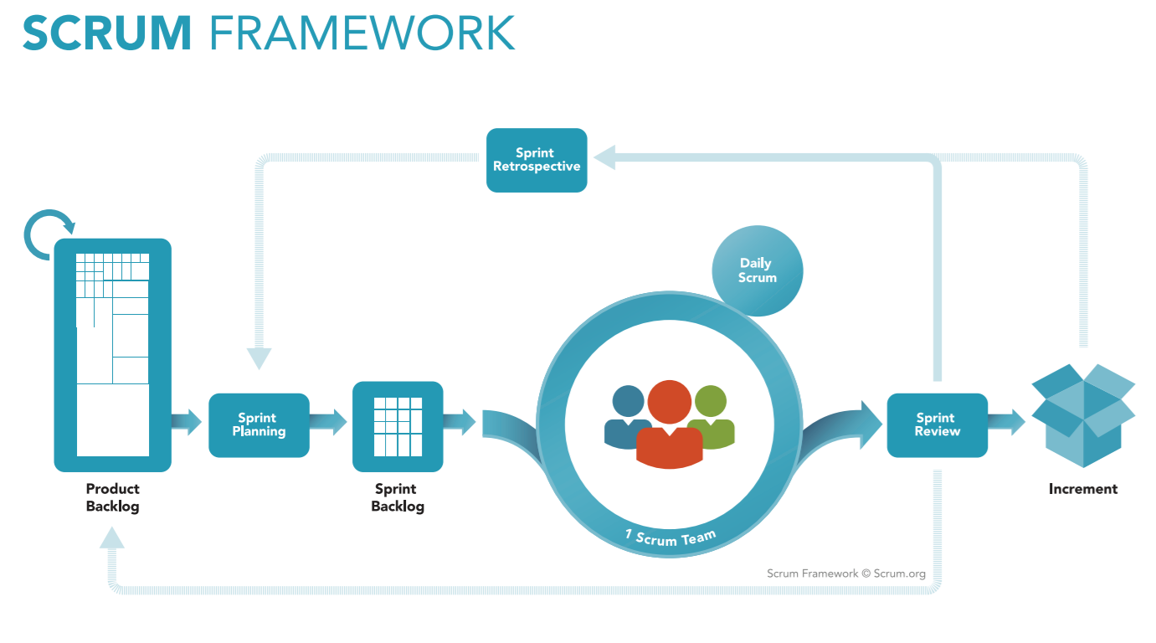

Figure 1: Scrum process

(<https://www.scrum.org/resources/what-is-scrum>)

### Roles and responsibilities

|  |  |  |  |
| --- | --- | --- | --- |
| **No** | **Role in Scrum** | **Name** | **Responsibilities** |
| 1 | Product owner | Kiều Trọng Khánh | * Specify scope and user requirement. * Supervise the development progress. * Provide professional techniques and business analysis support. |
| 2 | Scrum master | Mai Minh Quý | * Create Sprint Backlog and Product Backlog. * Make sure the Scrum teams understand and follow the process. * Always be present to answer questions and give advice when product owner or scrum member needs. * Help the team master scrum artifacts such as: Sprint Backlog, Product Backlog, ... |
| 3 | Scrum team member | Mai Minh Quý  Trương Hữu Thành  Phan Minh Huấn  Phạm Trung Hiếu | * Designing database * Clarifying requirements * Prepare documents * GUI design * Coding * Testing |
|  | | | |

Table 4: Roles and Responsibilities Details

### Tools and Techniques

|  |  |
| --- | --- |
|  | Tool/Technique |
| Mobile Application | Android SDK, Firebase |
| Web Portal | CSS, HTML5, React JS, Java Script, Firebase |
| Back-end | SpringBoot framework, Java, JPA |
| IDE | IntelliJ 2017.2.4, Android Studio 2.3.3 |
| Database | MySQL Server 5.7.19, MySQL Workbench 6.3.9 |
| Modeling tools | Star UML 2.8.0 |

Table 5: Tools and Techniques

## Project Management Plan

### Product Backlog

All product backlog could be found here

### Sprint Backlog

All sprint backlog could be found here

### Deliverables

|  |  |  |  |  |
| --- | --- | --- | --- | --- |
| **No** | **Deliverable** | **Deliverable date** | **Deliverable location** | **Note** |
| 1 | Introduction, Project Management Plan, Concept Diagram, Class Diagram, Entity Relationship Diagram, Use Case Overview, Mock UI |  |  | Sprint 1 |
| 2 | Study Spring Boot Framework, Study React, Design User Interface for Mobile Programming, Mobile Architecture, Web Service Architecture |  |  | Sprint 2 |
| 3 | Code core flow RESTful API Web services, Web application and Mobile application |  |  | Sprint 3 |
| 4 | Code core flow Web application and Mobile application; Study firebase console services; User Requirement Specification |  |  | Sprint 4 |
| 5 | Code low priority functions, Conceptual Diagram, Design Overview, System Architectural Design, Component Diagram. |  |  | Sprint 5 |
| 6 | Testing, Entity Relationship Diagram, Database Diagram, Algorithms |  |  | Sprint 6 |
|  | | | | |
| Table 6: Deliverables | | | | |

* For each Sprint, deliverables are potentially shippable products, which can be a part of document or prototype implemented based on the project’s core flow.
* Each Sprint has a fixed duration of two weeks.

### All Meeting Minutes

All meeting documents could be found here

## Coding Convention

### Naming convention

* Camel Case: variable name, function name.
* Pascal Case: class name.
* Snake Case: name of table and field of database.
* Lower Case: package name.

### Functional convention

* Device code into multiple module functional oriented

**References:**

* <http://www.oracle.com/technetwork/java/codeconvtoc-136057.html>
* <https://laptrinhrails.wordpress.com/>

# Software Requirement Specifications

## User Requirement Specification

### Guest Requirement

Guest is a person who loves to play football. Guest can do the following functions:

* Sign up
* Sign in

### User Requirement

User is a person who represents a football team to reserve field. User can do the following functions:

* Manage account:
  + Get profile’s information
  + Edit profile
* Search field
* Reserve field (reserve friendly match: user finds and reserves a field)
* Manage matching requests:
  + Create reservation requests
  + Cancel reservation requests
  + Reserve tour match (user finds opponent, chooses suitable field from suggest of system and reserves a match)
* Get history (user views history about created reservation request and created matching request)
* Rating field/opponent
* Send report (report bad user or bad field owner)
* Set favorites field.
* Add opponent to blacklist
* Deposit (deposit money to user’s wallet in system)

### Field Owner Requirement

Field owner is a person who has football fields and let users reserve his/her fields by using our application. The following functions are available for field owner to use:

* Manage account:
  + Get profile’s information
  + Edit profile
* Manage field:
  + Create field
  + Disable field
  + Create promotions (discount reservation fee or free services for user)
* Manage active time:
  + Create active time
  + Update active time
* Send report (report bad user)
* Set field for match
* Get bills by date

### Admin Requirement

Admin is an employee from our company. Admin is responsible for managing service provider system and accounts. Admin can do following functions:

* Lock users’ accounts

### Staff Requirement

Staff is an employee from our company. Staff solves the problem for the user and field owner. Staff can do following functions:

* Accept the field owner’s account creation request (when field owner creates an account, staff will authenticate the actual situation of field owner to approve field owner’s account)
* Get report from user (view reports from user and field owner)
* Send lock account request (request admin to lock account of bad user, field owner)
* Set standard price of field (control reservation field fee to avoid devaluation)
* Change user’s balances (when user makes a transaction at a company office, staff will use this function to solve money problems)

### System Requirement

System performs functions that run underground and connects to external system (deposit money, notification system). System do following functions:

* Calculate bonus point (based on rating of user)
* Calculate rating score (based on rating of user)
* Send notification (when user reserves field, found suitable opponents…; field owner has reservation request)

## Software Requirement Specification

### External Interface Requirement

#### User Interface

* Mobile and Web application use Vietnamese interface, suitable for Vietnamese user.

#### Hardware Interface

* N/A

#### Software Interface

* JSON library,
* Ngân lượng payment gateway, Paypal payment gateway support to payment.
* Twilio supported to send SMS.
* Firebase: Google’s mobile platform supported to notify.

#### Communication Protocol

* Use HTTP protocol 1.1 for communication between the web browser and the web server, mobile application and the server, the server and the Microsoft services.

### System Overview Use Case

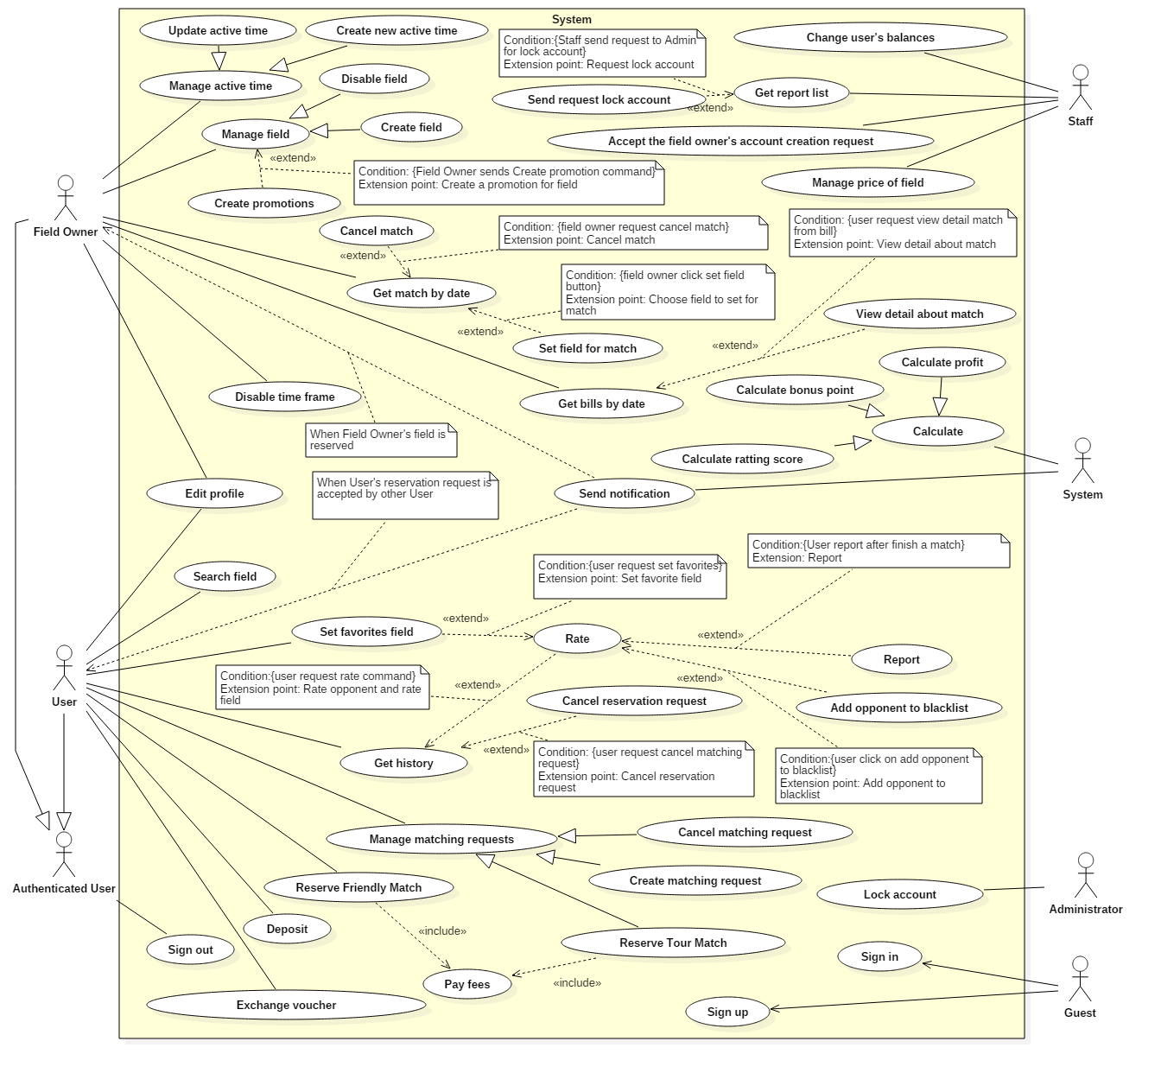

Figure 2: System Overview Use Case

### List of Use Case

#### Guest Use Case

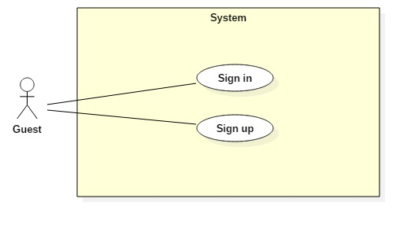

Figure 3: <Guest> Overview Use Case

##### <Guest> Sign up

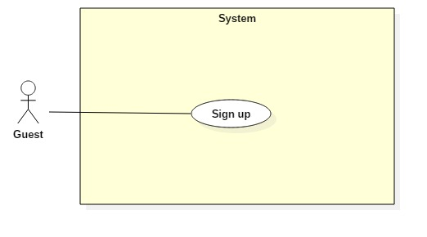

Figure 4: <Guest> Sign up

|  |  |  |  |
| --- | --- | --- | --- |
| **USE CASE – UC001** | | | |
| **Use Case No.** | 001 | **Use Case Version** | 1.0 |
| **Use Case Name** | Sign up | | |
| **Author** | HieuPT | | |
| **Date** | 10/10/2017 | **Priority** | High |
| **Actor:**   * Guest   **Summary:**   * This use case allows Guest to sign up new account.   **Goal:**   * Account is sign up successfully and store in database of the system.   **Triggers:**   * Guest sends command to sign up.   **Preconditions:**   * Actor has not accessed in the system.   **Post Conditions:**   * **Success:** New account is created. * **Fail:** Account is not created.   **Main Success Scenario:**   |  |  |  | | --- | --- | --- | | Step | Actor Action | System Response | | 1 | Guest sends command to request sign up. | System requires information from Guest:   * Full name: free text input, required, length (10-50) * Username: free text input, required, length (9-20) * Phone: free number input, required, length (10-12) positive integer, values: [0,9] | | 3 | Guest inputs information and sends command to sign up.  [Alternative 1]  [Alternative 2] | Account registered.  System will send password to phone number and display login view.  [Exception 1]  [Exception 2]  [Exception 3] |   **Alternative Scenario 1:**   |  |  |  | | --- | --- | --- | | Step | Actor Action | System Response | | 1 | Guest sends command to reset. | System reset all field to blank. |   **Alternative Scenario 2:**   |  |  |  | | --- | --- | --- | | Step | Actor Action | System Response | | 1 | Guest send command to back to login view. | System shows login view.  Account isn’t created. |   **Exceptions :**   |  |  |  | | --- | --- | --- | | No | Cause | System Response | | 1 | Guest input already exist username. | System show warning message “Tên đăng nhập này đã tồn tại”. | | 2 | Guest does not input required field. | System notices that guest need to input all these field:   * “Full name”: System display warning message: “Vui lòng điền dữ liệu vào trường này”. * “Username”: System display warning message: “Vui lòng điền dữ liệu vào trường này”. * “Phone”: System display warning message: “Vui lòng điền dữ liệu vào trường này”. | | 3 | Guest input wrong some fields with requirement. | System notices that guest need to re-input all these field:   * “Full name”: System display warning message: “Tên đầy đủ của đội từ 10-50 ký tự”. * “Username”: System display warning message: “Tên đăng nhập phải từ 6-20 ký tự”. * “Phone”: System display warning message: “Số điện thoại không đúng”. |   **Relationships:** N/A  **Business Rules:**   * If guest signs up a user account, system will send an authentication message for user to login to system. Guest will become a user immediately and can reserve a field. * If guest sign up a field owner account, guest must enter phone number to authenticate. In addition, system will require guest inputs address. If guest does not input address, system will get the current location as the guest address automatically. This registration will be reported to the staff. The field owner’s account will be valid only when staff check the authenticity of the address and approve. | | | |

Table 7: Sign up specification

##### <Guest> Sign in

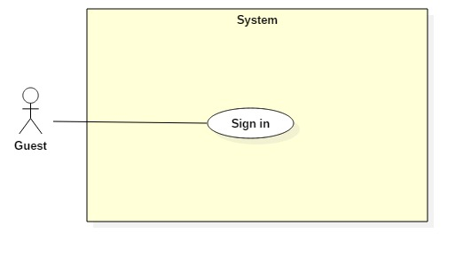

Figure 5: <Guest> Sign in

|  |  |  |  |
| --- | --- | --- | --- |
| **USE CASE – UC002** | | | |
| **Use Case No.** | 002 | **Use Case Version** | 1.0 |
| **Use Case Name** | Sign in | | |
| **Author** | HieuPT | | |
| **Date** | 24/10/2017 | **Priority** | High |
| **Actor:**   * Guest   **Summary:**   * This use case allows Guest sign in to the system on website and mobile application.   **Goal:**   * Guest sign in successfully with the proper role.   **Triggers:**   * Guest send the sign in command.   **Preconditions:**   * Guest has an account.   **Post Conditions:**   * **Success:** Guest accesses the system successfully. * **Fail:** System shows error message “Invalid username or password”.   **Main Success Scenario:**   |  |  |  | | --- | --- | --- | | Step | Actor Action | System Response | | 1 | Guest sends command to request sign in. | System requires identity information form Guest:   * Username: free text input. * Password: free text input. | | 2 | Guest inputs information |  | | 3 | Guest sends command to sign in to system.  [Alternative 1] | Guests will sign in system with their specific role. |   **Alternative Scenario:**   |  |  |  | | --- | --- | --- | | Step | Actor action | System Response | | 1 | Guest input invalid username or password. | System show error message “Tên đăng nhập hoặc mật khẩu không đúng”. |   **Exceptions :** N/A  **Relationships:** N/A  **Business Rules:**  - After sign in to system, guest will be redirected to specific view based on their role on the system: owner or user.   * If role is “User”, the system will display to User view. * If role is “Owner”, the system will display to Owner view. | | | |

Table 8: Sign in specification

#### User Use Case

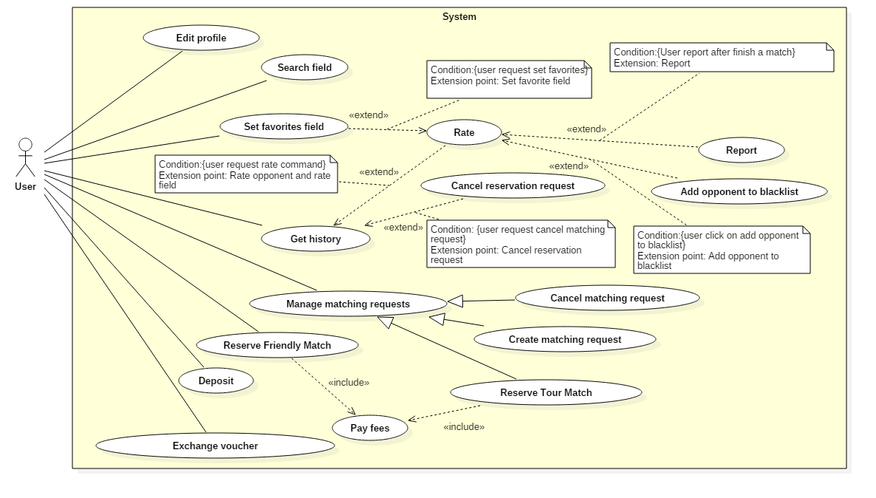

Figure 6: <User> Overview

##### <User, Field Owner> Edit profile

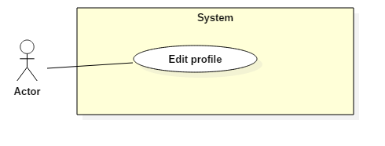

Figure 7: <User> Edit profile

|  |  |  |  |
| --- | --- | --- | --- |
| **USE CASE – UC003** | | | |
| **Use Case No.** | **003** | **Use Case Version** | 1.0 |
| **Use Case Name** | Edit profile | | |
| **Author** | HieuPT | | |
| **Date** | 24/10/2017 | **Priority** | Normal |
| **Actor:**   * User, Field Owner   **Summary:**   * This use case allows Actor to edit account profile.   **Goal:**   * Profile of account are updated.   **Triggers:**   * Actor sends command to edit profile.   **Preconditions:**   * Actor has accessed the system under user role or field owner role.   **Post Conditions:**   * **Success:** Information of account is updated and display. * **Fail:** Information of account is not updated.   **Main Success Scenario:**   |  |  |  | | --- | --- | --- | | Step | Actor Action | System Response | | 1 | Actor sends command to request edit profile. | System requires information from Actor.   * Full name: free text input, required, length (10-50) * New Password: free text input, required, length (6-12) * Repeat new password: free text input, required, length (6-12) * Address: free text input, required, length (6-500). System will automatically get the current position. * Phone: free number input, length(10-12), positive integer, value: [0,9] | | 2 | Actor inputs information, sends command to save edit.  [Alternative 1] [Alternative 2] | System shows edit successfully.  [Exception 1] [Exception 2] [Exception 3] |   **Alternative Scenario 1:**   |  |  |  | | --- | --- | --- | | Step | Actor Action | System Response | | 1 | Actor sends command to reset. | System resets all field to blank. |   **Alternative Scenario 2:**   |  |  |  | | --- | --- | --- | | Step | Actor Action | System Response | | 1 | Actor sends command to pick location via google maps. | System saves location Actor picked to Address field. |   **Exceptions:**   |  |  |  | | --- | --- | --- | | No | Cause | System Response | | 1 | Actor inputs already exist phone. | System shows warning message “This phone number has been used to create an account”. | | 2 | Actor does not input required field. | System notices that Actor need to input all these field:   * “Full name”: System display warning message: “Vui lòng nhập tên”. * “Password”: System display warning message: “Vui lòng nhập mật khẩu”. * “Repeat password”: System display warning message: “Vui lòng nhập lại mật khẩu”. * “Phone”: System display warning message: “Vui lòng nhập số điện thoại”. | | 3 | Actor inputs wrong some fields with requirement. | System notices that Actor need to re-input all these field:   * “Full name”: System display warning message: “Tên đầy đủ phải từ 10-50 kí tự”. * “Password”: System display warning message: “Mật khẩu phải từ 6-12 kí tự”. * “Repeat password”: System display warning message: “Không đúng với mật khẩu được nhập”. * “Phone”: System display warning message: “Số điện thoại phải là số”. |   **Relationships: N/A**  **Business Rules:**   * After edited, new information will be save to profile of account. * Approximate address depends on GPRS and Google maps. * Only Field Owner has longitude and latitude, it will be get based on address through Google API from input of user. | | | |

Table 9: Edit profile specification

##### <User> Search field

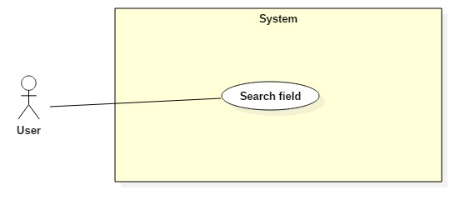

Figure 8: <User> Search field

|  |  |  |  |
| --- | --- | --- | --- |
| **USE CASE – UC004** | | | |
| **Use Case No.** | 004 | **Use Case Version** | 1.0 |
| **Use Case Name** | Search field | | |
| **Author** | HieuPT | | |
| **Date** | 24/10/2017 | **Priority** | High |
| **Actor:**   * User   **Summary:**   * This use case allows User to search Field Owner by input keyword.   **Goal:**   * User finds available Field Owner base on keyword.   **Triggers:**   * User sends command to search field.   **Preconditions:**   * User has accessed the system under user role or field owner role.   **Post Conditions:**   * **Success:** list field owners have suitable name are display. * **Fail:** No response from system.   **Main Success Scenario:**   |  |  |  | | --- | --- | --- | | Step | Actor Action | System Response | | 1 | User inputs keyword to search |  | | 2 | User sends Search Field command.  [Alternative 1] | System will search and return any field owners whose name matches the keyword entered. |   **Alternative Scenario 1:**   |  |  |  | | --- | --- | --- | | Step | Actor Action | System Response | | 1 | User inputs blank in textbox. | System show 10 field owners near based on user’s location. |   **Exceptions :**   |  |  |  | | --- | --- | --- | | No | Cause | System Response | | 1 | No field owner matches the keyword inputted. | System shows warning message “Không tìm thấy sân phù hợp”. |   **Relationships:** N/A  **Business Rules:**   * Use likely search for search command | | | |

Table 10: Search field specification

##### <User> Reserve friendly match

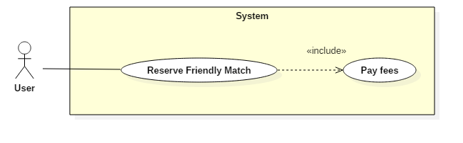

Figure 9: <User> Reserve friendly match

|  |  |  |  |
| --- | --- | --- | --- |
| **USE CASE – UC005** | | | |
| **Use Case No.** | 005 | **Use Case Version** | 1.0 |
| **Use Case Name** | Reserve friendly match | | |
| **Author** | QuyMM | | |
| **Date** | 24/10/2017 | **Priority** | High |
| **Actor:**   * User   **Summary:**   * This use case allows User to reserve field by chose field and time.   **Goal:**   * User reserves field successful.   **Triggers:**   * User sends command to reserve field.   **Preconditions:**   * Actor has accessed the system under user role.   **Post Conditions:**   * **Success:** User reserves friendly match successful and display field’s information. * **Fail:** Friendly match is not created.   **Main Success Scenario:**   |  |  |  | | --- | --- | --- | | Step | Actor Action | System Response | | 1 | User chooses expected field from list of fields. | System finds active time of field and response to User. | | 2 | User chooses field type and date. | System responses free time of field. | | 3 | User inputs start time, end time and sends reservation field command. | System responses information about match follow user’s choice (field owner, field type, start time, end time, price). | | 3 | User sends command to pay fees.  [Alternative 1] | System shows message: “Đặt sân thành công” and displays reservation request ‘s information.  System will decrease money from user’s wallet automatically, send notification to Field Owner and save information about friendly match.  [Exception 1][Exception 2] |   **Alternative Scenario 1:**   |  |  |  | | --- | --- | --- | | Step | Actor Action | System Response | | 1 | User cancels reservation command. | System comes back to information detail of field owner view |   **Exceptions:**   |  |  |  | | --- | --- | --- | | No | Cause | System Response | | 1 | Another reservation request has same time, that has reserved and paid off in advance. The time frame is already reserved by another user. | System shows message “Sân bạn đặt đã hết khung giờ trống”. | | 2 | User’s balance is not enough to pay for the match. | System shows message “Bạn không đủ tiền để thanh toán”.  System require deposit to checkout. |   **Relationships:** Include Pay fees  **Business Rules:**   * For the field owner has an optimal time frame, user must reserve the entire time frame. (start time and end time of reservation request must equal start time and end time of optimal time frame). * For regular time frames, the minimum duration that a user must reserve is one hour. User is not limited about maximum duration as long as field owner have enough free time. * User can review the field reservation information in the reservation history. * The field reservation request of user is successful if and only if the user has paid. * After field reservation request to be paid, the system will get the field information, time then send notification to field owner and save information about friendly match. | | | |

Table 11: Reserve friendly match specification

##### <User> Reserve tour match

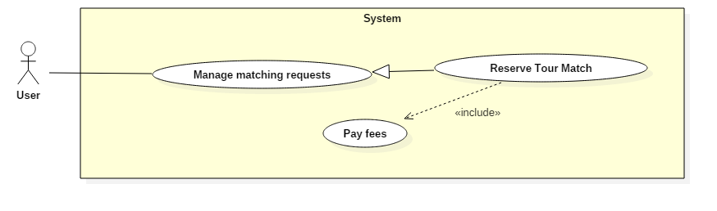

Figure 10: <User> Reserve tour match

|  |  |  |  |
| --- | --- | --- | --- |
| **USE CASE – UC006** | | | |
| **Use Case No.** | 006 | **Use Case Version** | 1.0 |
| **Use Case Name** | Reserve tour match | | |
| **Author** | QuyMM | | |
| **Date** | 24/10/2017 | **Priority** | High |
| **Actor:**   * User   **Summary:**   * This use case allows user reserves tour match.   **Goal:**   * User reserves tour match successful.   **Triggers:**   * User sends reservation tour match command.   **Preconditions:**   * Actor has accessed the system under user role.   **Post Conditions:**   * **Success:** User reserves tour match successfully and system show match’s information. * **Fail:** Tour match is not created.   **Main Success Scenario:**   |  |  |  | | --- | --- | --- | | Step | Actor Action | System Response | | 1 | User requires matching request function.  [Alternative 1] | System requires information from User:   * Start time and end time. * Duration. * Field type. * Distance expected.   System will automatically get the current location using GPS fill to address’s information. | | 2 | User inputs information and sends command to find opponent.  [Alternative 2] | System receives information inputted, find suitable opponents and return list suitable opponents.  Display list opponent.  [Exception 1] [Exception 2] | | 3 | User chooses an opponent in list and sends command to choose suitable field.  [Alternative 3] [Alternative 5] | System will find and return suitable field list.  Get first field in suitable field list and display. System allow user to change field in suitable field list.  [Exception 3] | | 4 | User sends command to pay fees.  [Alternative 4] | System shows reservation match’s information.  System will decrease money from user’s wallet automatically, send notification to Field Owner, opponent about tour match and save information about tour match.  [Exception 4] [Exception 5] |   **Alternative Scenario 1:**   |  |  |  | | --- | --- | --- | | Step | Actor Action | System Response | | 1 |  | System notifies about matching request has opponent to user. | | 2 | User views notifies | System displays list suitable opponents. | | 3 | User chooses an opponent in list and sends command to choose suitable field.  [Alternative 3] [Alternative 5] | System will find and return suitable field list.  Get first field in suitable field list and display. System allow user to change field in suitable field list.  [Exception 3] | | 4 | User sends command to pay fees.  [Alternative 4] | System shows reservation match’s information.  System will decrease money from user’s wallet automatically, send notification to Field Owner, opponent about tour match and save information about tour match.  [Exception 4] [Exception 5] |   **Alternative Scenario 2:**   |  |  |  | | --- | --- | --- | | Step | Actor Action | System Response | | 1 | User chose other position by input address to “address” text input. | System call google map API to get address same with input text of user.  [Exception 1] |   **Alternative Scenario 3:**   |  |  |  | | --- | --- | --- | | Step | Actor Action | System Response | | 1 |  | If duration of request is less than end time – start time of matching request.  System will require user input start time and end time equal expected duration. | | 2 | User input start time | System will response end time automatically with end time – start time equal duration of matching request. | | 3 | User sends choose suitable field command. | System will find and return list suitable field.  Get first field in list suitable field and display.  System will continue processing like step 4 of main scenario.  [Exception 3] |   **Alternative Scenario 4:**   |  |  |  | | --- | --- | --- | | Step | Actor Action | System Response | | 1 | User chooses another field in suitable field list. | System will display information of the selected field.  System will continue processing like step 4 of main scenario. |   **Alternative Scenario 5:**   |  |  |  | | --- | --- | --- | | Step | Actor Action | System Response | | 1 | User dislikes all suggested opponent from system and sends command to comes back. | System will come back to main view.  If user created matching request, user’s matching request is saved and system will continue find more suitable opponents. |   **Exception :**   |  |  |  | | --- | --- | --- | | No | Cause | System Response | | 1 | User input blank and wrong address. | System shows warning message “Không tìm thấy địa chỉ phù hợp”. | | 2 | System does not find suitable opponents | System shows warning message: “Không tìm thấy đối thủ phù hợp”. | | 3 | System does not find suitable field. | System shows warning message: “Không tìm thấy sân phù hợp.”  System will require extend searching radius. | | 4 | User’s balance is not enough to pay for the match. | System shows message “Bạn không đủ tiền để thanh toán”.  System shows “Nạp tiền” button to Deposit. | | 5 | Another reservation request has same time, that has reserved and paid off in advance. The time frame is already reserved by another user. | System shows message “Sân bạn đặt đã hết khung giờ trống”.  System will get another field in list suitable field and display. |   **Relationships:** Include Checkout  **Business Rules:**   * System will find similar matching with the criteria:   + Duration is equal or longer than duration of user inputted  + End time of information inputted must be longer than start time of matching request in database.  + Location of user have matching request in database must be within the searching radius request.  + Have same field type.  + 2 users must have difference ranking score is not exceed 50 points.  + Opponent is not in the user’s blacklist.   * System will suggest suitable field for match with criteria:   + Search for field in the search radius requested by two users, the returned list contain common field of two lists found.  + If in the returned list, there are common favorites field of two user or one of two users, system will only recommend these fields.  + If in the returned list, there is no favorites field of any user, system will return all returned list   * User pays haft reservation field fee; the other half is paid by opponent. * When user reserves tour match successful, system will decrease money from opponent’s wallet and return money that was taken when the opponent created matching request. | | | |

Table 12: Reserve tour match specification

* + - 1. **<User> Get History List**

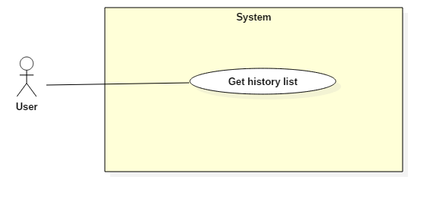

Figure 11: <User> Get history

|  |  |  |  |
| --- | --- | --- | --- |
| **USE CASE – UC007** | | | |
| **Use Case No.** | 007 | **Use Case Version** | 1.0 |
| **Use Case Name** | Get history list | | |
| **Author** | HuanPM | | |
| **Date** | 2/12/2017 | **Priority** | High |
| **Actor:**   * User   **Summary:**   * This use case allows Actor to get Actor’s history list.   **Goal:**   * System gets history list and display it to Actor.   **Triggers:**   * Actor sends get history command.   **Preconditions:**   * Actor has accessed the system under User role.   **Post Conditions:**   * **Success:** History list is displayed. * **Fail:** Show error messages.   **Main Success Scenario:**   |  |  |  | | --- | --- | --- | | Step | Actor Action | System Response | | 1 | Actor sends get history list command. | System gets history list.  [Exception 1]  System displays history list to Actor. |   **Exceptions:**   |  |  |  | | --- | --- | --- | | No | Cause | System Response | | 1 | Actor’s history list is empty | System shows error message “Không có danh sách lịch sử”. |   **Relationships:** N/A  **Business Rules:**   * History consists of reserved matches and pending matching requests. | | | |

Table 13: Get history specification

* + - 1. **<User> Set favorite field**

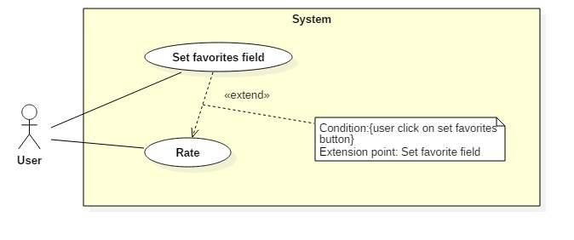

Figure 12: <User> Set favorite field

|  |  |  |  |
| --- | --- | --- | --- |
| **USE CASE – UC008** | | | |
| **Use Case No.** | 008 | **Use Case Version** | 1.0 |
| **Use Case Name** | Set favorites field | | |
| **Author** | HuanPM | | |
| **Date** | 2/12/2017 | **Priority** | Normal |
| **Actor:**   * User   **Summary:**   * This use case allows Actor to add a field to favorite field list.   **Goal:**   * System update favorite field list.   **Triggers:**   * Actor sends add to favorite command.   **Preconditions:**   * Actor has accessed the system under User role.   **Post Conditions:**   * **Success:** Favorite field is saved into user’s profile. * **Fail:** Favorite field is not saved into user’s profile.   **Main Success Scenario:**   |  |  |  | | --- | --- | --- | | Step | Actor Action | System Response | | 1 | Actor sends add to favorite command. | System adds field to Actor’s favorite field list.  System displays message “Bạn đã thêm sân vào danh sách yêu thích”. |   **Relationships:** Extends use case Rate.  **Business Rules:**   * The field in favorite list has higher priority (than others field) when Actor search field. | | | |

Table 14: Set favorite field specification

* + - 1. **<User> Rate field/opponent**

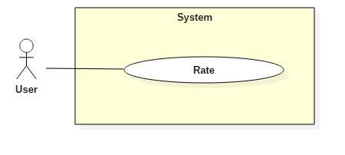

Figure 13: <User> Rate field/opponent

|  |  |  |  |
| --- | --- | --- | --- |
| **USE CASE – UC009** | | | |
| **Use Case No.** | 009 | **Use Case Version** | 1.0 |
| **Use Case Name** | Rate field/opponent | | |
| **Author** | QuyMM | | |
| **Date** | 01/11/2017 | **Priority** | Normal |
| **Actor:**   * User   **Summary:**   * This use case allows User to rate field or opponent.   **Goal:**   * User rate field or opponent successful.   **Triggers:**   * User sends rating command.   **Preconditions:**   * Actor has accessed the system under User role.   **Post Conditions:**   * **Success:** Rating result of user is saved and calculated. * **Fail:** System will rollback and user can rate again.   **Main Success Scenario:**   |  |  |  | | --- | --- | --- | | Step | Actor Action | System Response | | 1 | User sends rate opponent command.  [Alternative 1] | System will require user to rate with criteria:   * Result of match * Level of opponent with 3 level:   + Yếu (Amateur)  + Bình thường (Regular)  + Hay (Professional)   * Goals difference | | 2 | User inputs all and sends submit rating opponent command. | System receives information and show message: “Bạn đã đánh giá thành công”.  [Exception 1] |   **Alternative Scenario 1:**   |  |  |  | | --- | --- | --- | | Step | Actor Action | System Response | | 1 | User sends rate field command. | System will require user to rate with criteria.   * 5 stars (user can choose haft a star) * Comment | | 2 | User inputs all and sends submit rating field command. | System receives information and show message: “Bạn đã đánh giá thành công”.  [Exception 1] |   **Exceptions :**   |  |  |  | | --- | --- | --- | | No | Cause | System Response | | 1 | User does not input to all field. | System shows warning message “Vui lòng điền đầy đủ thông tin”. |   **Relationships:** N/A  **Business Rules:**   * User will be rewarded bonus points when rating to encourage user to perform the rating. * Rating field is relative so all rating field will be accepted. * Rating opponent affects to evaluate user’s level, supports for finding suitable opponent in the future so rating opponent results must be checked for correctness before evaluate. | | | |

Table 15: Rate field/opponent specification

* + - 1. **<User, Field Owner> Report account**

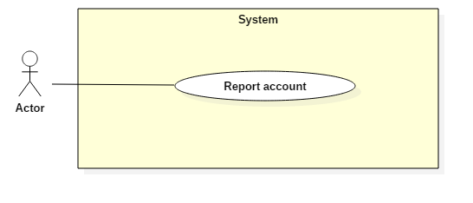

Figure 14: <User> Report account

|  |  |  |  |
| --- | --- | --- | --- |
| **USE CASE – UC010** | | | |
| **Use Case No.** | 010 | **Use Case Version** | 1.0 |
| **Use Case Name** | Report account | | |
| **Author** | QuyMM | | |
| **Date** | 01/11/2017 | **Priority** | Normal |
| **Actor:**   * User, Field Owner   **Summary:**   * This use case allows User to report account.   **Goal:**   * Actor sends report account successful.   **Triggers:**   * User sends report command.   **Preconditions:**   * Actor has accessed the system under User or Field Owner role.   **Post Conditions:**   * **Success:** Report is saved and calculated. * **Fail:** System will rollback and user can report again.   **Main Success Scenario:**   |  |  |  | | --- | --- | --- | | Step | Actor Action | System Response | | 1 | User sends report command. | System will display report view with requires:   * Accused * Reason * Match | | 2 | User inputs all and sends submit report command. | System receives information and show message: “Bạn đã tố cáo thành công”. |   **Alternative Scenario 1:**   |  |  |  | | --- | --- | --- | | Step | Actor Action | System Response | | 1 | User sends rate field command. | System will require user to rate with criteria.   * 5 stars (user can choose haft a star) * Comment | | 2 | User inputs all and sends submit rating field command. | System receives information and show message: “Bạn đã đánh giá thành công”. |   **Exceptions :**   |  |  |  | | --- | --- | --- | | No | Cause | System Response | | 1 | User does not input to all field. | System shows warning message “Vui lòng điền đầy đủ thông tin”. |   **Relationships:** N/A  **Business Rules:**   * User will be rewarded bonus points when rating to encourage user to perform the rating. * Rating field is relative so all rating field will be accepted. * Rating opponent affects to evaluate user’s level, supports for finding suitable opponent in the future so rating opponent results must be checked for correctness before evaluate. | | | |

Table 16: Report account specification

* + - 1. **<User> Add opponent to blacklist**

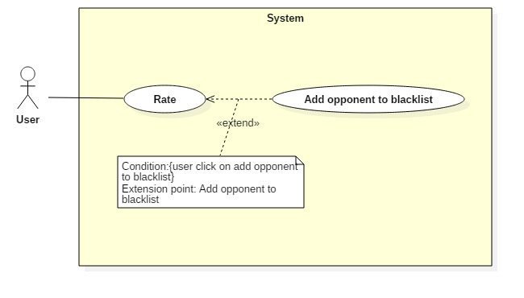

Figure 15: <User> Add opponent to blacklist

|  |  |  |  |
| --- | --- | --- | --- |
| **USE CASE – UC011** | | | |
| **Use Case No.** | 011 | **Use Case Version** | 1.0 |
| **Use Case Name** | Add opponent to blacklist | | |
| **Author** | HuanPM | | |
| **Date** | 2/12/2017 | **Priority** | Normal |
| **Actor:**   * User   **Summary:**   * This use case allows Actor to add another Actor to blacklist.   **Goal:**   * System update Actor’s blacklist.   **Triggers:**   * Actor sends rating command.   **Preconditions:**   * Actor has accessed the system under User role.   **Post Conditions:**   * **Success:** The rating is created. Actor’s blacklist is updated. * **Fail:** Actor’s blacklist is not updated.   **Main Success Scenario:**   |  |  |  | | --- | --- | --- | | Step | Actor Action | System Response | | 1 | Actor sends add User to blacklist command. | System saves User’s information to Actor’s blacklist.  System displays message “Bạn đã thêm đối thủ vào danh sách chặn” |   **Relationships:** Extends use case Rate.  **Business Rules:**   * User that is in Actor’s blacklist cannot find Actor when using find matching request function. | | | |

Table 17: Add opponent to blacklist specification

##### <User> Exchange voucher

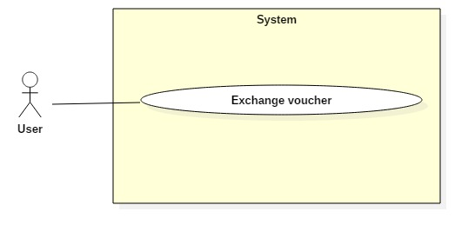

Figure 16: <User> Exchange voucher

|  |  |  |  |
| --- | --- | --- | --- |
| **USE CASE – UC012** | | | |
| **Use Case No.** | 012 | **Use Case Version** | 1.0 |
| **Use Case Name** | Exchange voucher | | |
| **Author** | HuanPM | | |
| **Date** | 2/12/2017 | **Priority** | Normal |
| **Actor:**   * User   **Summary:**   * This use case allows Actor to exchange bonus point to voucher code.   **Goal:**   * Update voucher bonus point after exchange, save voucher code in database.   **Triggers:**   * Actor sends exchange voucher command.   **Preconditions:**   * Actor has accessed the system under User role.   **Post Conditions:**   * **Success:** System updated Actor’s balance and bonus point. * **Fail:** User’s bonus point is not changed and user is not received voucher.   **Main Success Scenario:**   |  |  |  | | --- | --- | --- | | Step | Actor Action | System Response | | 1 | Actor sends get voucher list command | System displays voucher list. | | 2 | Actor sends exchange voucher command.  [Alternative 1] | System checks if Actor’s bonus point is enough to exchange voucher.  [Exception 1]  System updates Actor’s bonus point and balance.  System display successful message “Bạn đã đổi thưởng thành công”.  System creates voucher code and display voucher code. |   **Alternative Scenario 1:**   |  |  |  | | --- | --- | --- | | Step | Actor Action | System Response | | 1 | Actor send cancel command. | System back to previous window and allow Actor choose other voucher. |   **Exceptions:**   |  |  |  | | --- | --- | --- | | No | Cause | System Response | | 1 | Actor’s bonus point is not enough to exchange the voucher. | System shows error message “Không đủ điểm để đối thưởng”. |   **Relationships:** N/A  **Business Rules:**   * Voucher code is used to discount field’s price. | | | |

Table 18: Exchange voucher specification

##### <User> Create matching request

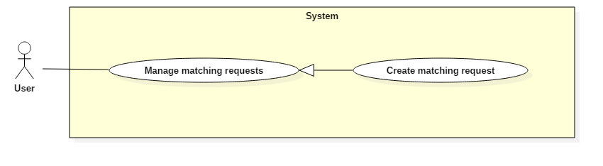

Figure 17: <User> Create matching request

|  |  |  |  |
| --- | --- | --- | --- |
| **USE CASE – UC013** | | | |
| **Use Case No.** | 013 | **Use Case Version** | 1.0 |
| **Use Case Name** | Create matching request | | |
| **Author** | HuanPM | | |
| **Date** | 28/10/2017 | **Priority** | High |
| **Actor:**   * User   **Summary:**   * This use case allows User to create a matching request.   **Goal:**   * User creates a matching request successful.   **Triggers:**   * User sends command to create matching request.   **Preconditions:**   * Actor has accessed the system under user role.   **Post Conditions:**   * **Success:** User creates matching request successful and system saves information about matching request. * **Fail:** Show error message.   **Main Success Scenario:**   |  |  |  | | --- | --- | --- | | Step | Actor Action | System Response | | 1 | User requires the matching request function. | System requires information from User:   * Start time and end time. * Duration. * Field type. * Distance expected.   System will automatically get the current location using GPS fill to address information. | | 2 | User inputs information and sends new creation matching request command.  [Alternative 1] | System takes information inputted and saves information of matching request. System will decrease money from user’s wallet automatically.  [Exception 1][Exception 2] |   **Alternative Scenario 1:**   |  |  |  | | --- | --- | --- | | Step | Actor Action | System Response | | 1 | User chooses other position by input address to “address” text input. | System call google map API to get address same with input text of user. |   **Exceptions:**   |  |  |  | | --- | --- | --- | | No | Cause | System Response | | 1 | User’s balance is not enough to pay for the match. | System shows warning message “Không đủ tiền để tạo yêu cầu mới”.  System shows link to Deposit. | | 2 | User input blank in search address field or wrong address. | System shows warning message “Không tìm thấy địa chỉ phù hợp”. |   **Relationships:** N/A  **Business Rules:**   * Start time and end time when user input to create matching request is time frame that user is free. So, it may be larger than or equal to expected duration of user. * Duration of matching request must be longer than one hour. * The expected distance is radius for the system to find the opponent, it is also used as the search radius of the field. * System will take up some money from user’s wallet, this amount is half the maximum of reservation field fee. This amount will be refunded if the actual reservation field fee is lower. * After create new request, system will save information matching request and find suitable opponent. If the suitable opponent is found, the system will notify the user. | | | |

Table 19: Create matching request specification

##### <User> Cancel matching request

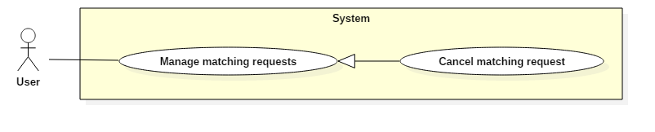

Figure 18: <User> Cancel matching request

|  |  |  |  |
| --- | --- | --- | --- |
| **USE CASE – UC014** | | | |
| **Use Case No.** | 014 | **Use Case Version** | 1.0 |
| **Use Case Name** | Cancel matching request | | |
| **Author** | HuanPM | | |
| **Date** | 24/10/2017 | **Priority** | Normal |
| **Actor:**   * User   **Summary:**   * This use case allows User cancels previously created matching request.   **Goal:**   * User cancels matching request successful.   **Triggers:**   * User sends command to cancel matching request.   **Preconditions:**   * Actor has accessed the system under user role.   **Post Conditions:**   * **Success:** Matching request is canceled and display in user’s history. * **Fail:** Show matching errors.   **Main Success Scenario:**   |  |  |  | | --- | --- | --- | | Step | Actor Action | System Response | | 1 | User sends command to view matching request history | System finds matching request and display user’s matching request. | | 2 | User chooses a matching request | System displays matching request’s information. | | 3 | User sends canceling matching request command. | System refunds money that was taken when user created matching request.  System show message: “Đã hủy yêu cầu thành công”.  [Exception 1] |   **Alternative Scenario:** N/A  **Exceptions:**   |  |  |  | | --- | --- | --- | | No | Cause | System Response | | 1 | Matching request was accepted by another user. | System shows message “Yêu cầu tìm kiếm đối thủ của bạn đã được tạo thành trận đấu. Bạn không thể hủy”. |   **Relationships:** N/A  **Business Rules:**   * When user cancels matching request, this matching request will not be deleted. It will change to disabling status. If user cancels a lot of matching request, user will be reported. * User can view creation matching request’s history. | | | |

Table 20: Cancel matching request specification

##### <User> Cancel reservation request

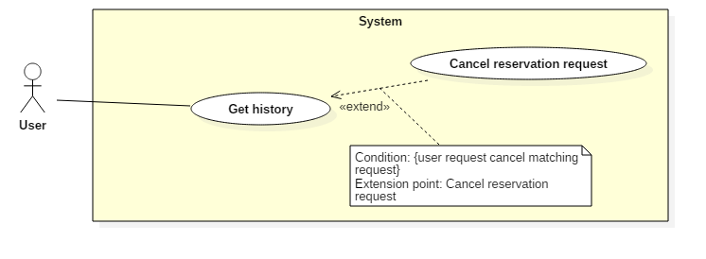

Figure 19: <User> Cancel reservation request

|  |  |  |  |
| --- | --- | --- | --- |
| **USE CASE – UC015** | | | |
| **Use Case No.** | 015 | **Use Case Version** | 1.0 |
| **Use Case Name** | Cancel reservation request | | |
| **Author** | QuyMM | | |
| **Date** | 24/10/2017 | **Priority** | Normal |
| **Actor:**   * User   **Summary:**   * This use case allows User cancels reservation request.   **Goal:**   * User cancels matching request successful.   **Triggers:**   * User sends command to cancel reservation request.   **Preconditions:**   * Actor has accessed the system under user role.   **Post Conditions:**   * **Success:** Reservation request is canceled and user received refunds. * **Fail:** Show error message.   **Main Success Scenario:**   |  |  |  | | --- | --- | --- | | Step | Actor Action | System Response | | 1 | User sends command to view reservation request history | System finds reservation request and display user’s reservation request. | | 2 | User chooses a reservation request | System displays reservation request’s information. | | 3 | User sends canceling matching request command. | System shows warning message about cancellation fees.  [Exception 1] | | 4 | User agrees with cancellation fees.  [Alternative 1] | System refunds money that was taken when user reserved field.  System shows message: “Đã hủy trận đấu thành công”. |   **Alternative Scenario 1:**   |  |  |  | | --- | --- | --- | | Step | Actor Action | System Response | | 1 | User disagrees with cancellation fees. | System comes back to show match’s information and the match will still continue. |   **Exceptions:**   |  |  |  | | --- | --- | --- | | No | Cause | System Response | | 1 | Match is about to begin. User can not cancel. | System shows message “Trận đấu sắp bắt đầu. Bạn không thể hủy lúc này”. |   **Relationships:** N/A  **Business Rules:**   * Depending on when user cancels match, cancellation fees will be difference.   + Before kickoff time greater than or equal 1 day, cancellation fees = 5% reservation fees.  + Before kickoff time greater than or equal 6 hours, cancellation fees = 10% reservation fees.  + Before kickoff time greater than or equal 3 hours, cancellation fees = 20% reservation fees.  + Before kickoff time less than 3 hours, user can not cancel reservation request. | | | |

Table 21: Cancel reservation request specification

##### <User> Deposit

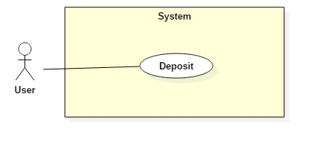

Figure 20: <User> Deposit

|  |  |  |  |
| --- | --- | --- | --- |
| **USE CASE – UC016** | | | |
| **Use Case No.** | 016 | **Use Case Version** | 1.0 |
| **Use Case Name** | Deposit | | |
| **Author** | HuanPM | | |
| **Date** |  | **Priority** | High |
| **Actor:**   * User, Field owner   **Summary:**   * This use case allows Actor deposit money to wallet in system.   **Goal:**   * Actor can increase balance of user’s wallet in system.   **Triggers:**   * Actor sends deposit command.   **Preconditions:**   * Actor has accessed the system under User or Field owner role.   **Post Conditions:**   * **Success:** Actor’s balance is increased. * **Fail:** Show error message.   **Main Success Scenario:**   |  |  |  | | --- | --- | --- | | Step | Actor Action | System Response | | 1 | Actor sends command to requires deposit function. | System will show current balance and available balance and requires actor input the amount that the actor needs to deposit. | | 2 | Actor inputs the amount and sends command to deposit. | System will show many options about payment gateways for actor to deposit.  [Exception 1] | | 3 | Actor chooses a payment gateway to deposit | System will call payment gateway system.  [Exception 2] | | 4 | Actor performs the payment  [Alternative 1] | System will show messages “Bạn đã nạp tiền thành công” and show account’s balance.  [Exception 3] |   **Alternative Scenario 1:**   |  |  |  | | --- | --- | --- | | Step | Actor Action | System Response | | 1 | Actor sends command to decline. | System displays payment gateways for user chooses. |   **Exceptions:**   |  |  |  | | --- | --- | --- | | No | Cause | System Response | | 1 | The amount requested by user is too small or too large. | System shows message “Số tiền mà bạn muốn nạp không phù hợp”. | | 2 | System can not connect to payment gateway system. | System shows message: “Xảy ra lỗi khi kết nối thanh toán, bạn vui lòng thử lại sau”. | | 3 | Payment gateway system have exception when withdraw money to transfer to FFRS System | System shows message: “Có lỗi khi thực hiện thanh toán, bạn vui lòng thử lại sau”. |   **Relationships:** N/A  **Business Rules:**   * The currency of the system is Vietnam dong. * If the user’s payment gateways use a difference currency or not supports for Vietnam dong currency, the system will support convert automatically. * The system is not responsible when the users have problems with their payment gateway. * The amount that user requires is greater than 20 thousand and less than 5 million Vietnam dong. | | | |

Table 22: Deposit specification

#### Field Owner Use Case

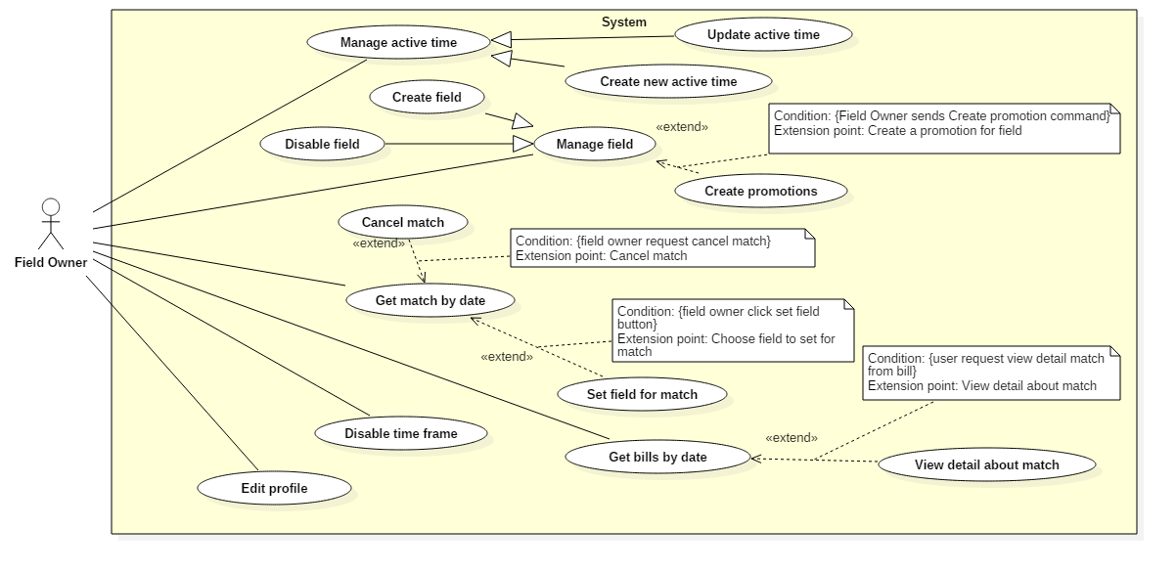

Figure 21: <Field Owner> Overview

##### <Field Owner> Get match by date

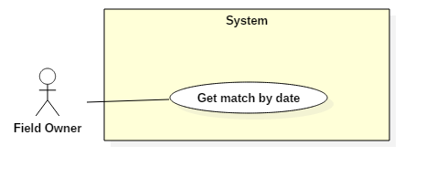

Figure 22: <Field Owner> Get match by date

|  |  |  |  |
| --- | --- | --- | --- |
| **USE CASE – UC0017** | | | |
| **Use Case No.** | 017 | **Use Case Version** | 1.0 |
| **Use Case Name** | Get match by date | | |
| **Author** | QuyMM | | |
| **Date** |  | **Priority** | Normal |
| **Actor:**   * Field Owner   **Summary:**   * This use case allows Field owner get match by date.   **Goal:**   * Field Owner get matches by date successful.   **Triggers:**   * Field owner sends get match by date command.   **Preconditions:**   * Actor has accessed the system under field owner role.   **Post Conditions:**   * **Success:** Field owner viewed matches by date. * **Fail:** Show error messages.   **Main Success Scenario:**   |  |  |  | | --- | --- | --- | | Step | Actor Action | System Response | | 1 | Field owner sends a request to view reserved matches. | System returns reserved matches today and display.  [Exception 1] | | 2 | Field owner chooses a date in the future.  [Alternative 1] | System will return reserved matches in the day selected and display.  [Exception 1] |   **Alternative Scenario 1:**   |  |  |  | | --- | --- | --- | | Step | Cause | System Response | | 1 | Field owner sends a request to get matches in the next day | System will return reserved matches in the next day and display. |   **Exceptions:**   |  |  |  | | --- | --- | --- | | No | Cause | System Response | | 1 | There are no matches today | System shows warning message “Không có trận đấu nào được đặt hôm nay”. |   **Relationships:** N/A  **Business Rules:**   * Field owner can only view matches in the current and in the next 7 days because the user only reserved field within 7 days. * The system will use difference color when display matches to help field owner distinguish matches are reserved by field owner and matches are reserved by user. * The field owner can view matches of the day on the field if the matches was set field. | | | |

Table 23: Get match by date specification

##### <Field Owner> Create promotion

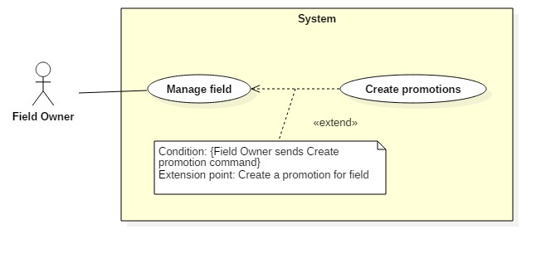

Figure 23: <Field Owner> Create promotion

|  |  |  |  |
| --- | --- | --- | --- |
| **USE CASE – UC018** | | | |
| **Use Case No.** | 018 | **Use Case Version** | 1.0 |
| **Use Case Name** | Create promotion | | |
| **Author** | ThanhTH | | |
| **Date** |  | **Priority** | Normal |
| **Actor:**   * Field Owner   **Summary:**   * This use case allows Field owner to create promotion.   **Goal:**   * Field owner creates promotion for field.   **Triggers:**   * Field owner sends create matching request command.   **Preconditions:**   * Actor has accessed the system under field owner role.   **Post Conditions:**   * **Success:** Field owner creates promotion and system displays promotion’s information. * **Fail:** Show error messages.   **Main Success Scenario:**   |  |  |  | | --- | --- | --- | | Step | Actor Action | System Response | | 1 | Actor sends command to create field. | System requires information from Actor:   * Start time * End time * Start date * End date * Promotion content * Percent discount * Field type | | 2 | Actor sends create promotion command.  [Alternative 1] | System will create a new promotion with inputted information and save to database.  [Exception 1] |   **Alternative Scenario 1:**   |  |  |  | | --- | --- | --- | | Step | Cause | System Response | | 1 | Actor send cancel command. | System comes back to previous view.  Promotion will not be created. |   **Exceptions 1:**   |  |  |  | | --- | --- | --- | | Step | Cause | System Response | | 1 | Actor input blank in required field. | System shows warning message “Vui lòng nhập đầy đủ thông tin”. |   **Relationships:** N/A  **Business Rules:**   * At the time of promotion, system will calculate field fee minus promotion fee. * Percent discount is promotion on total reservation field fee. * Promotion contents are services promotion like: free iced tea, no parking fee… | | | |

Table 24: Create promotion specification

##### <Field Owner> Create field

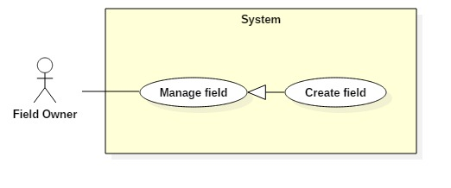

Figure 24: <Field Owner> Create field

|  |  |  |  |
| --- | --- | --- | --- |
| **USE CASE – UC019** | | | |
| **Use Case No.** | 019 | **Use Case Version** | 1.0 |
| **Use Case Name** | Create field | | |
| **Author** | ThanhTH | | |
| **Date** |  | **Priority** | High |
| **Actor:**   * Field Owner   **Summary:**   * This use case allows Field owner to create field.   **Goal:**   * Field Owner can create a new field.   **Triggers:**   * Field owner sends command to create field.   **Preconditions:**   * Actor has accessed the system under field owner role.   **Post Conditions:**   * **Success:** Field owner creates field successfully. * **Fail:** Show error messages.   **Main Success Scenario:**   |  |  |  | | --- | --- | --- | | Step | Actor Action | System Response | | 1 | Field owner sends a request to create field. | System requires information:   * Field name. * Field Type. | | 2 | Field owner sends create field command. | System will create a new field.  [Exception 1]  [Exception 2] |   **Alternative Scenario:** N/A  **Exceptions:**   |  |  |  | | --- | --- | --- | | No | Cause | System Response | | 1 | Field owner inputs blank in field name. | System shows warning message “Vui lòng nhập tên sân”. | | 2 | Field owner inputs field name already exists. | System shows warning message “Tên sân này đã tồn tại”. |   **Relationships:** N/A  **Business Rules:**   * Field owner must be responsible for creating new field because the field can be reserved as soon as the new field is created finished. | | | |

Table 25: Create field specification

##### <Field Owner> Disable field

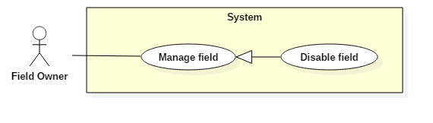

Figure 25: <Field Owner> Disable field

|  |  |  |  |
| --- | --- | --- | --- |
| **USE CASE – UC020** | | | |
| **Use Case No.** | 020 | **Use Case Version** | 1.0 |
| **Use Case Name** | Disable field | | |
| **Author** | ThanhTH | | |
| **Date** |  | **Priority** | Normal |
| **Actor:**   * Field Owner   **Summary:**   * This use case allows Actor to disable field over a period of time.   **Goal:**   * Field owner disables field successful.   **Triggers:**   * Field owner sends disable field command.   **Preconditions:**   * Actor has accessed the system under Field Owner role.   **Post Conditions:**   * **Success:** Field is disabled over a period of time. * **Fail:** Show error messages.   **Main Success Scenario:**   |  |  |  | | --- | --- | --- | | Step | Actor Action | System Response | | 1 | Field owner sends command request information about disable field. | System will check latest match and show message for field owner. System requires field owner input start time and end time of disabled period. | | 2 | Field owner inputs start time and end time of disable period and send command to disable field.  [Alternative 1] | System will update information about status of field and display for field owner.  [Exception 1] |   **Alternative Scenario 1:**   |  |  |  | | --- | --- | --- | | Step | Actor Action | System Response | | 1 | Field owner does not input end time of disable period. | System will update information about status of field and understand that the field will be remove from start time of disable period. |   **Exceptions:**   |  |  |  | | --- | --- | --- | | No | Cause | System Response | | 1 | Field owner inputs start time of disable period before day that have last reservation request. | System show error message: “Bạn không thể vô hiệu sân vào ngày x vì đã có yêu cầu đặt sân sau nó.” |   **Relationships:** N/A  **Business Rules:**   * If a field is disable, the user can not reserve the field or do any action. * Field owner can cancel matches to disable field at the expected time. | | | |

Table 26: Disable field specification

##### <Field Owner> Create active time

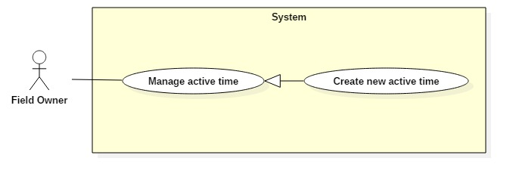

Figure 26: <Field Owner> Create active time

|  |  |  |  |
| --- | --- | --- | --- |
| **USE CASE – UC021** | | | |
| **Use Case No.** | 021 | **Use Case Version** | 1.0 |
| **Use Case Name** | Create active time | | |
| **Author** | QuyMM | | |
| **Date** |  | **Priority** | High |
| **Actor:**   * Field Owner   **Summary:**   * This use case allows Field owner to create active time.   **Goal:**   * Field owner creates active time for the field successful.   **Triggers:**   * Field owner sends create active time command.   **Preconditions:**   * Actor has accessed the system under field owner role.   **Post Conditions:**   * **Success:** Actor create field successfully * **Fail:** Show error messages.   **Main Success Scenario:**   |  |  |  | | --- | --- | --- | | Step | Actor Action | System Response | | 1 | Field owner requests to create active time | System requires information from Actor:   * Opening time * Close time * Field Type * Day in week * Price of field per hour | | 2 | Field owner inputs and sends command to create active time.  [Alternative 1] | System will create active time and save information.  [Exception 1] |   **Alternative Scenario 1:**   |  |  |  | | --- | --- | --- | | Step | Actor Action | System Response | | 1 | Field owner requires optimal time in the rush hour. | System will require field owner input expected number of optimal time in rush hour. | | 2 | Field owner inputs number of optimal time. | System will display expected optimal time of field owner. | | 3 | Field owner sends command to create active time | System will save information and display active time of field. |   **Exceptions:**   |  |  |  | | --- | --- | --- | | No | Cause | System Response | | 1 | Field owner input blank in required field | System show warning message: “Vui lòng nhập đủ dữ liệu”. |   **Relationships:** N/A  **Business Rules:**   * The active time of field owner is set on each day in week. If field owner does not update, the active time will be continuing use for next 7 days. * If field owner set the active time of field, setup again will be understood as an update. The updated information will not be effective immediately if someone already reserve field in next 7 days. Effective date will be after the last day have match one day. * Optimal time frame is the time frame can not be broken down. User who reserve field must set entire this time frame. The function is used in rush hours when the field owner has too many matches. * Field owner can create active time for multiple days of the week by selecting multiple days of the week when creating active time. | | | |

Table 27: Create active time specification

##### <Field Owner> Disable time frame

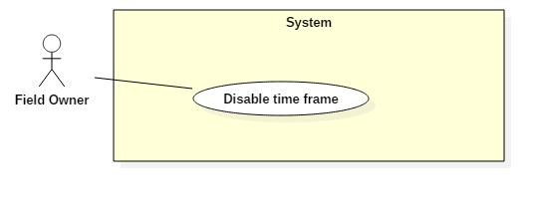

Figure 27: <Field Owner> Disable time frame

|  |  |  |  |
| --- | --- | --- | --- |
| **USE CASE – UC022** | | | |
| **Use Case No.** | 022 | **Use Case Version** | 1.0 |
| **Use Case Name** | Disable time frame | | |
| **Author** | ThanhTH | | |
| **Date** | 24/10/2017 | **Priority** | High |
| **Actor:**   * Field Owner   **Summary:**   * This use case allows Field owner to disable time frame.   **Goal:**   * Field owner disables time frame successful.   **Triggers:**   * Actor sends disable time frame command.   **Preconditions:**   * Actor has accessed the system under field owner role.   **Post Conditions:**   * **Success:** Time frame is disabled. * **Fail:** Show error messages.   **Main Success Scenario:**   |  |  |  | | --- | --- | --- | | Step | Actor Action | System Response | | 1 | Field owner sends command to get free time of field. | System will return free time of field by date and display. | | 2 | Field owner inputs start time, end time and send disable time frame command. | System shows free time after disable time frame and save information about disabled time frame.  [Exception 1] |   **Alternative Scenario:** N/A  **Exceptions:**   |  |  |  | | --- | --- | --- | | Step | Cause | System Response | | 1 | Time frame that are required had reserved a match. | System shows warning message “Khung giờ này đã có trận đấu”. |   **Relationships:** N/A  **Business Rules:**   * This function supports field owner when have user reserves field manually without account in FFR System. * Disabling time frame must also meet the conditions of the reserve field normal. Ex: When field owner disables optimal time frame, field must disable entire time frame. * Field owner can view disabled time frame by getting matches by date. | | | |

Table 28: Disable time frame specification

##### <Field Owner> Set field for match

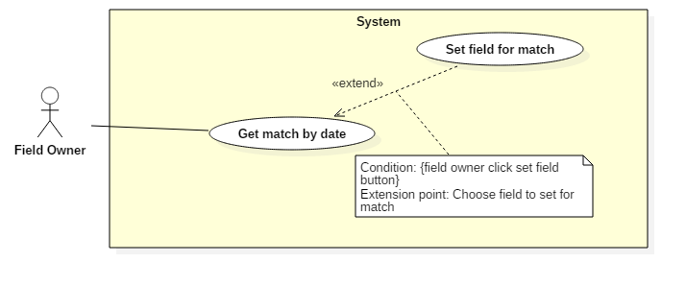

Figure 28: <Field Owner> Set field for match

|  |  |  |  |
| --- | --- | --- | --- |
| **USE CASE – UC023** | | | |
| **Use Case No.** | 023 | **Use Case Version** | 1.0 |
| **Use Case Name** | Set field for match | | |
| **Author** | QuyMM | | |
| **Date** | 01/11/2017 | **Priority** | High |
| **Actor:**   * Field Owner   **Summary:**   * This use case allows Actor set field for match.   **Goal:**   * Field owner set field for match successful.   **Triggers:**   * Field owner sends set command.   **Preconditions:**   * Actor has accessed the system under Field Owner role.   **Post Conditions:**   * **Success:** Match is set field by field owner. * **Fail:** Show error messages.   **Main Success Scenario:**   |  |  |  | | --- | --- | --- | | Step | Actor Action | System Response | | 1 | Field owner sends a request to view reserved matches. | System will get reserved matches and display match list.  [Exception 1] | | 2 | Field owner sends command to get free field at the time that match kickoffs. | System will get free fields at the time that match kickoffs and display for field owner. | | 3 | Field owner chooses a field and send commands to set field for match  [Alternative 1] | System will update field for match, save information and display match list. |   **Alternative Scenario 1:**   |  |  |  | | --- | --- | --- | | Step | Actor Action | System Response | | 1 | Field owner cancels process. | System will display match list and not save information about field for match. |   **Relationships:** N/A  **Business Rules:**   * When user reserves field, the match is created but not yet assigns field for match. User will choose field for the user at the start of the match. | | | |

Table 29: Set field for match specification

##### <Field Owner> Get bills by date

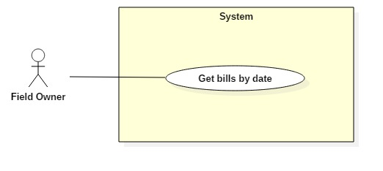

Figure 29: <Field Owner> Get bills by date

|  |  |  |  |
| --- | --- | --- | --- |
| **USE CASE – UC024** | | | |
| **Use Case No.** | 024 | **Use Case Version** | 1.0 |
| **Use Case Name** | Get bills by date | | |
| **Author** | ThanhTH | | |
| **Date** | 01/11/2017 | **Priority** | High |
| **Actor:**   * Field Owner   **Summary:**   * This use case allows Field owner to get bills by input date.   **Goal:**   * Field owner gets bills by date successful.   **Triggers:**   * Actor sends get bills by date command.   **Preconditions:**   * Actor has accessed the system under field owner role.   **Post Conditions:**   * **Success:** System shows list of bills based on inputted date successfully. * **Fail:** Show error messages.   **Main Success Scenario:**   |  |  |  | | --- | --- | --- | | Step | Actor Action | System Response | | 1 | Field owner inputs date and sends command to get bills by date | System will get bills by date and field owner to return bill list and display for field owner.  [Exception 1] |   **Alternative Scenario:** N/A  **Exceptions:**   |  |  |  | | --- | --- | --- | | No | Cause | System Response | | 1 | There are no bills on date. | System show empty screen. |   **Relationships:** N/A  **Business Rules:**   * Bill is created when user pays reservation fee. * For friendly match, only one bill is created. For tour match, there are two bills is created for user and opponent. * Field owner can view detail match of bill with detailed view of the match function. | | | |

Table 30: Get bills by date specification

#### Staff Use Case

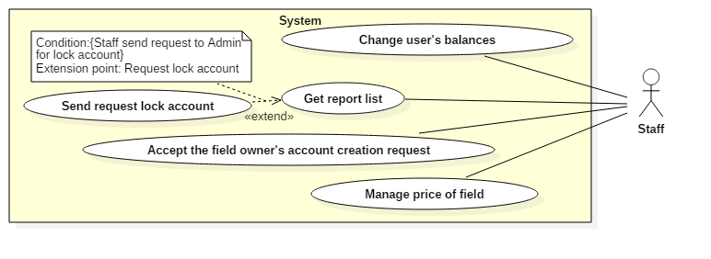

Figure 30: <Staff> Overview

* + - 1. **<Staff> Get report list**

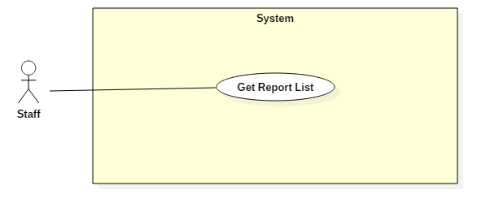

Figure 31: <Staff> Get report list

|  |  |  |  |
| --- | --- | --- | --- |
| **USE CASE – UC025** | | | |
| **Use Case No.** | 025 | **Use Case Version** | 1.0 |
| **Use Case Name** | Get Report List | | |
| **Author** | HuanPM | | |
| **Date** | 10/11/2017 | **Priority** | Normal |
| **Actor:**   * Staff   **Summary:**   * This use case allows Actor to get report list.   **Goal:**   * System gets report list and display it to Actor.   **Triggers:**   * Actor sends get report list command.   **Preconditions:**   * Actor has accessed the system under Staff role.   **Post Conditions:**   * **Success:** Report list is displayed. * **Fail:** Show error messages.   **Main Success Scenario:**   |  |  |  | | --- | --- | --- | | Step | Actor Action | System Response | | 1 | Actor sends get report list command. | [Exception 1]  System displays report list to Actor. |   **Exceptions 1:**   |  |  |  | | --- | --- | --- | | Step | Cause | System Response | | 1 | Report list is empty | System shows error message “Không có tố cáo”. |   **Relationships:** N/A  **Business Rules:**   * Report consists of field owner report and user report. | | | |

Table 31: Get report list specification

* + - 1. **<Staff> Send lock account request**

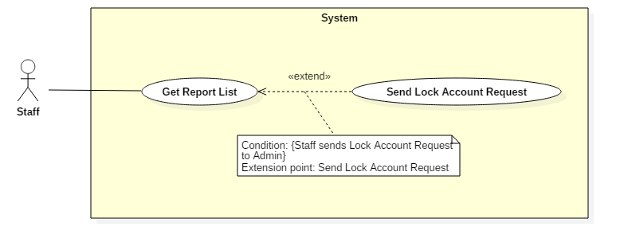

Figure 32: <Staff> Send lock account request

|  |  |  |  |
| --- | --- | --- | --- |
| **USE CASE – UC026** | | | |
| **Use Case No.** | 26 | **Use Case Version** | 1.0 |
| **Use Case Name** | Send lock account request | | |
| **Author** | HuanPM | | |
| **Date** | 10/11/2017 | **Priority** | Normal |
| **Actor:**   * Staff   **Summary:**   * This use case allows Actor to send lock account request.   **Goal:**   * System saves lock account request and notify to Admin.   **Triggers:**   * Actor sends lock account request command.   **Preconditions:**   * Actor has accessed the system under Staff role.   **Post Conditions:**   * **Success:** Lock account request is saved. * **Fail:** Show error messages.   **Main Success Scenario:**   |  |  |  | | --- | --- | --- | | Step | Actor Action | System Response | | 1 | Actor sends lock account request command. | System checks account information.  [Exception 1]  System saves request and notify to Admin.  System displays message “Đã gửi yêu cầu thành công”. |   **Exceptions:**   |  |  |  | | --- | --- | --- | | No | Cause | System Response | | 1 | Account does not exist. | System shows error message “Tài khoản không tồn tại”. |   **Relationships:** Extends use case Get report list  **Business Rules:**   * Staff will directly view report of the user and make a lock account decision based on the level of violation of the user. * This request will be sent to admin. | | | |

Table 32: Send lock account request specification

* + - 1. **<Staff> Accept the field owner’s account creation request**

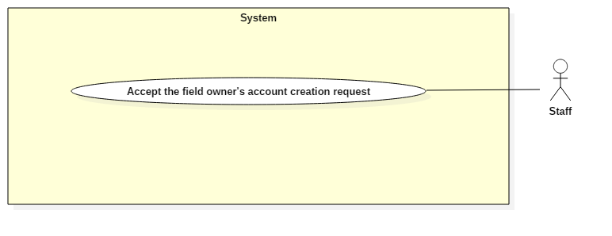

Figure 33: <Staff> Accept the field owner’s account creation request

|  |  |  |  |
| --- | --- | --- | --- |
| **USE CASE – UC027** | | | |
| **Use Case No.** | 027 | **Use Case Version** | 1.0 |
| **Use Case Name** | Accept field owner’s account creation request | | |
| **Author** | HuanPM | | |
| **Date** | 10/11/2017 | **Priority** | Normal |
| **Actor:**   * Staff   **Summary:**   * This use case allows Staff accept the field owner’s account creation request.   **Goal:**   * Staff accepts field owner’s account creation request successful.   **Triggers:**   * Staff sends active field owner’s account request command.   **Preconditions:**   * Actor has accessed the system under Staff role.   **Post Conditions:**   * **Success:** Field owner’s account is activated. * **Fail:** Show error messages.   **Main Success Scenario:**   |  |  |  | | --- | --- | --- | | Step | Actor Action | System Response | | 1 | Staff send active account command. | System shows message: “Tài khoản của chủ sân đã được kích hoạt” |   **Alternative Scenario: N/A**  **Exceptions: N/A**  **Relationships:** Extends use case Get report list  **Business Rules:**   * Staff will reality check field owner status to determine field owner’s account activation. * The field owner’s account will be effective as soon as the staff accepts. | | | |

Table 33: Accept the field owner’s account creation request specification

* + - 1. **<Staff> Manage price of field**

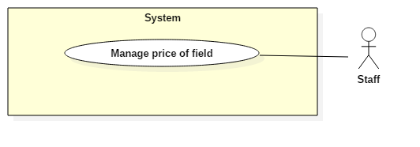

Figure 34: <Staff> Manage price of field

|  |  |  |  |
| --- | --- | --- | --- |
| **USE CASE – UC028** | | | |
| **Use Case No.** | 028 | **Use Case Version** | 1.0 |
| **Use Case Name** | Manage price of field | | |
| **Author** | HuanPM | | |
| **Date** | 10/11/2017 | **Priority** | Normal |
| **Actor:**   * Staff   **Summary:**   * This use case allows Staff set standard price for all field owner.   **Goal:**   * Standard price is set by staff successful.   **Triggers:**   * Staff sends set standard price command.   **Preconditions:**   * Actor has accessed the system under Staff role.   **Post Conditions:**   * **Success:** Standard price is applied for system. * **Fail:** Show error messages.   **Main Success Scenario:**   |  |  |  | | --- | --- | --- | | Step | Actor Action | System Response | | 1 | Staff calls function set standard price for field | System requires information:   * Rush hour * Maximum price * Minimum price | | 2 | Staff inputs information and send set standard price command. | System will receive information and display information.  Standard price information is saved.  [Exception 1] [Exception 2] |   **Alternative Scenario:** N/A  **Exceptions:**   |  |  |  | | --- | --- | --- | | No | Cause | System Response | | 1 | Staff inputs wrong data type. | System shows error message “Kiểu dữ liệu bạn nhập không đúng”. | | 2 | Staff inputs standard price is not suitable. | System shows error message: “Mức giá mà bạn nhập không phù hợp: |   **Relationships:** N/A  **Business Rules:**   * Standard price includes maximum price and minimum price in rush hour; maximum price and minimum price in normal hour. * Rush hour is set to default is 17:00. * This function supports staff to avoid devaluation on the system. * The price that the staff sets must match the actual market situation. * This function is limited in number of executions. Not all staffs can perform this function. | | | |

Table 34: Manage price of field specification

* + - 1. **<Staff> Change user’s balances**

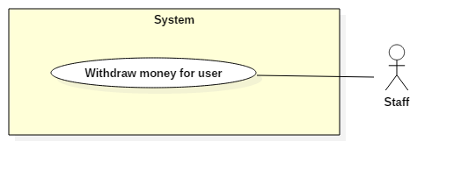

Figure 35: <Staff> Change user’s balaces

|  |  |  |  |
| --- | --- | --- | --- |
| **USE CASE – UC029** | | | |
| **Use Case No.** | 029 | **Use Case Version** | 1.0 |
| **Use Case Name** | Change user’s balances | | |
| **Author** | HieuPT | | |
| **Date** | 20/11/2017 | **Priority** | Normal |
| **Actor:**   * Staff   **Summary:**   * This use case allows Staff decreases or increases money from user’s wallet.   **Goal:**   * Staff deposits/ withdraws from user’s wallet successful.   **Triggers:**   * Staff sends deposit/ withdraw money from user’s wallet command.   **Preconditions:**   * Actor has accessed the system under Staff role.   **Post Conditions:**   * **Success:** Balances of user’s wallet is changed and system display current balances. * **Fail:** Show error messages.   **Main Success Scenario:**   |  |  |  | | --- | --- | --- | | Step | Actor Action | System Response | | 1 | Staff sends deposit/ withdraw money for user command. | System requires amount of money to deposit or withdraw. | | 2 | Staff inputs amount of money and submit change money command. | System displays current balances of user after change.  Balances of user’s wallet is changed.  [Exception 1] |   **Alternative Scenario:** N/A  **Exceptions:**   |  |  |  | | --- | --- | --- | | Step | Cause | System Response | | 1 | User’s balance is not enough to withdraw | System show error message: “Số dư không đủ để thực hiện rút”. |   **Relationships:** N/A  **Business Rules:**   * This function supports staff when staff conducts transactions with users at the company office. * Money in system can be converted into cash and vice versa. * This process must be performed in the presence of the user. | | | |

Table 35: Change user’s balaces specification

#### System Use Case

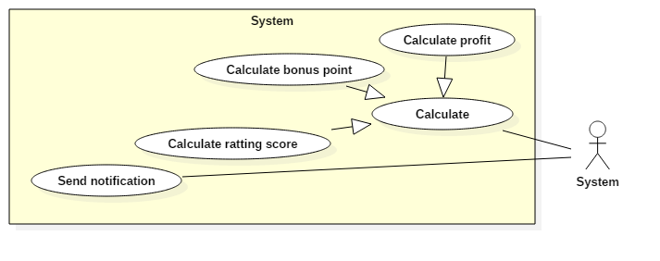

Figure 36: <System> Overview

* + - 1. **<System> Calculate bonus point**

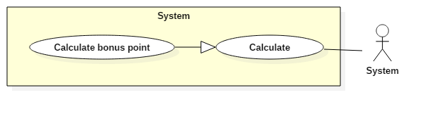

Figure 37: <System> Calculate bonus point

|  |  |  |  |
| --- | --- | --- | --- |
| **USE CASE – UC030** | | | |
| **Use Case No.** | 030 | **Use Case Version** | 1.0 |
| **Use Case Name** | Calculate bonus point | | |
| **Author** | QuyMM | | |
| **Date** | 10/11/2017 | **Priority** | Normal |
| **Actor:**   * System   **Summary:**   * System runs under this function to calculate bonus points for user.   **Goal:**   * Bonus point of user is calculated.   **Triggers:**   * Rating is send to system enough for calculating.   **Preconditions:**   * System operates stably and receives full rating from user.   **Post Conditions:**   * **Success:** Bonus point of user is updated. * **Fail:** Bonus point of user isn’t updated.   **Main Success Scenario:**   |  |  |  | | --- | --- | --- | | Step | Actor Action | System Response | | 1 | System receives full rating from user about tour match. | System will calculate and update correctly bonus points of user. |   **Alternative Scenario:** N/A  **Exceptions:** N/A  **Relationships:** N/A  **Business Rules:**   * If user rates for field after finished match, user will be received 2 bonus points. * If user rates for opponent after finished match, system will check accuracy of rating from user. If user’s rating and opponent’s rating reflect exactly result of a tour match, user and opponent will receive 10 bonus points. * If user and opponent record exactly goals difference, user and opponent will receive 3 bonus points. | | | |

Table 36: Calculate bonus point specification

* + - 1. **<System> Calculate rating score**

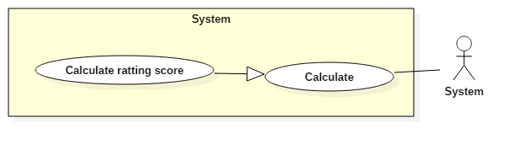

Figure 38: <System> Calculate rating score

|  |  |  |  |
| --- | --- | --- | --- |
| **USE CASE – UC031** | | | |
| **Use Case No.** | 031 | **Use Case Version** | 1.0 |
| **Use Case Name** | Calculate rating score | | |
| **Author** | QuyMM | | |
| **Date** | 10/11/2017 | **Priority** | Normal |
| **Actor:**   * System   **Summary:**   * System runs under this function to calculate rating score for user.   **Goal:**   * Rating score of user is calculated.   **Triggers:**   * Rating is send to system enough for calculating.   **Preconditions:**   * System operates stably and receives full rating from user.   **Post Conditions:**   * **Success:** Rating score of user is updated. * **Fail:** Rating scoreof user isn’t updated.   **Main Success Scenario:**   |  |  |  | | --- | --- | --- | | Step | Actor Action | System Response | | 1 | System receives full rating from user about tour match. | System will calculate and update correctly rating score of user. |   **Alternative Scenario:** N/A  **Exceptions:** N/A  **Relationships:** N/A  **Business Rules:**   * If user’s rating and opponent’s rating reflect exactly result of a tour match, system will calculate based on the criteria:   + If match is over and there is a winner, the winner’s rating score = current rating score + 30 scores + goals difference + rating level values. The loser’s rating score = current rating score – goals difference + rating level values.  + If match has a draw result, two user’s rating score = current rating score + 10 scores + rating level values.   * Rating level values:   = 0: amateur level  = 2: normal level  = 4: professional level | | | |

Table 37: Calculate rating score specification

* + - 1. **<System> Send notification**

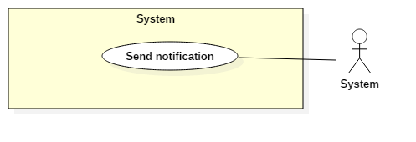

Figure 39: <System> Send notification

|  |  |  |  |
| --- | --- | --- | --- |
| **USE CASE – UC032** | | | |
| **Use Case No.** | 032 | **Use Case Version** | 1.0 |
| **Use Case Name** | Send notifications | | |
| **Author** | HuanPM | | |
| **Date** | 10/11/2017 | **Priority** | Normal |
| **Actor:**   * System   **Summary:**   * System runs under this function to send notifications to user and field owner.   **Goal:**   * User and field owner are received notifications.   **Triggers:**   * User reserves a tour match. * User’s matching request is matched. * Field owner has reservation request.   **Preconditions:**   * System operates stably and user and field owner perform function successful.   **Post Conditions:**   * **Success:** User and field owner are received notifications. * **Fail:** User and field owner are not received notification.   **Main Success Scenario:**   |  |  |  | | --- | --- | --- | | Step | Actor Action | System Response | | 1 | System receives changed data when user or field owner perform functions that have notification to another people in system. | System will send notification to field owner and user. |   **Alternative Scenario:** N/A  **Exceptions:**   |  |  |  | | --- | --- | --- | | No | Cause | System Response | | 1 | System connects to notification system fail. | System does not notify to field owner and user. |   **Relationships:** N/A  **Business Rules:**   * When field owner has reservation request, field owner will receive notifications about matches. The notification contains information about user reserved field. * When user’s matching request is matched, system will notify to user about opponent. * When user reserves a tour match, system will notify to opponent about match’s information. | | | |

Table 38: Send notification specification

#### Admin

* + - 1. **<User> Lock Account**

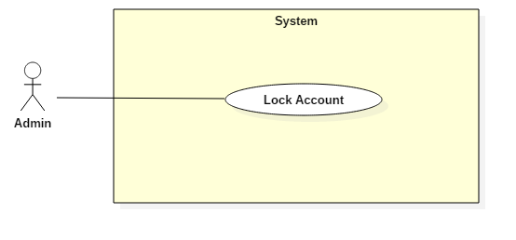

Figure 40: <Admin> Lock Account

|  |  |  |  |
| --- | --- | --- | --- |
| **USE CASE – UC033** | | | |
| **Use Case No.** | 033 | **Use Case Version** | 1.0 |
| **Use Case Name** | Lock Account | | |
| **Author** | HuanPM | | |
| **Date** | 2/12/2017 | **Priority** | Normal |
| **Actor:**   * Admin   **Summary:**   * This use case allows Actor to get Actor’s history.   **Goal:**   * System gets history list and display it to Actor.   **Triggers:**   * Actor sends get history command.   **Preconditions:**   * Actor has accessed the system under User role.   **Post Conditions:**   * **Success:** History list is displayed. * **Fail:** Show error messages.   **Main Success Scenario:**   |  |  |  | | --- | --- | --- | | Step | Actor Action | System Response | | 1 | Actor sends lock account command. | System requests confirmation from Actor. | | 2 | Actor confirms request. | System checks account information.  [Exception 1]  System displays message “Đã khóa tài khoản thành công”. |   **Exceptions 1:**   |  |  |  | | --- | --- | --- | | Step | Cause | System Response | | 1 | Account does not exist. | System shows error message “Tài khoản không tồn tại”. |   **Relationships:** N/A  **Business Rules:**   * Admin perform lock account based on requested by staff. | | | |

Table 39: Lock account specification

#### Authenticated User Use Case

##### <Authenticated user> Sign out

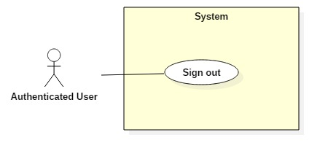

Figure 41: <Authenticated User> Sign out

|  |  |  |  |
| --- | --- | --- | --- |
| **USE CASE – UC034** | | | |
| **Use Case No.** | 034 | **Use Case Version** | 1.0 |
| **Use Case Name** | Sign out | | |
| **Author** | HieuPT | | |
| **Date** | 10/10/2017 | **Priority** | Normal |
| **Actor:**   * Authenticated user.   **Summary:**   * This use case allows Authenticated user signs out the system.   **Goal:**   * Authenticated user signs out the system successfully, the session is killed.   **Triggers:**   * Authenticated User send request to sign out.   **Preconditions:**   * Actors has accessed the system.   **Post Conditions:**   * **Success:** Authenticated user logouts successfully. * **Fail:** N/A   **Main Success Scenario:**   |  |  |  | | --- | --- | --- | | Step | Actor Action | System Response | | 1 | Actor sends command to Sign out. | System clears session state if any, takes user out of the system.  System displays sign in view. |   **Exceptions:** N/A  **Relationships:** N/A  **Business Rules:**   * After sign out, role “Authenticated User” will become “Guest”. | | | |

Table 40: Sign out specification

## Software System Attribute

### Usability

* Admin. field owner and staff should need less than 0.5 day of training to use the system.
* Mobile and web application use Vietnamese including all dialogs and messages.
* Players who have played football can understand and perform functions immediately without the training process.

### Availability

* System is divided into modules, if a function is down, it will not influence others. Security
* The system can be adapted for a huge number of request.

### Security

* All input data should be validated before saving to database.
* Roles permission should be specified clearly and user should be authenticated and authorized when accessing to the system.

### Maintainability

* System is divided into modules.
* When a module of a function is down, it is easy to take it down to fix without impact other functions.

### Portability

* Web application can run on Chrome browser version 58 later.
* User can use the mobile application on devices running Android 6 or later.

### Performance

* System converts and returns results in 1 seconds or less depend on information of driver inputted.

## Conceptual Diagram

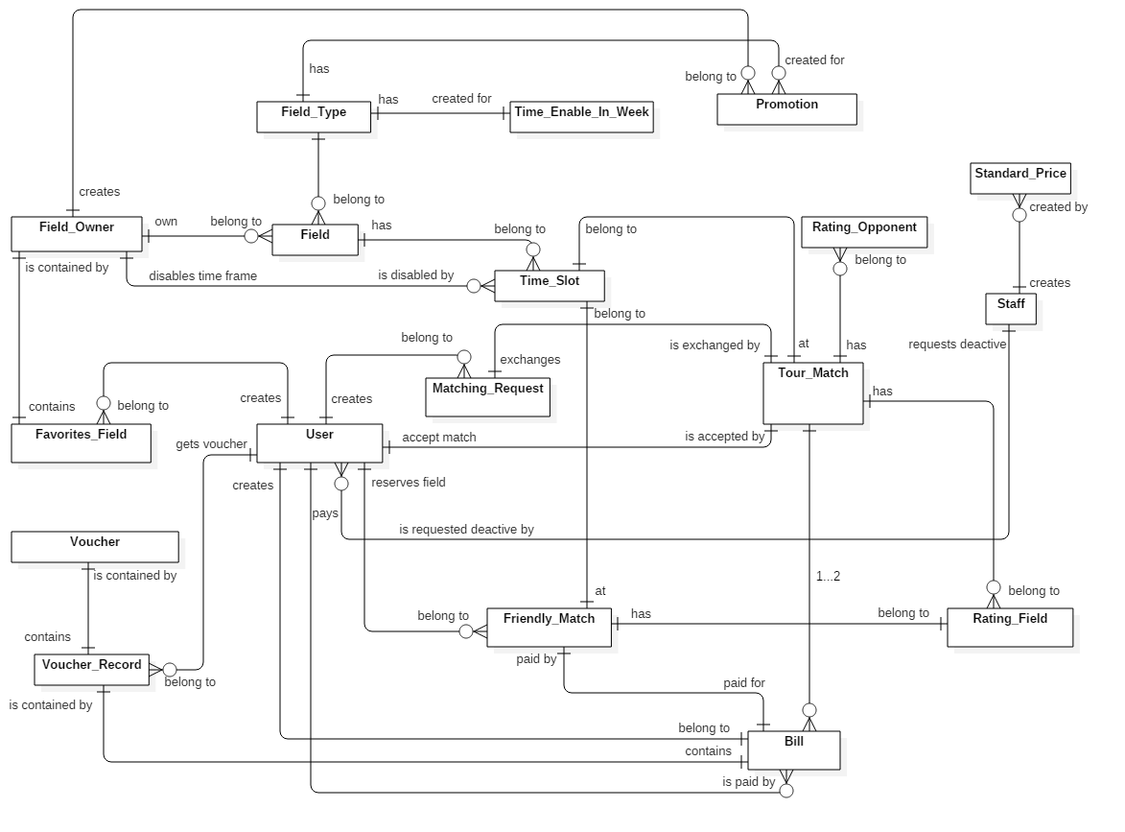

Figure 42: Conceptual Diagram

**Data Dictionary**

|  |  |
| --- | --- |
| **Entity Data dictionary: describe content of all entities** | |
| **Entity Name** | **Description** |
| Staff | Contain the staff information |
| Standard Price | Contain standard price for field in system |
| Field Owner | Contain the field owner information |
| Field | Contain the field information |
| Field Type | Contain the field type information |
| Time Enable In Week | Contain field’s active time information of field owner |
| Promotion | Contain promotion information |
| User | Contain the user information |
| Time Slot | Contain time slot information (start time, end time, price…) |
| Matching Request | Contain matching request information of user |
| Friendly Match | Contain information about match that reserved by a team |
| Tour Match | Contain information about match that reserved by 2 team |
| Voucher | Contain information about voucher of system |
| Voucher Record | Contain information about voucher get by user |
| Bill | Contain information about reservation field fees |
| Rating Field | Contain information about rating field |
| Rating Opponent | Contain information about rating opponent |

Table 41: Conceptual diagram data dictionary

# Software Requirement Specifications

## 1. Design Overview

This document describes the technical and user interface design of FFRS System. It includes the architectural design, the detailed design of common functions and business functions and the design of database model.

* The architectural design describes the overall architecture of the system and the architecture of each main component and subsystem.
* The detailed design describes static and dynamic structure for each component and functions. It includes class diagram, class explanations and sequence diagrams for each use cases.
* The database design describes the relationships between entities and details of each entity.
* Document overview:
  + Section 2: gives an overall description of the system architecture design.
  + Section 3: gives component diagrams that describes the connection and integration of the system.
  + Section 4: gives the detail design description which includes class diagram, class explanation and sequence diagram to details the application functions.
  + Section 5: describes screen design.
  + Section 6: describes a fully attributed ERD.
  + Section 7: describes algorithms.

## System Architectural Design

### System Architecture Design

We choose Restful Web Service model as main model because of following advantages:

* + In the future, our application may expand for other platforms as well. Web service provides reusable API that can be called by any platforms, so that our system could easily expand.
  + Beacon is a newly developed technology; its SDK is changing frequently. When does, we only need to update mobile application without affecting other components.

Web Service is developed from Spring MVC architecture style beacause:

* + It provides comprehensive infrastructure support for developing Java enterprise level applications. Spring also enables the developer to create high performing, easily testable, reusable and loose coupling enterprise Java application.
  + Spring enables the developers to develop the enterprise applications using POJOs (Plain Old Java Object). The benefit of developing the applications using POJO is, that we do not need an enterprise container such as an application server, but we have the option of using a robust servlet container.
  + Spring provides a very clean division between controllers and JavaBean models.

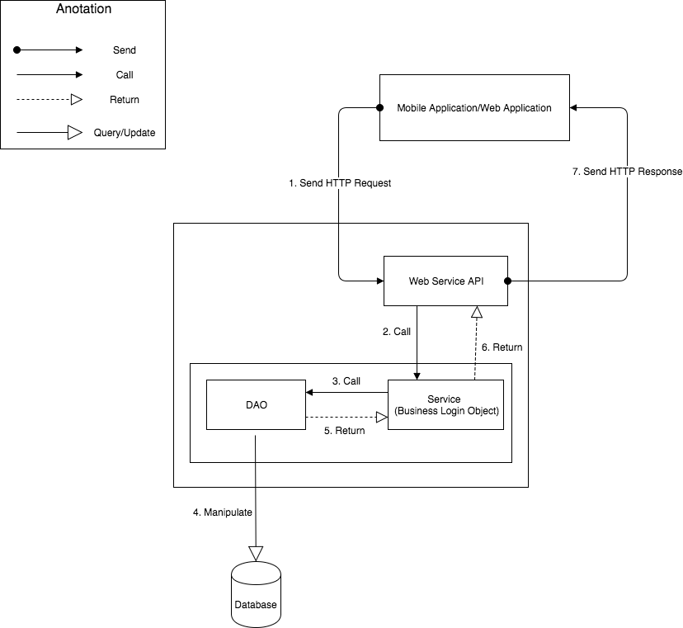

Figure 43: System Architecture Design

### 2.2 Mobile Application Architecture Design

The application is developed as an Android native application. In general, the application architecture conforms to Android architecture.

*Reference: Android Developer Guider – Application Fundamentals*

[*http://developer.android.com/guide/components/fundamentals.html*](http://developer.android.com/guide/components/fundamentals.html)

Our team chooses Android because of following reasons:

* + Android is currently the most common mobile platforms in the world, and it doesn’t have any signs of slowing down. As we want to maximize our potential users, choosing Android will give us the highest popularity market.
  + Developing other mobile platforms (such as iOS or Windows Phone) may require specific expensive devices and tools. On the other hand, Android development can be done on either Mac, Windows or Linux devices with free tools.
  + Native Android applications are developed using Java programing language. Our team is strong at Java and chooses it as the main programing language.

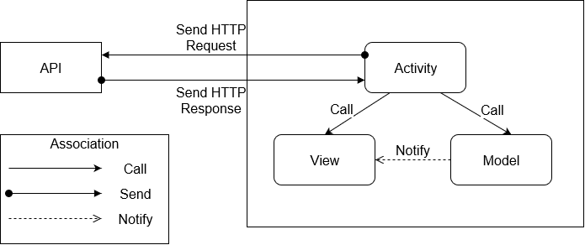

Figure 44: Mobile Application architecture design

### 2.3 Web Application Architecture Design

* + In general, use Redux when you have reasonable amounts of data changing over time, you need a single source of truth, and you find that approaches like keeping everything in a top-level React component's state are no longer sufficient.
* However, it's also important to understand that using Redux comes with tradeoffs. It's not designed to be the shortest or fastest way to write code. It's intended to help answer the question "When did a certain slice of state change, and where did the data come from?", with predictable behavior. It does so by asking you to follow specific constraints in your application: store your application's state as plain data, describe changes as plain objects, and handle those changes with pure functions that apply updates immutably. This is often the source of complaints about "boilerplate". These constraints require effort on the part of a developer, but also open up a number of additional possibilities (such as store persistence and synchronization).
  + In the end, Redux is just a tool. It's a great tool, and there's some great reasons to use it, but there's also reasons you might not want to use it. Make informed decisions about your tools, and understand the tradeoffs involved in each decision.

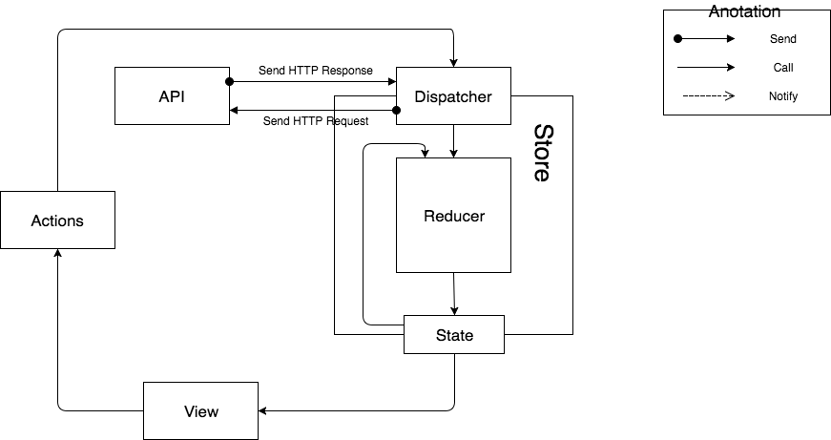

Figure 45: Web Application Architecture Design

## Component Diagram

## Detailed Description

### Class Diagram

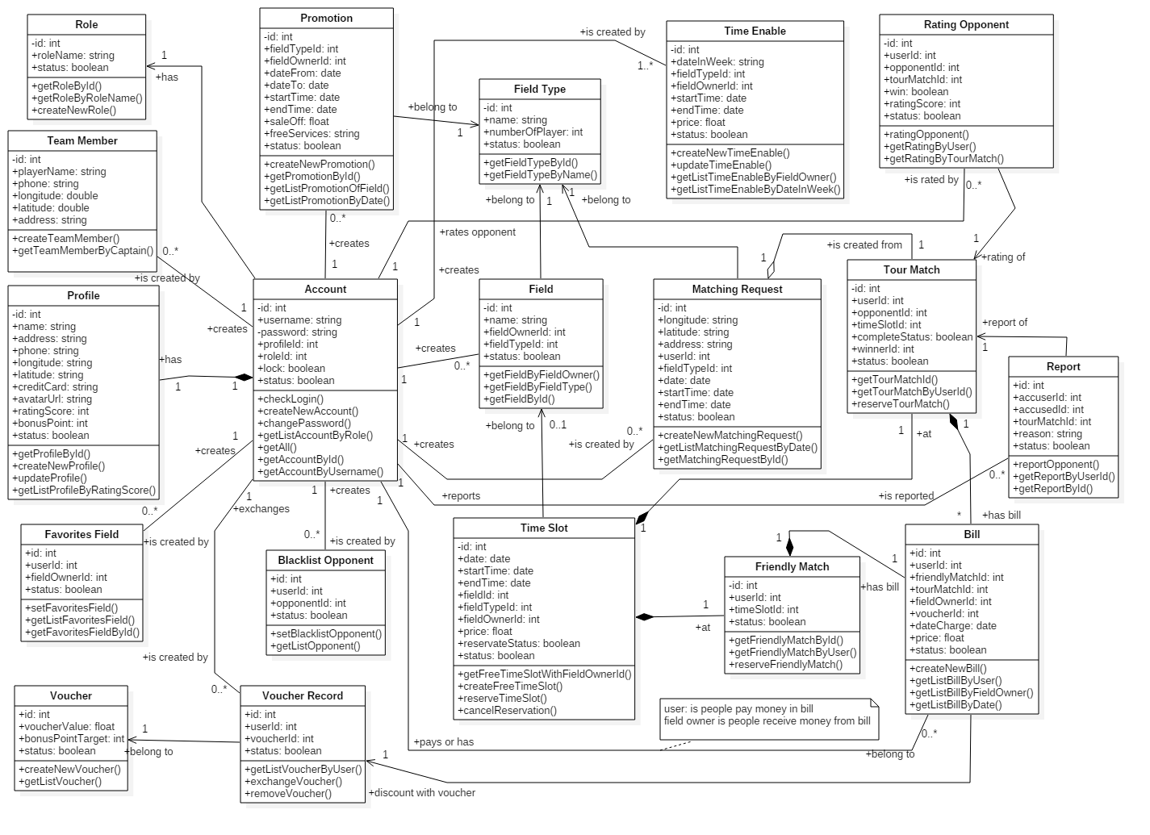

Figure 42: Class Diagram

|  |  |
| --- | --- |
| Class dictionary: describe Class | |
| Class Name | **Description** |
| *Account* | Contain the account information |
| *Profile* | Contain the profile information |
| *Role* | Contain the role information |
| *Promotion* | Contain the promotion information |
| *FavoriteField* | Contain the favorite field information |
| *BlacklistOpponent* | Contain the blacklist opponent information |
| *Voucher* | Contain the voucher information |
| *VoucherRecord* | Contain the voucher record information |
| *Field* | Contain the field information |
| *FieldType* | Contain the field type information |
| *TimeEnable* | Contain the time enable information |
| *TimeSlot* | Contain the time slot information |
| *MatchingRequest* | Contain the matching request information |
| *TourMatch* | Contain the tour match information |
| *FriendlyMatch* | Contain the friendly match information |
| *Bill* | Contain the bill information |
| *RattingOpponent* | Contain the ratting opponent information |
| *Report* | Contain the report information |
| *TeamMember* | Contain the team member information |

Table 42: Class dictionary

### Class Diagram Explanation

#### Account

|  |  |  |  |
| --- | --- | --- | --- |
| Attribute | Type | Visibility | Description |
| id | Integer | Private | Unique identifier of an account |
| username | String | Private | Username of Account |
| password | String | Private | Password of Account |
| profileId | Integer | Private | Identifier of the profile of Account |
| roleId | Integer | Private | Identifier of the role of Account |
| lock | Boolean | Private | Staff request lock Actor |
| status | Boolean | Private | Active account checker |

Table 43: Account attributes

#### Profile

|  |  |  |  |
| --- | --- | --- | --- |
| Attribute | Type | Visibility | Description |
| id | Integer | Private | Unique identifier of a profile |
| name | String | Private | Name of Actor |
| address | String | Private | Address of Actor |
| phone | String | Private | Phone of Actor |
| longitude | String | Private | Longitude of Actor |
| latitude | String | Private | Latitude of Actor |
| creditCard | String | Private | Credit card of Actor |
| avatarUrl | String | Private | Avatar url of Actor |
| rattingScore | Integer | Private | Ratting score of Actor |
| bonusPoint | Integer | Private | Bonus point of Actor |
| status | Boolean | Private | Active profile checker |

Table 44: Profile attributes

#### Role

|  |  |  |  |
| --- | --- | --- | --- |
| Attribute | Type | Visibility | Description |
| id | Integer | Private | Unique identifier of a role |
| roleName | String | Private | Name of the role |
| status | Boolean | Private | Active role checker |

Table 45: Role attributes

#### Promotion

|  |  |  |  |
| --- | --- | --- | --- |
| Attribute | Type | Visibility | Description |
| id | Integer | Private | Unique identifier of a promotion |
| fieldTypeId | Integer | Private | Id of field type that promotion belongs |
| fieldOwnerId | Integer | Private | Id of field owner that promotion belongs |
| dateFrom | Date | Private | Sent notification tracker |
| dateTo | Date | Private | Notification content |
| startTime | Date | Private | Time to start apply promotion (in a day) |
| endTime | Date | Private | Time to end apply promotion (in a day) |
| saleOff | Float | Private | Sale off percent of promotion |
| freeServices | String | Private | Free services content |
| status | Boolean | Private | Active promotion checker |

Table 46: Promotion attributes

#### FavoriteField

|  |  |  |  |
| --- | --- | --- | --- |
| Attribute | Type | Visibility | Description |
| id | Integer | Private | Unique identifier of a favorite field |
| userId | Integer | Private | Id of the user that the favorite field belongs |
| fieldOwnerId | Integer | Private | Id of the field owner that the favorite field belongs |
| status | Boolean | Private | Active favorite field checker |

Table 47: FavoriteField attributes

#### BlacklistOpponent

|  |  |  |  |
| --- | --- | --- | --- |
| Attribute | Type | Visibility | Description |
| id | Integer | Private | Unique identifier of a black list opponent |
| userId | Integer | Private | Id of the user that the black list opponent belongs |
| opponentId | Integer | Private | Id of the opponent that the black list opponent belongs |
| status | Boolean | Private | Active black list checker |

Table 48: BlacklistOpponent attributes

#### Voucher

|  |  |  |  |
| --- | --- | --- | --- |
| Attribute | Type | Visibility | Description |
| id | Integer | Private | Unique identifier of a voucher |
| voucherValue | Float | Private | Value of the voucher |
| bonusPointTarget | Integer | Private | Number of bonus point to exchange the voucher |
| status | Boolean | Private | Active voucher checker |

Table 49: Voucher attributes

#### VoucherRecord

|  |  |  |  |
| --- | --- | --- | --- |
| Attribute | Type | Visibility | Description |
| id | Integer | Private | Unique identifier of a voucher record |
| userId | Integer | Private | Id of the user that the voucher record belongs |
| voucherId | Integer | Private | Id of the voucher that the voucher record belongs |
| status | Boolean | Private | Active voucher checker |

Table 50: VoucherRecord attributes

#### Field

|  |  |  |  |
| --- | --- | --- | --- |
| Attribute | Type | Visibility | Description |
| id | Integer | Private | Unique identifier of a field |
| name | String | Private | Name of a field |
| fieldOwnerId | Integer | Private | Id of the field owner that the field belongs |
| fieldTypeId | Integer | Private | Id of the field type that the field belongs |
| status | Boolean | Private | Active field checker |

Table 51: Field attributes

#### FieldType

|  |  |  |  |
| --- | --- | --- | --- |
| Attribute | Type | Visibility | Description |
| id | Integer | Private | Unique identifier of a field type |
| name | String | Private | Name of a field type |
| numberOfPlayer | Integer | Private | Number of player of the field type |
| status | Boolean | Private | Active field type checker |

Table 52: FieldType attributes

#### TimeEnable

|  |  |  |  |
| --- | --- | --- | --- |
| Attribute | Type | Visibility | Description |
| id | Integer | Private | Unique identifier of a time enable |
| dateInWeek | String | Private | Date in week that the time enable belongs |
| fieldTypeId | Integer | Private | Id of the field type that the time enable belongs |
| fieldOwnerId | Integer | Private | Id of the field owner that the time enable belongs |
| startTime | Date | Private | Start time of the time enable |
| endTime | Date | Private | End time of the time enable |
| price | Float | Private | Price (per hour) of the time enable |
| status | Boolean | Private | Active time enable checker |

Table 53: TimeEnable attributes

#### TimeSlot

|  |  |  |  |
| --- | --- | --- | --- |
| Attribute | Type | Visibility | Description |
| id | Integer | Private | Unique identifier of a time slot |
| dateInWeek | String | Private | Date in week that the time slot belongs |
| startTime | Date | Private | Start time of the time slot |
| endTime | Date | Private | End time of the time slot |
| fieldId | Integer | Private | Id of the field that the time slot belongs |
| fieldTypeId | Integer | Private | Id of the field type that the time slot belongs |
| fieldOwnerId | Integer | Private | Id of the field owner that the time slot belongs |
| price | Float | Private | Price (per hour) of the time slot |
| reservateStatus | Boolean | Private | Active reserve checker |
| status | Boolean | Private | Active time slot checker |

Table 54: TimeSlot attributes

#### MatchingRequest

|  |  |  |  |
| --- | --- | --- | --- |
| Attribute | Type | Visibility | Description |
| id | Integer | Private | Unique identifier of the matching request |
| longitude | String | Private | Longitude of the matching request |
| latitude | String | Private | Latitude of the matching request |
| address | String | Private | Address of the matching request |
| userId | Integer | Private | Id of the user that the matching request belongs |
| fieldTypeId | Integer | Private | Id of the field type that the matching request belongs |
| date | Date | Private | Date of the matching request |
| startTime | Date | Private | Start time of the matching request |
| endTime | Date | Private | End time of the matching request |
| status | Boolean | Private | Active matching request checker |

Table 55: MatchingRequest attributes

#### TourMatch

|  |  |  |  |
| --- | --- | --- | --- |
| Attribute | Type | Visibility | Description |
| id | Integer | Private | Unique identifier of the tour match |
| userId | Integer | Private | Id of the user that the tour match belongs |
| opponentId | Integer | Private | Id of the opponent that the tour match belongs |
| timeSlotId | Integer | Private | Id of the time slot that the tour match belongs |
| completeStatus | Boolean | Private | Active complete checker |
| winnerId | Integer | Private | Id of the winner that the tour match belongs |
| status | Boolean | Private | Active tour match checker |

Table 56: TourMatch attributes

#### FriendlyMatch

|  |  |  |  |
| --- | --- | --- | --- |
| Attribute | Type | Visibility | Description |
| id | Integer | Private | Unique identifier of the friendly match |
| userId | Integer | Private | Id of the user that friendly match belongs |
| timeSlotId | Integer | Private | Id of the time slot that friendly match belongs |
| status | Boolean | Private | Active friendly match checker |

Table 57: FriendlyMatch attributes

#### Bill

|  |  |  |  |
| --- | --- | --- | --- |
| Attribute | Type | Visibility | Description |
| id | Integer | Private | Unique identifier of a bill |
| userId | Integer | Private | Id of the user that the bill belongs |
| friendlyMatchId | Integer | Private | Id of the friendly match that the bill belongs |
| tourMatchId | Integer | Private | Id of the tour match that the bill belongs |
| fieldOwnerId | Integer | Private | Id of the field owner that the bill belongs |
| voucherId | Integer | Private | Id of the voucher that the bill belongs |
| dateCharge | Date | Private | Date charge the bill |
| price | Float | Private | Price of the bill |
| status | Boolean | Private | Active bill checker |

Table 58: Bill attributes

#### RatingOpponent

|  |  |  |  |
| --- | --- | --- | --- |
| Attribute | Type | Visibility | Description |
| id | Integer | Private | Unique identifier of a ratting opponent |
| userId | Integer | Private | Id of the user that the ratting belongs |
| opponentId | Integer | Private | Id of the opponent that the ratting belongs |
| tourMatchId | Integer | Private | Id of the tour match that the ratting belongs |
| win | Boolean | Private | Active win checker |
| rattingScore | Integer | Private | Ratting score of the ratting |
| status | Boolean | Private | Active ratting checker |

Table 59: RatingOpponent attributes

#### Report

|  |  |  |  |
| --- | --- | --- | --- |
| Attribute | Type | Visibility | Description |
| id | Integer | Private | Unique identifier of a report opponent |
| userId | Integer | Private | Id of the user that the report belongs |
| opponentId | Integer | Private | Id of the opponent that the report belongs |
| tourMatchId | Integer | Private | Id of the tour match that the report belongs |
| reason | String | Private | Reason of the report |
| status | Boolean | Private | Active report checker |

Table 60: Report attributes

#### TeamMember

|  |  |  |  |
| --- | --- | --- | --- |
| Attribute | Type | Visibility | Description |
| id | Integer | Private | Unique identifier of a team member |
| playerName | String | Private | Player name of the team member |
| phone | String | Private | Phone of the team member |
| longitude | Double | Private | Longitude of the team member |
| latitude | Double | Private | Latitude of the team member |
| address | String | Private | Address of the team member |

Table 61: TeamMember attributes

### Interaction Diagram

#### Sequence Diagram

#### Create new Field

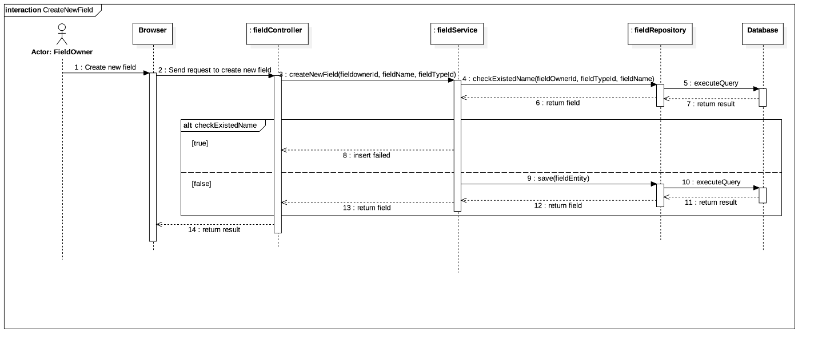

Figure 43: Sequence Diagram Create new field

#### Set field for match

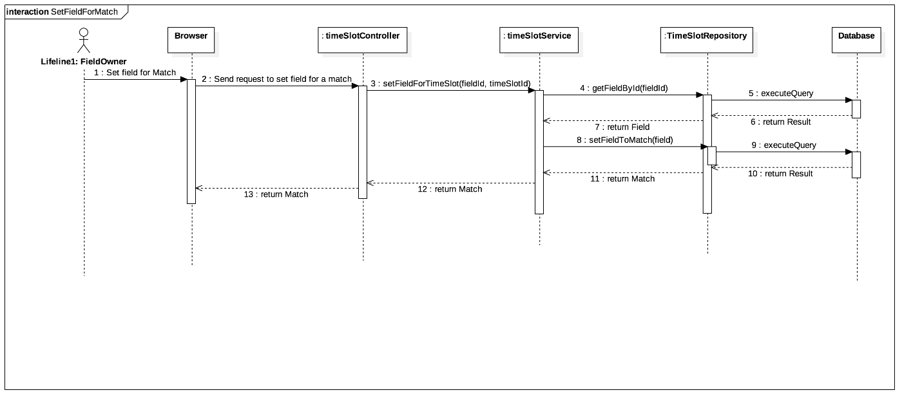

Figure 44: Sequence Diagram Set field for match

#### Set time enable

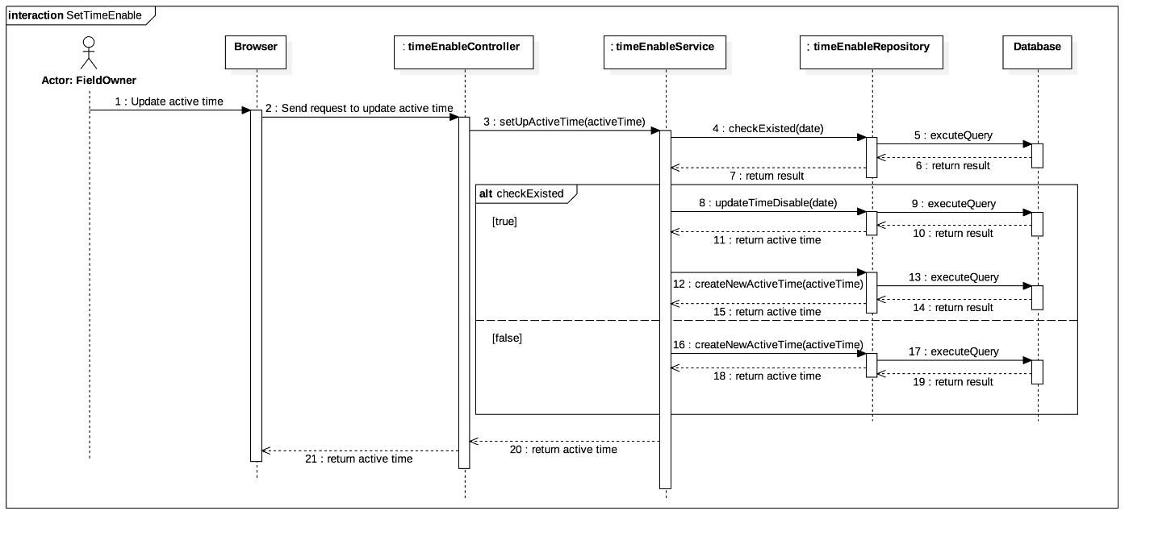

Figure 45: Sequence Diagram Set time enable

#### Reserve field

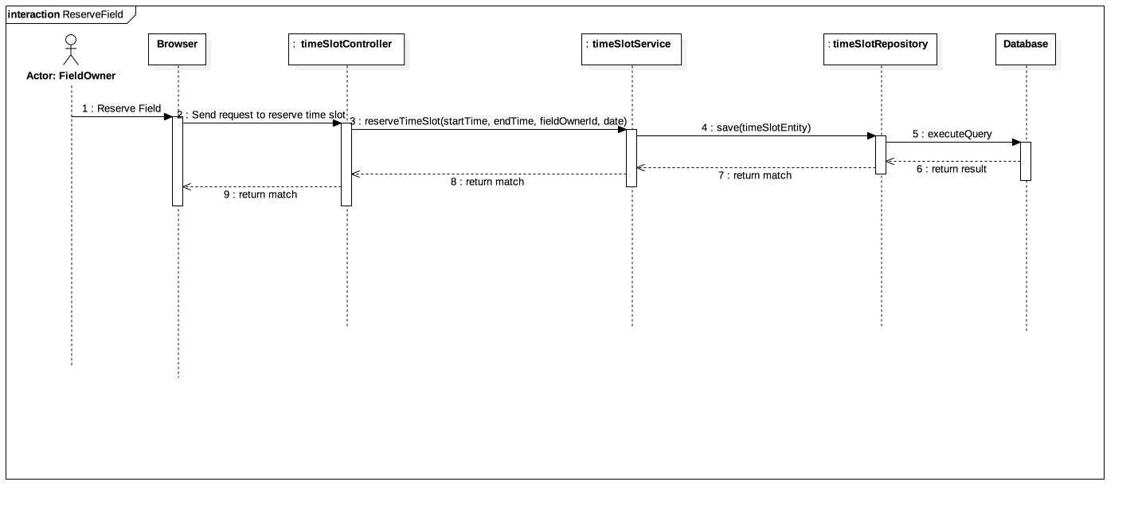

Figure 46: Sequence Diagram Reserve field

#### Activity Diagram

#### Create matching request

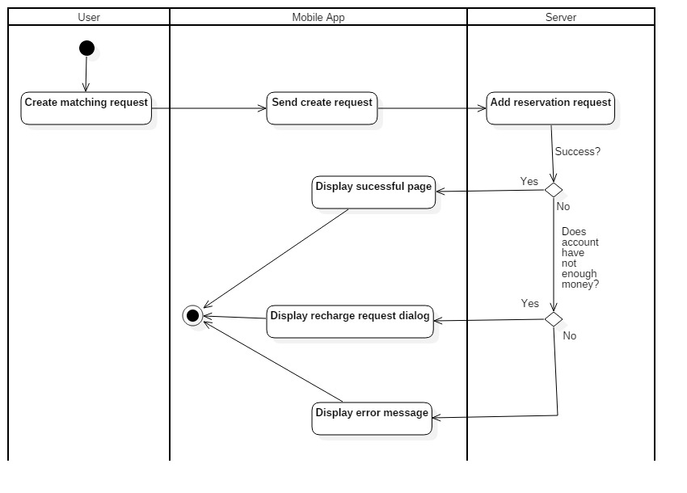

Figure 47: Activity Diagram Create matching request

#### Reserve tour match

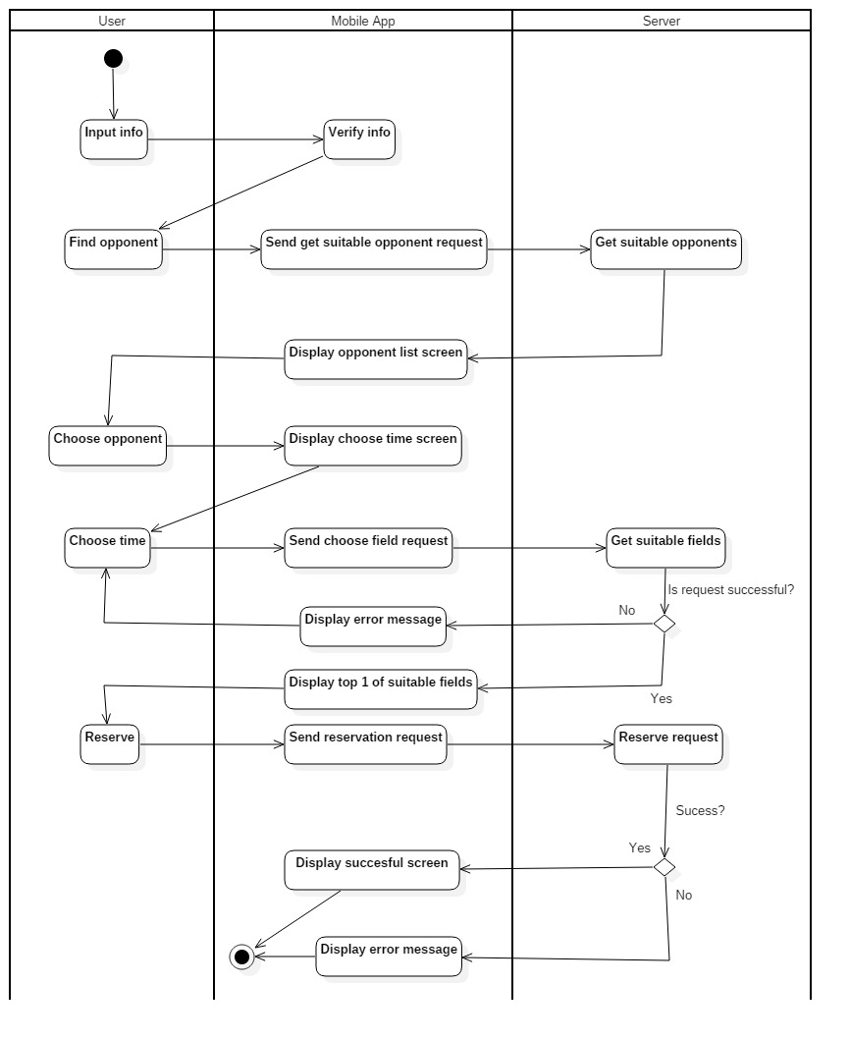

Figure 48: Activity Diagram Reserve tour match

#### Reserve friendly match

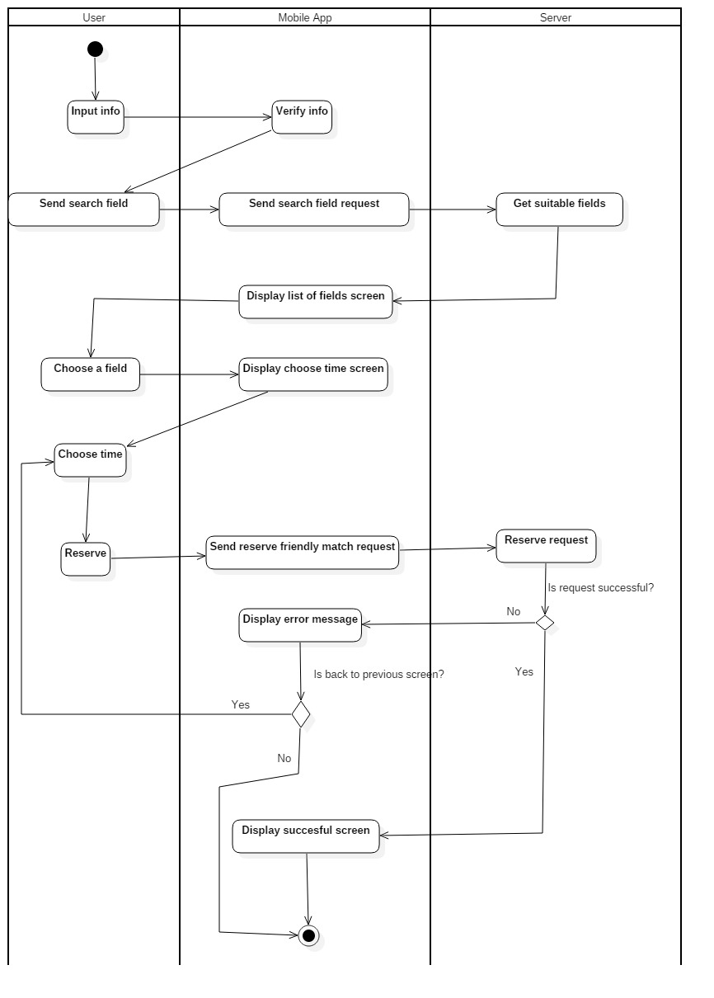

Figure 49: Activity Diagram Reserve friendly match

#### Cancel reserve request

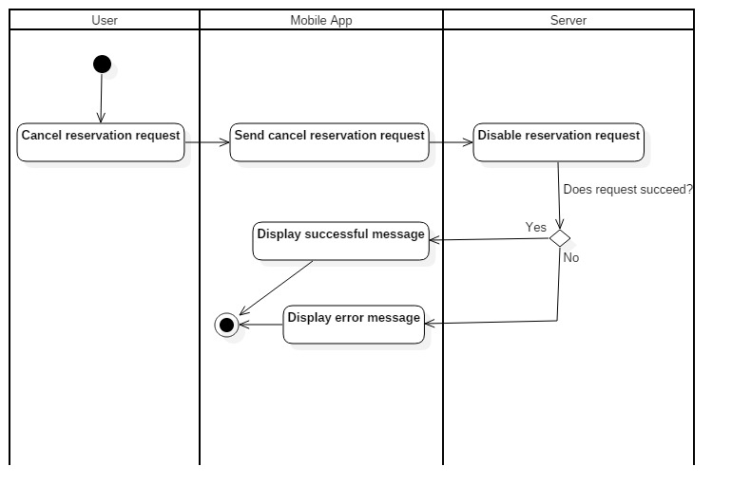

Figure 50: Activity Diagram Cancel reserve request

## User Interface Design

### Mobile Application

#### 5.1.2 Register

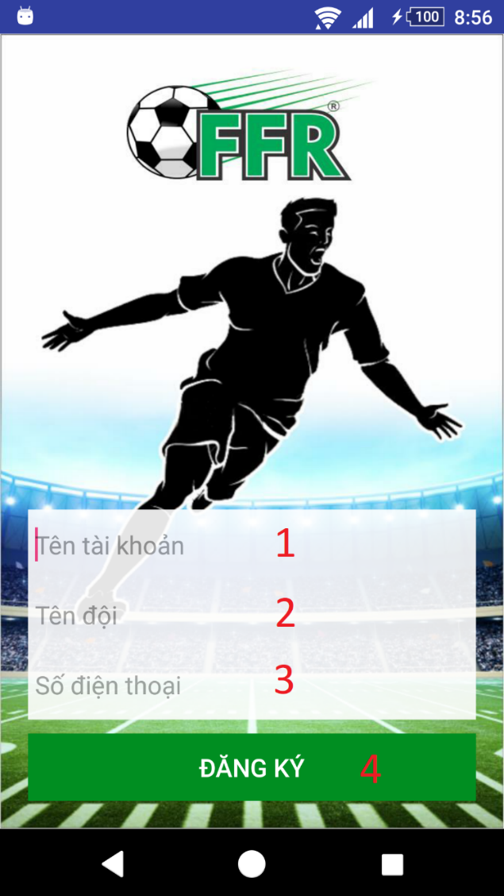

Figure 51: <Mobile Application>Register UI

**Fields**

|  |  |  |  |  |  |  |
| --- | --- | --- | --- | --- | --- | --- |
| **No** | **Field Names** | **Description** | **Read Only** | **Mandatory** | **Control Type** | **Data Type** |
| 1 | username | Fill username | No | Yes | EditText | String |
| 2 | teamName | Fill user’s team name | No | Yes | EditText | String |
| 3 | phone | Fill phone | No | Yes | EditText | String |

Table 62: <Mobile application> Register Fields

**Buttons/Hyperlinks**

|  |  |  |  |  |
| --- | --- | --- | --- | --- |
| **No** | **Function** | **Description** | **Validation** | **Outcome** |
| 4 | register | Create new account | All fields required before summit | Redirect to search field view. |

Table 63: <Mobile application>Register Buttons/Hyperlinks

#### 5.1.3 Menu

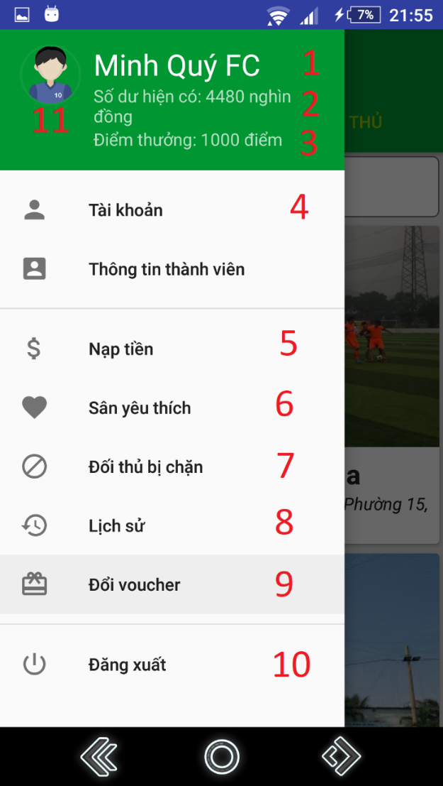

Figure 52: <Mobile Application>Menu UI

**Fields**

|  |  |  |  |  |  |  |
| --- | --- | --- | --- | --- | --- | --- |
| **No** | **Field Names** | **Description** | **Read Only** | **Mandatory** | **Control Type** | **Data Type** |
| 1 | name | User’s team name | Yes | Yes | TextView | String |
| 2 | balance | User’s current balance | Yes | Yes | TextView | String |
| 3 | bonusPoint | User’s current bonus point | Yes | Yes | TextView | String |
| 11 | avatar | User’s avatar | Yes | Yes | Image | N/A |

Table 64: <Mobile application>Menu Field

**Buttons/Hyperlinks**

|  |  |  |  |  |
| --- | --- | --- | --- | --- |
| **No** | **Function** | **Description** | **Validation** | **Outcome** |
| 4 | viewProfile | View user’s profile | N/A | Redirect to view profile view. |
| 5 | recharge | Go to recharge view | N/A | Redirect to recharge view. |
| 6 | viewFavoriteField | Show current area of user | N/A | Redirect to view location view. |
| 7 | viewBlacklist | Show user’s current blacklist | N/A | Redirect to view blacklist view. |
| 8 | viewHistory | Show user’s history | N/A | Redirect to view history view. |
| 9 | viewVoucher | Show available vouchers. | N/A | Redirect to view vouchers view. |
| 10 | logout | Logout of system | N/A | Redirect to login view. |

Table 65: <Mobile application>Menu Buttons/Hyperlinks

#### 5.1.4 Search Field

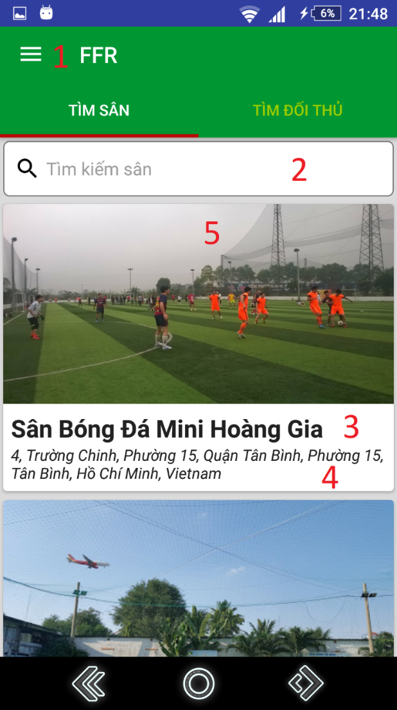

Figure 53: <Mobile Application>Search Field UI

**Fields**

|  |  |  |  |  |  |  |
| --- | --- | --- | --- | --- | --- | --- |
| **No** | **Field Names** | **Description** | **Read Only** | **Mandatory** | **Control Type** | **Data Type** |
| 2 | searchText | Input search field name | No | No | EditText | String |
| 3 | fieldName | Field’s name | Yes | No | TextView | String |
| 4 | address | Address | Yes | No | TextView | String |
| 5 | image | Field’s image | Yes | No | ImageView | N/A |

Table 66: <Mobile application>Search field’s Field

**Buttons/Hyperlinks**

|  |  |  |  |  |
| --- | --- | --- | --- | --- |
| **No** | **Function** | **Description** | **Validation** | **Outcome** |
| 1 | showNavigation | Show navigation view | N/A | Show navigation bar |

Table 67: <Mobile application>Search field buttons/hyperlinks

#### 5.1.5 Choose field’s free time

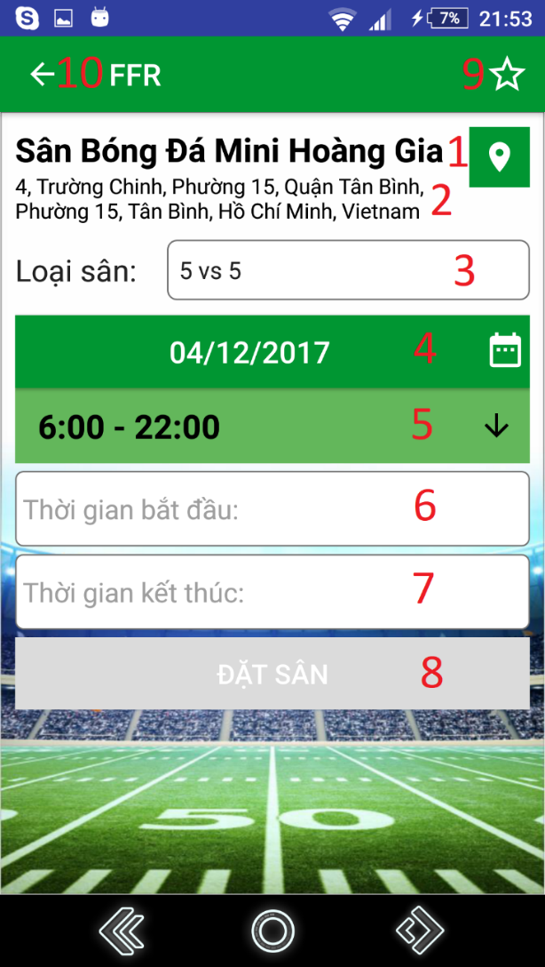

Figure 54: <Mobile Application>Choose field’s free time UI

**Fields**

|  |  |  |  |  |  |  |
| --- | --- | --- | --- | --- | --- | --- |
| **No** | **Field Names** | **Description** | **Read Only** | **Mandatory** | **Control Type** | **Data Type** |
| 1 | fieldName | Field’s name | Yes | Yes | TextView | String |
| 2 | fieldAddress | Field’s address | Yes | Yes | TextView | String |
| 3 | date | Choose date to reserve | No | Yes | DatePicker | String |
| 4 | fieldType | Field’s type | No | Yes | Dropdown box | String |
| 5 | timeFrame | Time frame | Yes | Yes | TextView | String |
| 6 | startTime | Input start time of reservation | No | Yes | EditText | String |
| 7 | endTime | Input end time of reservation | No | Yes | EditText | String |

Table 68: <Mobile application>Choose field’s free time Field

**Buttons/Hyperlinks**

|  |  |  |  |  |
| --- | --- | --- | --- | --- |
| **No** | **Function** | **Description** | **Validation** | **Outcome** |
| 8 | chooseTime | Set inputted time. | All fields required before summit | Redirect to view reservation detail view |
| 9 | setFavoriteField | Add/Remove field to/from favorite list | N/A | Show result message. |
| 10 | goBack | Go back to previous view | N/A | Show previous view |

Table 69: <Mobile application>Choose field’s free time Buttons/Hyperlinks

#### 5.1.6 View Reservation Details

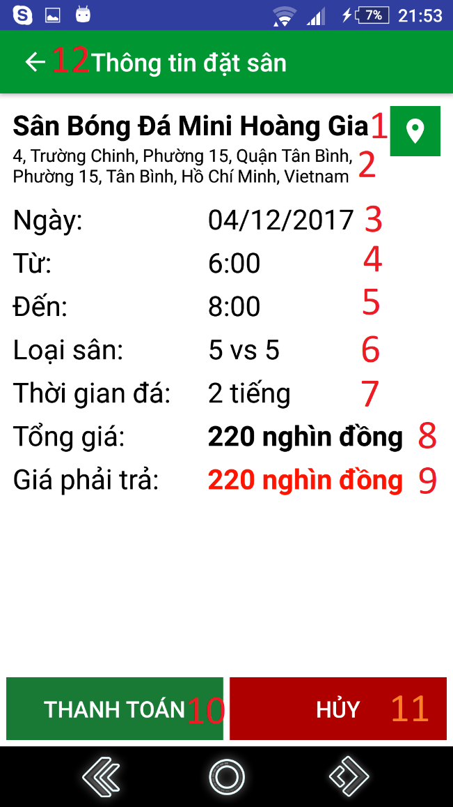

Figure 55: <Mobile Application>View Reservation Details UI

**Fields**

|  |  |  |  |  |  |  |
| --- | --- | --- | --- | --- | --- | --- |
| **No** | **Field Names** | **Description** | **Read Only** | **Mandatory** | **Control Type** | **Data Type** |
| 1 | fieldName | Field’s name | Yes | Yes | TextView | String |
| 2 | fieldAddress | Field’s address | Yes | Yes | TextView | String |
| 3 | date | Reserved date | Yes | Yes | TextView | String |
| 4 | startTime | Start time | Yes | Yes | TextView | String |
| 5 | endTime | End time | Yes | Yes | TextView | String |
| 6 | fieldType | Field’s type | Yes | Yes | TextView | String |
| 7 | duration | Duration of match | Yes | Yes | TextView | String |
| 8 | totalPrice | Total price for the reservation | Yes | Yes | TextView | String |
| 9 | paidPrice | The price user must pay | Yes | Yes | TextView | String |

Table 70: <Mobile application>View reservation details fields

**Buttons/Hyperlinks**

|  |  |  |  |  |
| --- | --- | --- | --- | --- |
| **No** | **Function** | **Description** | **Validation** | **Outcome** |
| 10 | Reserve | Reserve field | N/A | Show reservation result view |
| 11 | Cancel | Cancel reservation | N/A | Redirect to choose field’s free time view |
| 12 | goBack | Go back to previous view | N/A | Show previous view |

Table 71: <Mobile application>View reservation details buttons/hyperlinks

#### 5.1.7 Find Opponent

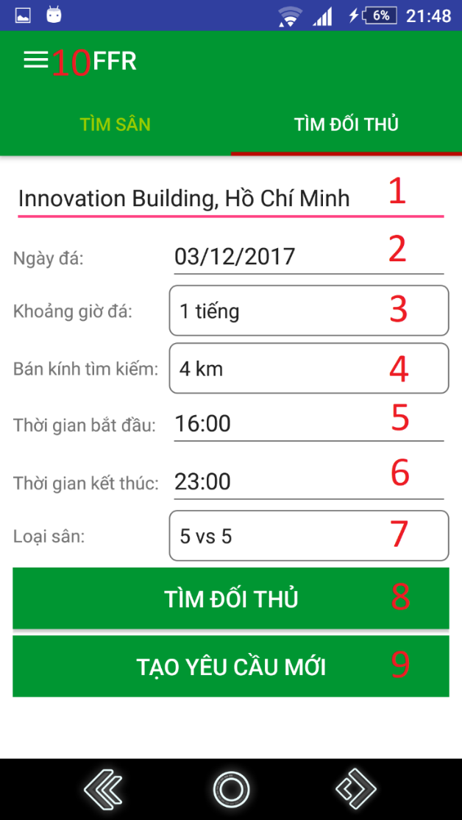

Figure 56: <Mobile Application>Find Opponent UI

**Fields**

|  |  |  |  |  |  |  |
| --- | --- | --- | --- | --- | --- | --- |
| **No** | **Field Names** | **Description** | **Read Only** | **Mandatory** | **Control Type** | **Data Type** |
| 1 | address | Input address where user wants to play | No | Yes | EditText | String |
| 2 | date | Choose date to reserve | No | Yes | Dropdown box | String |
| 3 | duration | Input duration | No | Yes | Spinner | String |
| 4 | distance | Input maximum distance for searching opponent | No | Yes | Spinner | String |
| 5 | startTime | Input start time for searching | No | Yes | EditText | String |
| 6 | endTime | Input end time for searching | No | Yes | EditText | String |
| 7 | fieldType | Field’s type | No | Yes | Dropdown box | String |

Table 72: <Mobile application>Find opponent fields

**Buttons/Hyperlinks:**

|  |  |  |  |  |
| --- | --- | --- | --- | --- |
| **No** | **Function** | **Description** | **Validation** | **Outcome** |
| 8 | findOpponent | Find opponent | All fields required before summit | Show find opponent result view |
| 9 | createNewRequest | Create new request | All fields required before summit | Show create new request result view |
| 10 | showNavigation | Show navigation view | N/A | Show navigation bar |

Table 73: <Mobile application>Find opponent buttons/hyperlinks

#### 5.1.8 Matching Result

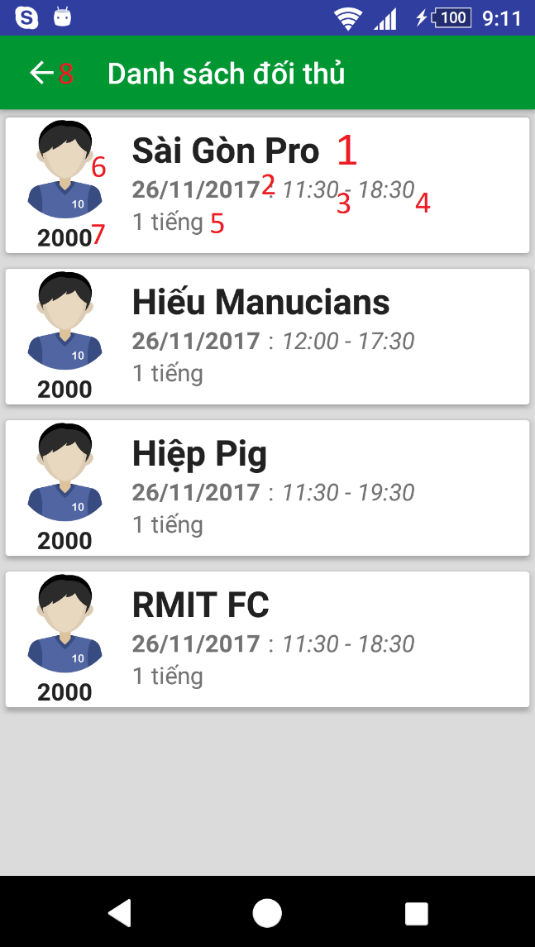

Figure 57: <Mobile Application>Matching Result UI

**Fields**

|  |  |  |  |  |  |  |
| --- | --- | --- | --- | --- | --- | --- |
| **No** | **Field Names** | **Description** | **Read Only** | **Mandatory** | **Control Type** | **Data Type** |
| 1 | teamName | User’s team name | Yes | Yes | TextView | String |
| 2 | date | Date | Yes | Yes | TextView | String |
| 3 | startTime | Start time | Yes | Yes | TextView | String |
| 4 | endTime | End time | Yes | Yes | TextView | String |
| 5 | duration | Duration | Yes | Yes | TextView | String |
| 6 | avatar | User’s avatar | Yes | Yes | ImageView | N/A |
| 7 | ratingScore | User’s rating score for ranking | Yes | Yes | TextView | String |

Table 74: <Mobile application>Matching result fields

**Buttons/Hyperlinks:**

|  |  |  |  |  |
| --- | --- | --- | --- | --- |
| **No** | **Function** | **Description** | **Validation** | **Outcome** |
| 8 | goBack | Go back to previous view | N/A | Show previous view |

Table 75: <Mobile application>Matching result buttons/hyperlinks

#### 5.1.9 Deposit

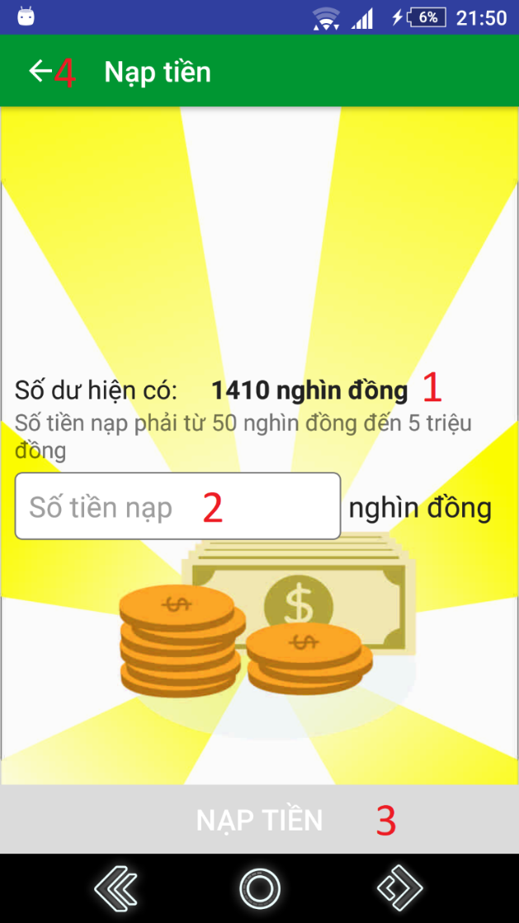

Figure 58: <Mobile Application>Deposit UI

**Fields**

|  |  |  |  |  |  |  |
| --- | --- | --- | --- | --- | --- | --- |
| **No** | **Field Names** | **Description** | **Read Only** | **Mandatory** | **Control Type** | **Data Type** |
| 1 | balance | User’s current balance | Yes | Yes | TextView | String |
| 2 | rechargeMoney | Fill amount of money user wants to recharge | No | Yes | EditText | Integer |

Table 76: <Mobile application>Deposit fields

**Buttons/Hyperlinks:**

|  |  |  |  |  |
| --- | --- | --- | --- | --- |
| **No** | **Function** | **Description** | **Validation** | **Outcome** |
| 3 | createNewRequest | Create new request | All fields required before summit | Show create new request result view |
| 4 | goBack | Go back to previous view | N/A | Show previous view |

Table 77: <Mobile application>Deposit buttons/hyperlinks

#### 5.1.10 Get reserved matches

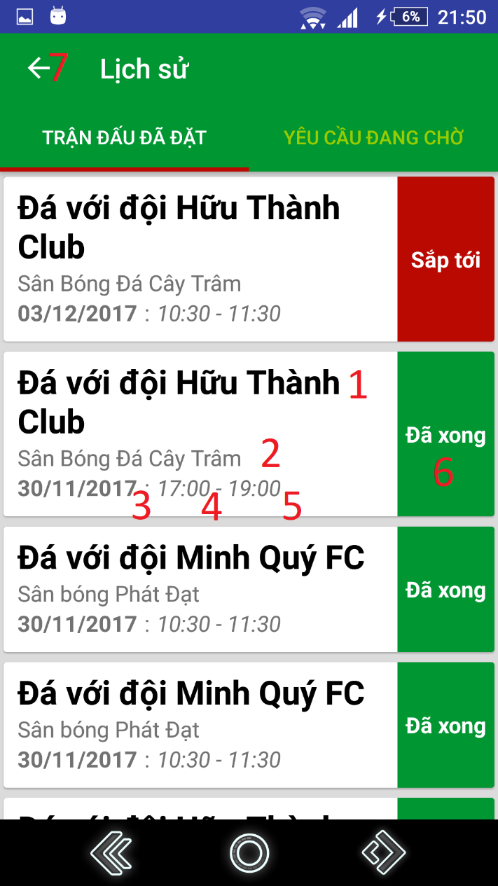

Figure 59: <Mobile Application>Get reserved matches UI

**Fields**

|  |  |  |  |  |  |  |
| --- | --- | --- | --- | --- | --- | --- |
| **No** | **Field Names** | **Description** | **Read Only** | **Mandatory** | **Control Type** | **Data Type** |
| 1 | matchInfo | Information about match’s type and opponent’s team name played with (if have) | Yes | Yes | TextView | String |
| 2 | fieldName | Field name | Yes | Yes | TextView | String |
| 3 | date | Date | Yes | Yes | TextView | String |
| 4 | startTime | Start time | Yes | Yes | TextView | String |
| 5 | endTime | End time | Yes | Yes | TextView | String |
| 6 | status | Match’s status | Yes | Yes | TextView | String |

Table 78: <Mobile application>Get reserved matches fields

**Buttons/Hyperlinks:**

|  |  |  |  |  |
| --- | --- | --- | --- | --- |
| **No** | **Function** | **Description** | **Validation** | **Outcome** |
| 7 | goBack | Go back to previous view | N/A | Show previous view |

Table 79: <Mobile application>Get reserved matches buttons/hyperlinks

#### 5.1.11 Get matching request

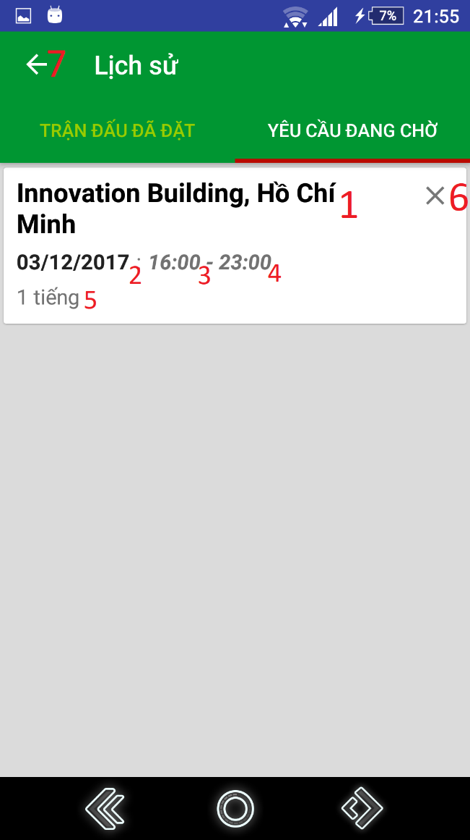

Figure 60: <Mobile Application>Get matching request UI

**Fields**

|  |  |  |  |  |  |  |
| --- | --- | --- | --- | --- | --- | --- |
| **No** | **Field Names** | **Description** | **Read Only** | **Mandatory** | **Control Type** | **Data Type** |
| 1 | address | Address where user create requests | Yes | Yes | TextView | String |
| 2 | date | Date | Yes | Yes | TextView | String |
| 3 | startTime | Start time | Yes | Yes | TextView | String |
| 4 | endTime | End time | Yes | Yes | TextView | String |
| 5 | duration | Duration | Yes | Yes | TextView | String |

Table 80: <Mobile application>Get matching request fields

**Buttons/Hyperlinks:**

|  |  |  |  |  |
| --- | --- | --- | --- | --- |
| **No** | **Function** | **Description** | **Validation** | **Outcome** |
| 6 | cancelRequest | Cancel Request | N/A | Refresh view pending matches view |
| 7 | goBack | Go back to previous view | N/A | Show previous view |

Table 81: <Mobile application>Get matching request buttons/hyperlinks

#### 5.1.12 Rate opponent

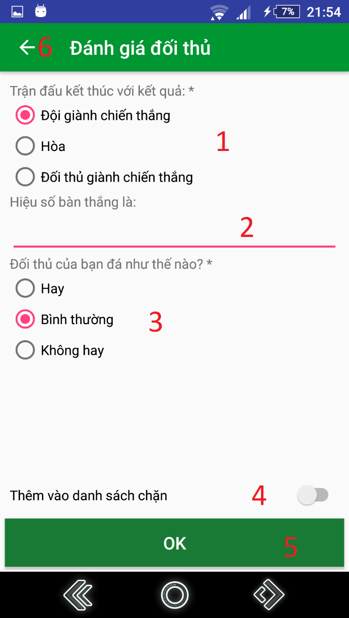

Figure 61: <Mobile Application>Rate Opponent UI

**Fields**

|  |  |  |  |  |  |  |
| --- | --- | --- | --- | --- | --- | --- |
| **No** | **Field Names** | **Description** | **Read Only** | **Mandatory** | **Control Type** | **Data Type** |
| 1 | winner | Input the match result | No | Yes | RadioButton | String |
| 2 | goalDifference | Input the match’s goal difference | No | No | EditText | Integer |
| 3 | opponentSkill | Input opponent’s performance in the match | No | Yes | RadioButton | String |

Table 82: <Mobile application>Rate opponent fields

**Buttons/Hyperlinks:**

|  |  |  |  |  |
| --- | --- | --- | --- | --- |
| **No** | **Function** | **Description** | **Validation** | **Outcome** |
| 4 | setBlacklist | Add opponent to blacklist | All fields required before summit | Show setting result message. |
| 5 | submitRating | Submit opponent rating | All fields required before summit | Show submit rating result message. |
| 6 | goBack | Go back to previous view | N/A | Show previous view |

Table 83: <Mobile application>Rate opponent buttons/hyperlinks

#### 5.1.13 Report opponent

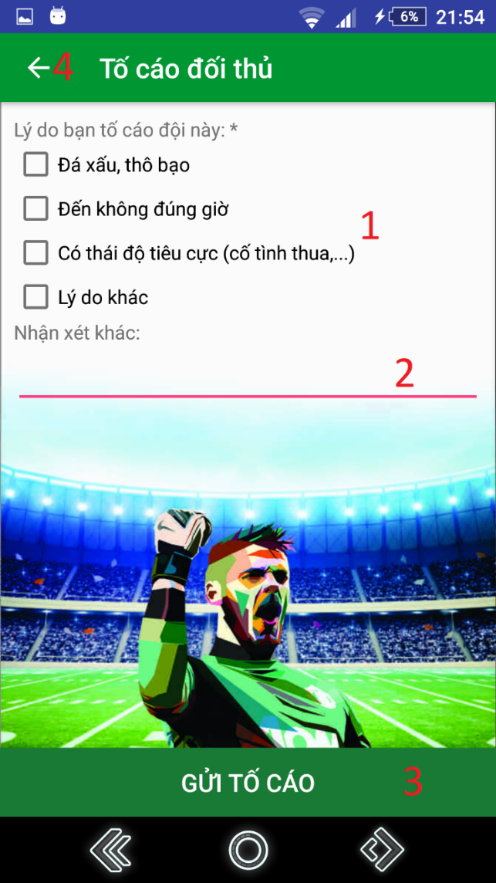

Figure 62: <Mobile Application>Report Opponent UI

**Fields**

|  |  |  |  |  |  |  |
| --- | --- | --- | --- | --- | --- | --- |
| **No** | **Field Names** | **Description** | **Read Only** | **Mandatory** | **Control Type** | **Data Type** |
| 1 | presetReasons | Input report reasons. | No | Yes | CheckBox | String |
| 2 | comments | Input comments. | No | No | EditText | String |

Table 84: <Mobile application>Report opponent fields

**Buttons/Hyperlinks:**

|  |  |  |  |  |
| --- | --- | --- | --- | --- |
| **No** | **Function** | **Description** | **Validation** | **Outcome** |
| 3 | submitReport | Submit opponent report | All fields required before summit | Show submit report result message. |
| 4 | goBack | Go back to previous view | N/A | Show previous view |

Table 85: <Mobile application>Report opponent buttons/hyperlinks

### Web application

#### Get Matches By Date

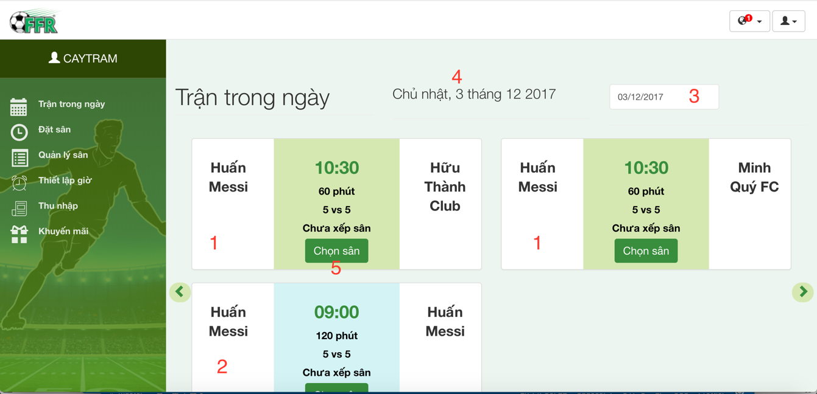

Figure 63: <Web Application>Get Matches By Date UI

**Fields**

|  |  |  |  |  |  |  |
| --- | --- | --- | --- | --- | --- | --- |
| **No** | **Field Names** | **Description** | **Read Only** | **Mandatory** | **Control Type** | **Data Type** |
| 1 | TourMatch  Data | The system matches two user | Yes | No | Text | String |
| 2 | FriendlyMatch  Data | User reserve match | Yes | No | Text | String |
| 4 | Current Date Format | Show date chosen | Yes | No | Text | String |

Table 86: <Web application>Get match by date fields

**Buttons/Hyperlinks**

|  |  |  |  |  |
| --- | --- | --- | --- | --- |
| **No** | **Function** | **Description** | **Validation** | **Outcome** |
| 3 | ChooseDate | Select target date | N/A | Date selected |

Table 87: <Web application>Get match by date buttons/hyperlinks

#### Choose Field For Match

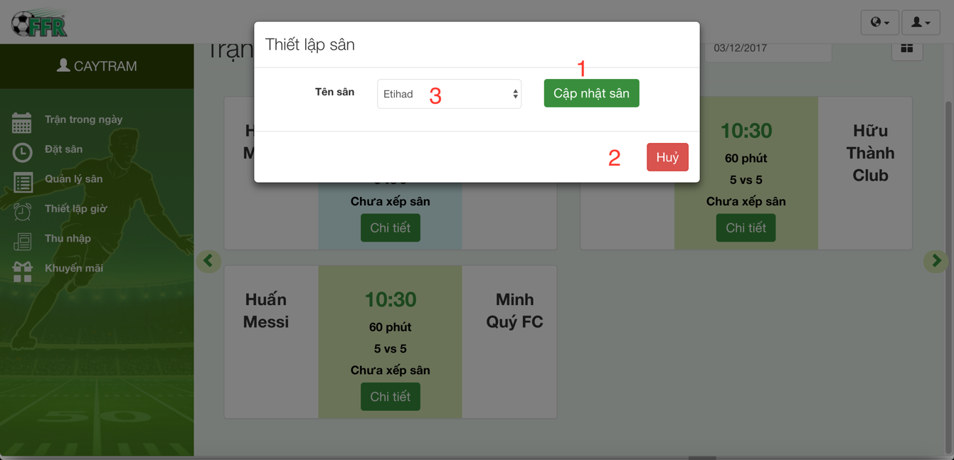

Figure 64: <Web Application>Field For Match UI

**Fields**

|  |  |  |  |  |  |  |
| --- | --- | --- | --- | --- | --- | --- |
| **No** | **Field Names** | **Description** | **Read Only** | **Mandatory** | **Control Type** | **Data Type** |
| 3 | FieldName | Name of a field | No | Yes | Dropbox | String |

Table 88: <Web application>Choose field for match fields

**Buttons/Hyperlinks**

|  |  |  |  |  |
| --- | --- | --- | --- | --- |
| **No** | **Function** | **Description** | **Validation** | **Outcome** |
| 1 | UpdateField  ForMatch | Update a field to a match | N/A | Set field for a match |
| 2 | Cancel | Cancel action set field to match | N/A | Back to field owner index page |

Table 89: <Web application>Choose field for match buttons/hyperlinks

#### Update Time Available

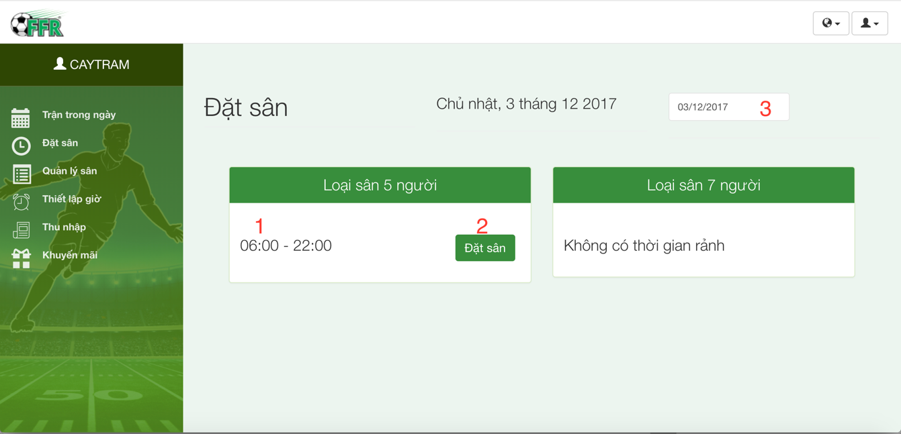

Figure 65: <Web Application>Update Time Available UI

**Fields:**

|  |  |  |  |  |  |  |
| --- | --- | --- | --- | --- | --- | --- |
| **No** | **Field Names** | **Description** | **Read Only** | **Mandatory** | **Control Type** | **Data Type** |
| 1 | Time | Time enable to update | Yes | Yes | Text | String |

Table 90: <Web application>Update time available fields

**Buttons/Hyperlinks**

|  |  |  |  |  |
| --- | --- | --- | --- | --- |
| **No** | **Function** | **Description** | **Validation** | **Outcome** |
| 2 | UpdateTimeAvailable | Update time available of field | N/A | Time available is updated |
| 3 | Date | Tagert date | N/A | Date selected |

Table 91: <Web application>Update time available buttons/hyperlinks

#### Field Management

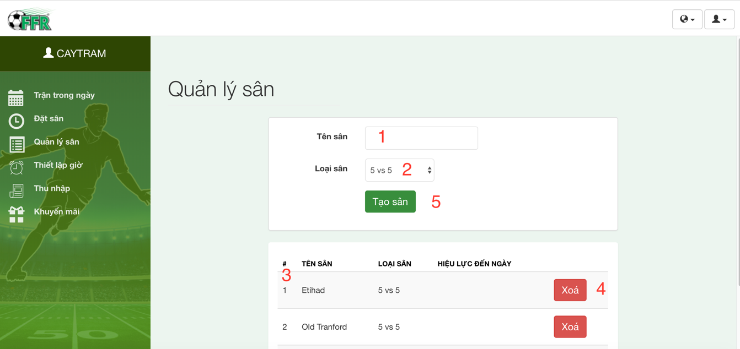

Figure 66: <Web Application>Field Management UI

**Fields:**

|  |  |  |  |  |  |  |
| --- | --- | --- | --- | --- | --- | --- |
| **No** | **Field Names** | **Description** | **Read Only** | **Mandatory** | **Control Type** | **Data Type** |
| 1 | FieldName | Name of field | No | Yes | Textbox | String |
| 2 | FieldType | Name of field type | No | Yes | Dropbox | String |
| 3 | DataField | Show all field | Yes | Yes | Table | String |

Table 92: <Web application>Field management

**Buttons/Hyperlinks**

|  |  |  |  |  |
| --- | --- | --- | --- | --- |
| **No** | **Function** | **Description** | **Validation** | **Outcome** |
| 4 | Delete Field | Delete field | N/A | Delete a field |
| 5 | Create Field | Create a new field | N/A | Create new field |

Table 93: <Web application>Field management buttons/hyperlinks

#### Manage Active Time

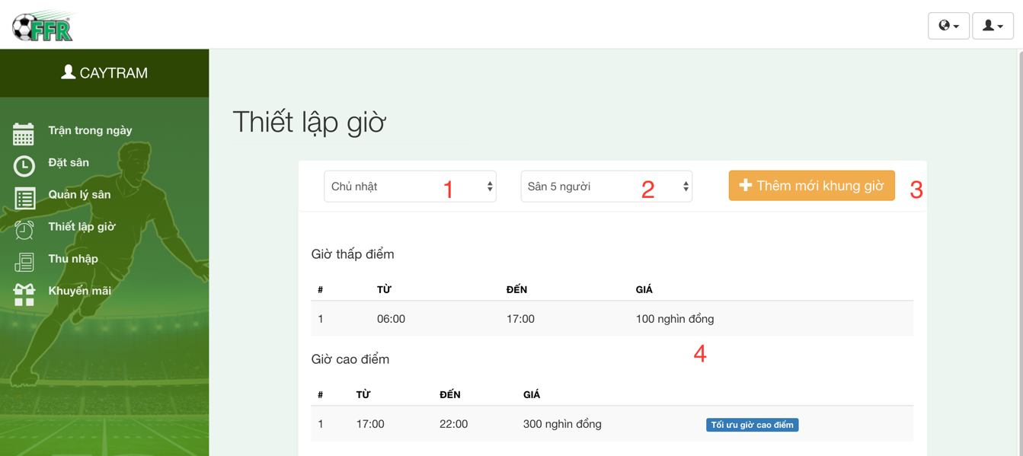

Figure 67: <Web Application> Manage Active Time UI

**Fields**

|  |  |  |  |  |  |  |
| --- | --- | --- | --- | --- | --- | --- |
| **No** | **Field Names** | **Description** | **Read Only** | **Mandatory** | **Control Type** | **Data Type** |
| 1 | DayInWeek | Day In week | No | Yes | Dropbox | String |
| 2 | FieldType | Type of field | No | Yes | Dropbox | String |
| 4 | Active  TimeData | Set active time for field | No | Yes | Table | String |

Table 94: <Web application>Manage active time

**Buttons/Hyperlinks**

|  |  |  |  |  |
| --- | --- | --- | --- | --- |
| **No** | **Function** | **Description** | **Validation** | **Outcome** |
| 3 | Update active time | Open popup to update new active time | N/A | Open popup |

Table 95: <Web application>Manage active time buttons/hyperlinks

#### Update Active Time Management

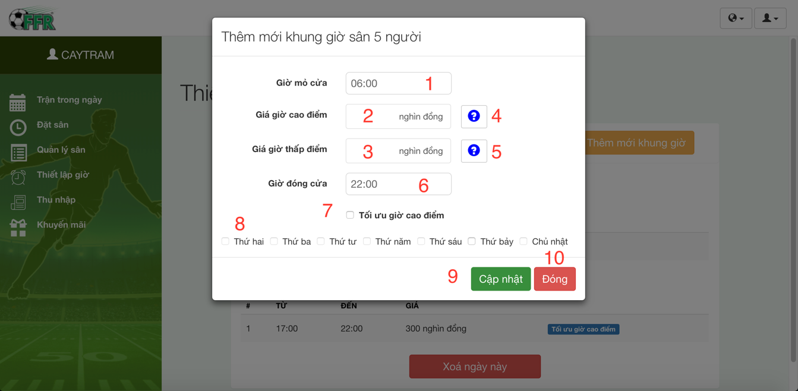

Figure 68: <Web Application>Update Active Time Management UI

**Fields**

|  |  |  |  |  |  |  |
| --- | --- | --- | --- | --- | --- | --- |
| **No** | **Field Names** | **Description** | **Read Only** | **Mandatory** | **Control Type** | **Data Type** |
| 1 | StartTime | Opening time | No | Yes | Dropbox | DateTime |
| 2 | Peakhourprice | Peak hour price | No | Yes | Textbox | Float |
| 3 | IdleHourPrice | Idle hour price | No | Yes | Textbox | Float |
| 6 | CloseTime | Closing time | No | Yes | Dropbox | DateTime |
| 7 | IsEnableOptimize | Optimize peak time | No | No | Checkbox | Boolean |
| 8 | DayInWeek | Day in week | No | Yes | Checkbox | Boolean |

Table 96: <Web application>Update active time

**Buttons/Hyperlinks**

|  |  |  |  |  |
| --- | --- | --- | --- | --- |
| **No** | **Function** | **Description** | **Validation** | **Outcome** |
| 4 | GetDetailPeakHour | Show detail peak hour | N/A | Show tooltip |
| 5 | GetDetailIdleHour | Show detail idle hour | N/A | Show tooltip |
| 9 | UpdateActiveTime |  | N/A |  |
| 10 | Cancel | Close popup | N/A | Close popup |

Table 97: <Web application>Update active time buttons/hyperlinks

#### Income Management

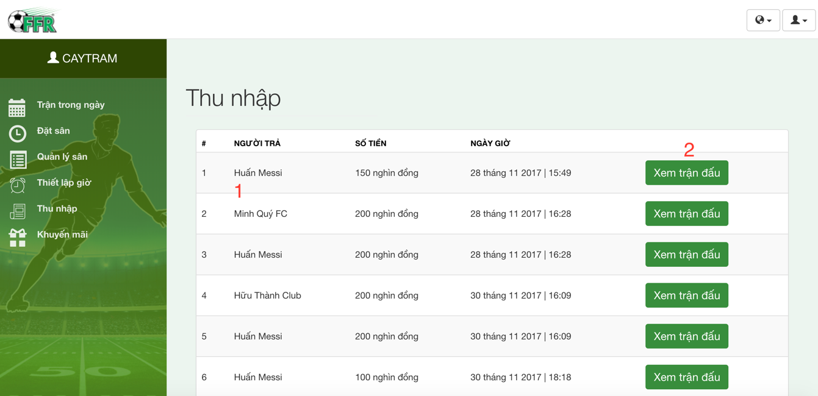

Figure 69: <Web Application>Income Management UI

**Fields:**

|  |  |  |  |  |  |  |
| --- | --- | --- | --- | --- | --- | --- |
| **No** | **Field Names** | **Description** | **Read Only** | **Mandatory** | **Control Type** | **Data Type** |
| 1 | Incomedata | Income data | Yes | No | Table | String |

Table 98: <Web application>Manage income

**Buttons/Hyperlinks**

|  |  |  |  |  |
| --- | --- | --- | --- | --- |
| **No** | **Function** | **Description** | **Validation** | **Outcome** |
| 2 | ViewDetailBill | View detail a bill | N/A | Open popup |

Table 99: <Web application>Manage income buttons/hyperlinks

#### Promotion Management

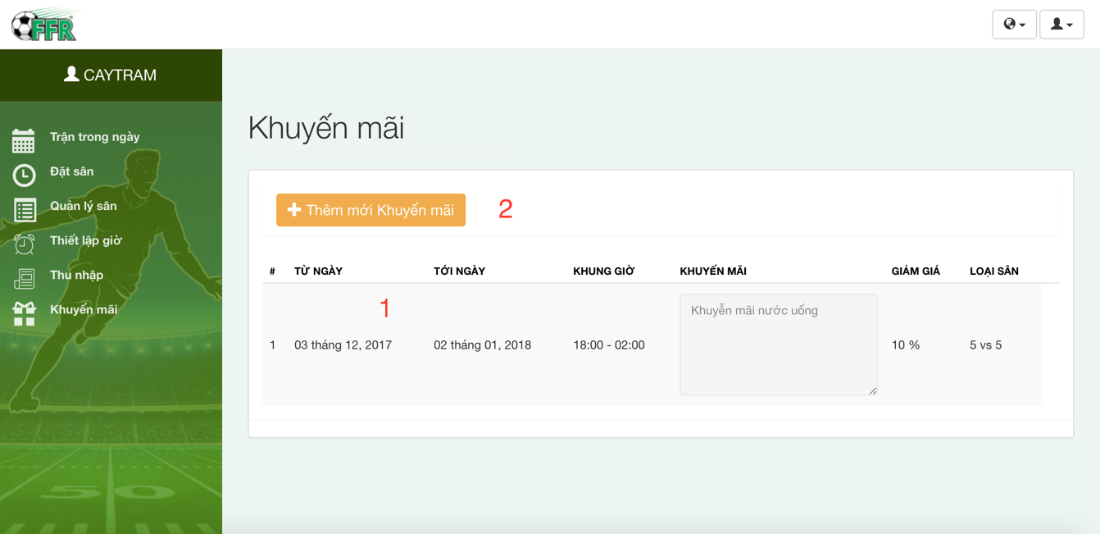

Figure 70: <Web Application>Promotion Management UI

**Fields**

|  |  |  |  |  |  |  |
| --- | --- | --- | --- | --- | --- | --- |
| **No** | **Field Names** | **Description** | **Read Only** | **Mandatory** | **Control Type** | **Data Type** |
| 1 | PromotionData | Promotion data | Yes | No | Table | String |

Table 100: <Web application>Promotion management

**Buttons/Hyperlinks**

| **No** | **Function** | **Description** | **Validation** | **Outcome** |
| --- | --- | --- | --- | --- |
| 2 | AddNewPromotion | Add new promotion | N/A | Open popup |

Table 101: <Web application>Promotion management buttons/hyperlinks

#### 5.2.10 Add promotion

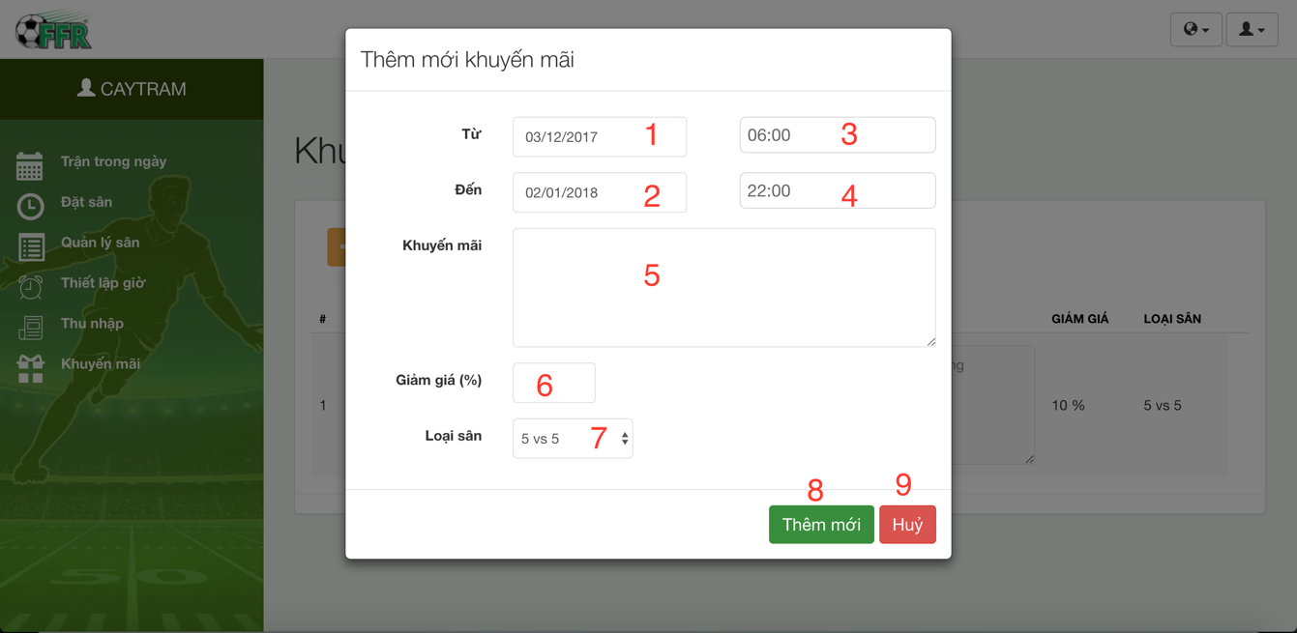

Figure 71: <Web Application>Add Promotion UI

**Fields**

|  |  |  |  |  |  |  |
| --- | --- | --- | --- | --- | --- | --- |
| **No** | **Field Names** | **Description** | **Read Only** | **Mandatory** | **Control Type** | **Data Type** |
| 1 | Startdate | Start Date promotion | No | Yes | Date Picker | Date |
| 2 | EndDate | End Date promotion | No | Yes | Date Picker | Date |
| 3 | StartTime | Start time promotion | No | Yes | Dropbox | DateTime |
| 4 | EndTime | End Time promotion | No | Yes | Dropbox | DateTime |
| 5 | Description | Promotion description | No | Yes | TextArea | String |
| 6 | DiscountPercent | Promotion discount percent | No | Yes | Textbox | Float |
| 7 | FieldType | Field type to promote | No | Yes | Dropbox | String |

Table 102: <Web application>Add promotion

**Buttons/Hyperlinks**

|  |  |  |  |  |
| --- | --- | --- | --- | --- |
| **No** | **Function** | **Description** | **Validation** | **Outcome** |
| 8 | AddNewPromotion | Add new promotion | N/A | Close popup, show notify. |
| 9 | Cancel | Close popu[ | N/A | Close popup |

Table 103: <Web application>Add promotion buttons/hyperlinks

#### 5.2.11 User Management

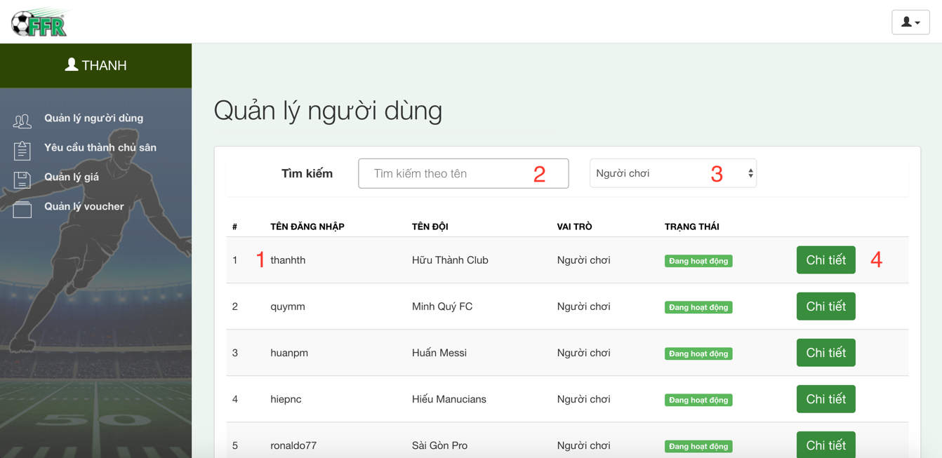

Figure 72: <Web Application> User management UI

**Fields**

|  |  |  |  |  |  |  |
| --- | --- | --- | --- | --- | --- | --- |
| **No** | **Field Names** | **Description** | **Read Only** | **Mandatory** | **Control Type** | **Data Type** |
| 1 | UserData | User data | Yes | No | Table | String |
| 2 | SearchByUsername | Search User | No | Yes | Textbox | String |
| 3 | TypeUserTarget | User target to search | No | Yes | Dropbox | String |

Table 104: <Web application>User management

**Buttons/Hyperlinks**

|  |  |  |  |  |
| --- | --- | --- | --- | --- |
| **No** | **Function** | **Description** | **Validation** | **Outcome** |
| 4 | ShowDetailUser | Show popup to view detail user | N/A | Open popup |

Table 105: <Web application>User management buttons/hyperlinks

#### 5.2.12 View User Details

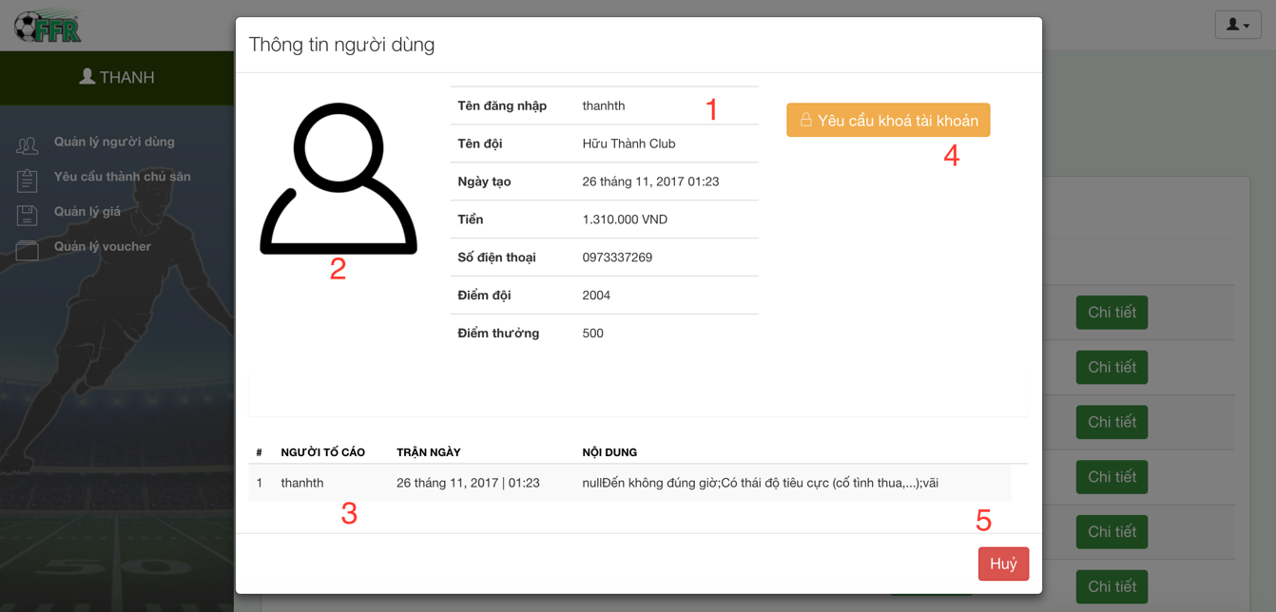

Figure 73: <Web Application>View User Details UI

**Fields**

|  |  |  |  |  |  |  |
| --- | --- | --- | --- | --- | --- | --- |
| **No** | **Field Names** | **Description** | **Read Only** | **Mandatory** | **Control Type** | **Data Type** |
| 1 | UserInfomaion | Information of user | Yes | No | Table | String |
| 2 | UserImage | Image of user | Yes | No | Image | Image |
| 3 | Reported data | Reports of user | Yes | No | Table | String |

Table 106: <Web application>View user details

**Buttons/Hyperlinks**

|  |  |  |  |  |
| --- | --- | --- | --- | --- |
| **No** | **Function** | **Description** | **Validation** | **Outcome** |
| 4 | RequestToLock | Request to lock user | N/A | Show message request lock. |
| 5 | Cancel | Close popup | N/A | Close popup |

Table 107: <Web application>View user details buttons/hyperlinks

#### 5.2.13 Lock User

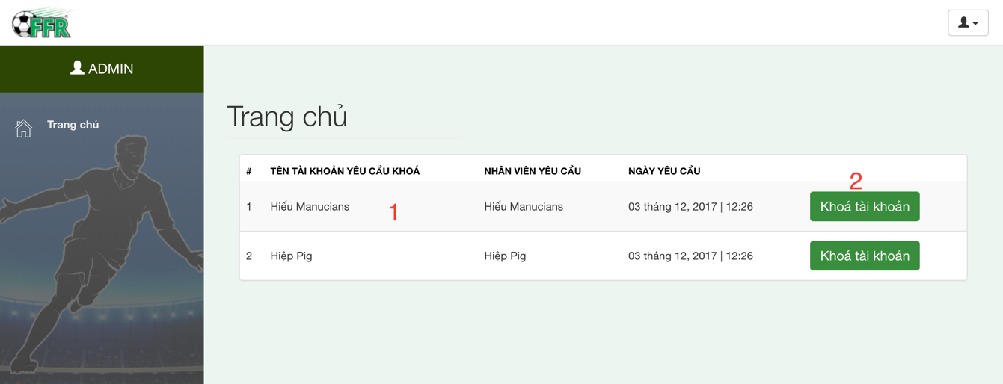

Figure 74: <Web Application>Lock User UI

**Fields**

|  |  |  |  |  |  |  |
| --- | --- | --- | --- | --- | --- | --- |
| **No** | **Field Names** | **Description** | **Read Only** | **Mandatory** | **Control Type** | **Data Type** |
| 1 | UserRequestedToLock | The user was requested to lock | Yes | No | Table | String |

Table 108: <Web application>Lock user

**Buttons/Hyperlinks**

| **No** | **Function** | **Description** | **Validation** | **Outcome** |
| --- | --- | --- | --- | --- |
| 2 | LockAccount | Show popup do confirm lock | N/A | Open popup confirm |

Table 109: <Web application>Lock user buttons/hyperlinks

#### 5.2.14 Confirm Lock Account

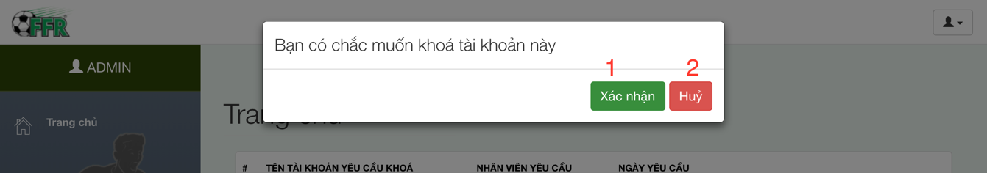

Figure 75: <Web Application>Confirm Lock Account UI

**Fields:** N/A

**Buttons/Hyperlinks**

|  |  |  |  |  |
| --- | --- | --- | --- | --- |
| **No** | **Function** | **Description** | **Validation** | **Outcome** |
| 1 | ConfirmLock | Confirm lock account | N/A | Show message lock |
| 2 | Cancel | Close popup | N/A | Close popup |

Table 110: <Web application>Confirm lock account buttons/hyperlinks

## Database design

### 6.1 Entity relationship diagram

### 

Figure 76: Entity Relationship Diagram

## Algorithms

### 7.1 Manage time

#### 7.1.1 Definition

The field management system is based on free time of the field, so that the System can quickly know which field owner can satisfy the user’s request.

#### 7.1.2 Define problem

The User may select the time frame arbitrarily and then reserves the field. The problem is how system can manage time of fields. System has to calculate free time quickly and effectively.

When a large number of users reserve field, the field’s timeline may be broken into fragments. Therefore, system has to choose field owners who received matching requests.

#### 7.1.3 Solution

The field management system is based on free time of the field, so that the system can decide which field owner can satisfy the user’s request. If H (0, ..., k, ..., 23) is the set of vacant fields for one hour from k (H (k), the number of vacant fields between k and k + 1 hour).

Let F(1, .., i, n) is the set of fields of a field owner. User A reserve field from x to y hour(s).

Step 1: The System will check H (k) with x <= k <= y-1 with all H (k)> 0, there exists at least 1 vacant field from x to y.

Step 2: Suppose F(i) is the field that Field owner choose for user A.

For (j = x, j = j +1, j<=y)

If (F(i) is free at j hour) then

User can reserve this field as normal till j hour

If (F(i) is reserved by other user) then

1. Field owner find other field F(ii) which has free time at j hour
2. Swap all reserve request of F(i) and F(ii) from j hour
3. After swap F(i) is free at j hour

#### 7.1.4 Example

Two fields of field owner “Cây Trâm”:

+ Field 1: 06AM to 22PM

+ Field 2: 06AM to 22PM

Reserve request:

+ User A reserved Field 1, time frame is: 06AM to 08AM

+ User B reserved Field 2, time frame is: 08AM to 10AM

New reserve request:

+User C reserves time frame 07AM to 09AM

**Field owner set field for Use**r:

|  |  |  |  |  |  |  |
| --- | --- | --- | --- | --- | --- | --- |
| **Field** | **06 - 07** | **07 - 08** | **08 - 09** | **09 - 10** | **10 - 11** | **11 - 12** |
| Field 1 | User A | User A | 0 | 0 | 0 | 0 |
| Field 2 | 0 | 0 | User B | User B | 0 | 0 |

**After system apply algorithm:**

|  |  |  |  |  |  |  |
| --- | --- | --- | --- | --- | --- | --- |
| **Field** | **06 - 07** | **07 - 08** | **08 - 09** | **09 - 10** | **10 - 11** | **11 - 12** |
| Field 1 | User A | User A | User B | User B | 0 | 0 |
| Field 2 | 0 | User C | User C | 0 | 0 | 0 |

#### 7.1.5 Complexity

The complexity is: O(n2)

### 7.2 Distance

#### 7.2.1 Definition

The situation is: when system finds fields around 1 location A (latitude1, longitude1), with k(km) radius.

If location B (latitude2, longtitude2) is within a radius of k(km) from A, the precondition is:

$$\left\{\begin{aligned}latitude1-x<latitude2<latitude1+x \\ longitude1-y<longitude2<longitude1+y\end{aligned}\right.$$

x, y are constants.

The main purpose is we calculate the approximately x, y then input to the system. Based on x, y, system can quickly find out which fields is the most suitable. X, y constants help system early removal fields can not afford.

#### 7.2.2 Define problem

Calculating the distance between 2 points is one of the most used functions in our system (user reserves field, system finds opponent, system matches 2 users).

Calculating the distance between 2 points takes so many steps.

#### 7.2.3 Solution

We calculate x, y as 2 constants. System based on x, y can calculate faster.

For any two points on a sphere, the haversine of the central angle between them is given by:

$$hav\left(\frac{d}{r}\right)=hav\left(φ2-φ1\right)+cos\left(φ1\right)cos\left(φ2\right)hav\left(λ2-λ1\right)$$

hav is the Havesin fuction:

$$hav(Ø)=\sin^{2}\left(\frac{Ø}{2}\right)$$

* *d* is the distance between the two points
* *r* is the radius of the sphere,
* *φ*1, *φ*2: latitude of point 1 and latitude of point 2, in radians
* *λ*1, *λ*2: longitude of point 1 and longitude of point 2, in radians

Note that φ and λ can be converted from radians to degrees by multiplying by $\frac{180 }{π }$  as usual.

A (latitude1, longitude1), B (latitude2, longtitude2)

The latitude of Ho Chi Minh City, Vietnam is 10.762622, and the longitude is 106.660172.

* Let latitude1 = latitude2 = 10.76, d=5(km), r= 6.367.449(m)
  + - longitude2 = longitude1±0.0455 (in decimal)
* Let longitude1 = longitude2, d=5(km), r=6.367.449(m)
  + - latitude2 = latitude1±0.045 (in decimal)

After testing, the erroneous is less than 5%.

#### 7.2.4 Example

A(10.8547079,106.6257702) (Google maps define as Công viên phần mềm quang trung)

B (latitude, longitude) has longitude the same as A, latitude as A+0.0455

B(10.9002079,106.6257702)

The distance between A and B is 5.04km (using google maps calculator)

C (latitude, longitude) has latitude the same as A, longitude as A+0.045

C (10.8547079, 106.6707702)

The distance between A and C is 4.98km (using google maps calculator)

#### 7.2.5 Complexity

The complexity is: O(n)

### 7.3 Matching 2 users

#### 7.3.1 Definition

After 2 users create matching request, if 2 requests are matched, system will suggest list of fields for user.

#### 7.3.2 Define problem

Usually, 2 requests will be matched by comparing time. However, just comparing time is not enough. We don’t know if they are as the same level (for example, a team is skilled and the other is not so good at playing football).

There are many other reasons why we have to build different criterions.

#### 7.3.3 Solution

The system not only match users based on time but also rely on the user's rank, distance between two users and the list of their favorite fields to make a list of fields suitable for both.

Set favorite field and blacklist functions make the matching system more accurate and preferable to users. After completing a match, two users will rate the match, which enables the system to calculate 2 users’ rank more accurately.

The favorite field has high priority on the suitable list of fields. If a user is in the blacklist of other user, they can not match each other.

# E. System implement and Test

## Introduction

### 1.1 Overview

This section describes the approach and methodologies used by group to plan, organize and manage the testing of FFRS system. It provides in the detail all necessary information about the implementation and testing procedure of the system included test plans, test cases, test result, test environments, pass/fail criteria and risks estimations as well as a checklist to cover all possible cases.

### Test Approach

* Goal: Test all features in the whole FFRS system based on the core flow.
* Method: black-box testing
* Technique: check list

The testing for this project will consists of Integration System test level. Testing the program which was integrated and as a complete system to ensure that the software requirements have been met.

* Integration testing would be performed by all member of team and approved by team leader.
* System testing is focused on assessing the system’s reliability. This process is concerned with finding errors that result from unanticipated interactions between components and component interface problems.

## 2. Database relationship diagram

### Physical diagram

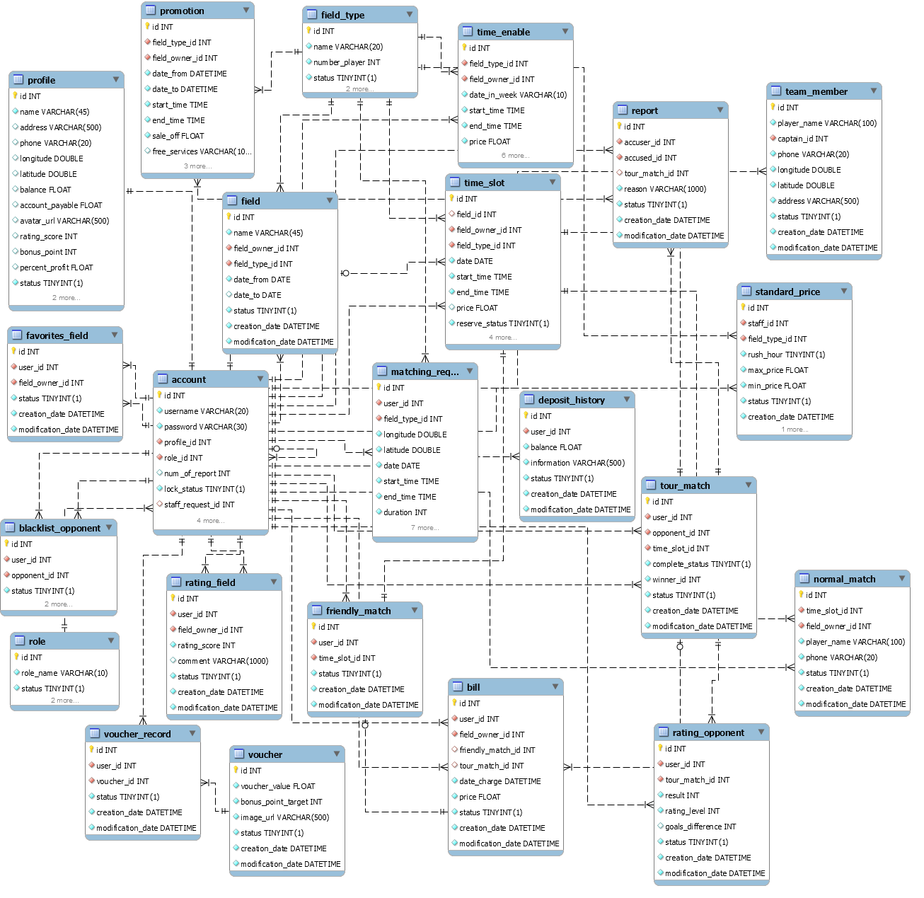

Figure 77: Physical Diagram

|  |  |  |
| --- | --- | --- |
| Data dictionary: describe content of all tables | | |
| Table Name | **Mapping with Conceptual diagram** | **Description** |
| Account | account | Contain the account information |
| Profile | profile | Contain the profile information |
| Role | role | Contain the role information |
| Promotion | promotion | Contain the promotion information |
| FavoriteField | favoriteField | Contain the favorite field information |
| BlacklistOpponent | blacklistOpponent | Contain the blacklist opponent information |
| Voucher | voucher | Contain the voucher information |
| VoucherRecord | voucherRecord | Contain the voucher record information |
| Field | field | Contain the field information |
| FieldType | fieldType | Contain the field type information |
| TimeEnable | timeEnable | Contain the time enable information |
| TimeSlot | timeSlot | Not exists in conceptual diagram but need to contain the time slot when field owner create time enable and user create reservation requests |
| MatchingRequest | matchingRequest | Contain the matching request information |
| TourMatch | tourMatch | Contain the tour match information |

|  |  |  |
| --- | --- | --- |
| FriendlyMatch | friendlyMatch | Contain the friendly match information |
| NormalMatch | normalMatch | Contain the normal match information |
| DepositHistory | depositHistory | Contain the deposit history information |
| Bill | bill | Contain the bill information |
| RatingField | ratingField | Contain the rating field information |
| RatingOpponent | ratingOpponent | Contain the rating opponent information |
| Report | report | Contain the report information |

Table 111: Describe content of all tables

### Data dictionary

|  |  |  |  |  |
| --- | --- | --- | --- | --- |
| Table Name | Attributes | Description | Domain | Null |
| Account | id(PK) | Unique identifier of an account | int | No |
| username | Username of Account | varchar(20) | No |
| password | Password of Account | varchar(30) | No |
| profile_id | Identifier of the profile of Account | int | No |
| role_id | Identifier of the role of Account | int | No |
| num_of_report | Number of report of Account | int | No |
| lock_status | Staff request lock Account checker | bit | No |
| staff_request_id | Identifier of staff requested | int | Yes |
| request_lock | Request lock account checker | bit | No |
| status | Active account checker | bit | No |
| creation_date | Date of account creation | datetime | No |
| modification_date | Date of account modification | datetime | No |
| Profile | id(PK) | Unique identifier of a profile | int | No |
| name | Name of profile | varchar(45) | No |
| address | Address of profile | varchar(500) | Yes |
| phone | Phone of profile | varchar(20) | Yes |
| longitude | Longitude of profile | double | Yes |
| latitude | Latitude of profile | double | Yes |
| balance | Balance of profile | float | Yes |
| account_payable | Account payable of profile | float | Yes |
| avatar_url | Avatar url of profile | varchar(500) | Yes |
| rating_score | Rating score of profile | int | Yes |
| bonus_point | Bonus point of profile | int | Yes |
| percent_profit | Percent profit of profile | float | Yes |
| status | Active profile checker | bit | No |
| creation_date | Date of profile creation | datetime | No |
| modification_date | Date of profile modification | datetime | No |
| Role | id(PK) | Unique identifier of a role | int | No |
| role_name | Name of the role | varchar(10) | No |
| status | Active role checker | bit | No |
| creation_date | Date of role creation | datetime | No |
| modification_date | Date of role modification | datetime | No |
| Promotion | Id(PK) | Unique identifier of a promotion | int | No |
| field_type_id | Id of field type that promotion belongs | int | No |
| field_owner_id | Id of field owner that promotion belongs | int | No |
| date_from | Sent notification tracker | datetime | No |
| date_to | Notification content | datetime | No |
| start_time | Time to start apply promotion (in a day) | time | No |
| end_time | Time to end apply promotion (in a day) | time | No |
| sale_off | Sale off percent of promotion | float | No |
| free_services | Free services content | varchar(1000) | Yes |
| status | Active promotion checker | bit | No |
| creation_date | Date of promotion creation | datetime | No |
| modification_date | Date of promotion modification | datetime | No |
| FavoriteField | id (PK) | Unique identifier of a favorite field | int | No |
| user_id | Id of the user that the favorite field belongs | int | No |
| field_owner_id | Id of field owner that favorite field belongs | int | No |
| status | Active favorite field checker | bit | No |
| creation_date | Date of favorite field creation | datetime | No |
| modification_date | Date of favorite field modification | datetime | No |
| BlacklistOpponent | Id(PK) | Unique identifier of a black list opponent | int | No |
| user_id | Id of the user that the black list opponent belongs | int | No |
| opponent_id | Id of the user that the black list opponent belongs | int | No |
| status | Active black list checker | bit | No |
| creation_date | Date of blacklist opponent creation | datetime | No |
| modification_date | Date of blacklist opponent modification | datetime | No |
| Voucher | id(PK) | Unique Identifier of License | int | No |
| voucher_value | Name of License | float | No |
| bonus_point_target | Price of License | int | No |
| image_url | Description of License | varchar(500) | No |
| status | Active checker of License | bit | No |
| creation_date | Date of voucher creation | datetime | No |
| modification_date | Date of voucher modification | datetime | No |
| VoucherRecord | id(PK) | Unique identifier of a voucher record | int | No |
| user_id | Id of the user that the voucher record belongs | int | No |
| voucher_id | Id of the voucher that the voucher record belongs | int | No |
| status | Active voucher checker | bit | No |
| creation_date | Date of voucher record creation | datetime | No |
| modification_date | Date of voucher record modification | datetime | No |
| Field | id(PK) | Unique identifier of a field | int | No |
| name | Name of a field | varchar(45) | No |
| field_owner_id | Id of the field owner that the field belongs | int | No |
| field_type_id | Id of the field type that the field belongs | int | No |
| date_from | The date when the field available | date | No |
| date_to | The date when the field not available | date | Yes |
| status | Active field checker | bit | No |
| creation_date | Date of field creation | datetime | No |
| modification_date | Date of field modification | datetime | No |
| FieldType | id(PK) | Unique identifier of a field type | int | No |
| name | Name of a field type | varchar(20) | No |
| numberOfPlayer | Number of player of the field type | int | No |
| status | Active field type checker | bit | No |
| creation_date | Date of field type creation | datetime | No |
| modification_date | Date of field type modification | datetime | No |
| TimeEnable | id (PK) | Unique identifier of a time enable | int | No |
| field_type_id | Id of the field type that the time enable belongs | int | No |
| field_owner_id | Id of the field owner that the time enable belongs | int | No |
| date_in_week | Date in week that the time enable belongs | varchar(10) | No |
| start_time | Start time of the time enable | time | No |
| end_time | End time of the time enable | time | No |
| price | Price (per hour) of the time enable | float | No |
| optimal | Optimal time enable checker | bit | No |
| date_from | Start date of time enable | date | No |
| date_to | End date of time enable | date | No |
| status | Active time enable checker | bit | No |
| creation_date | Date of time enable creation | datetime | No |
| modification_date | Date of time enable modification | datetime | No |
| TimeSlot | id (PK) | Unique identifier of a time slot | int | No |
| field_id | Id of the field that the time slot belongs | int | No |
| field_owner_id | Id of the field owner that the time slot belongs | int | No |
| field_type_id | Id of the field type that the time slot belongs | int | No |
| date | Date in week that the time slot belongs | date | No |
| start_time | Start time of the time slot | time | No |
| end_time | End time of the time slot | time | No |
| price | Price (per hour) of the time slot | float | Yes |
| reserve_status | Active reserve checker | bit | No |
| optimal | Is optimal checker | bit | No |
| status | Active time slot checker | bit | No |
| creation_date | Date of time slot creation | datetime | No |
| modification_date | Date of time slot modification | datetime | No |
| MatchingRequest | Id (PK) | Unique identifier of the matching request | int | No |
| user_id | Id of the user that the matching request belongs | int | No |
| field_type_id | Id of the field type that the matching request belongs | int | No |
| longitude | Longitude of the matching request | DOUBLE | No |
| latitude | Latitude of the matching request | DOUBLE | No |
| date | Date of the matching request | DATE | No |
| start_time | Start time of the matching request | TIME | No |
| end_time | End time of the matching request | TIME | No |
| duration | Duration of the matching request | INT | No |
| address | Address of the matching request | VARCHAR(500) | No |
| expected_price | Expected price of matching request | FLOAT | No |
| expected_distance | Expected distance of matching request | INT | No |
| priority_field | Is high priority field | Bit | No |
| status | Active matching request checker | bit | No |
| creation_date | Date of matching request creation | datetime | No |
| modification_date | Date of matching request modification | datetime | No |
| TourMatch | id(PK) | Unique identifier of the tour match | Int | No |
| user_id | Id of the user that the tour match belongs | INT | No |
| opponent_id | Id of the opponent that the tour match belongs | int | No |
| time_slot_id | Id of the time slot that the tour match belongs | INT | No |
| complete_status | Active complete checker | bit | No |
| winner_id | Id of the winner that the tour match belongs | INT | No |
| status | Active tour match checker | bit | No |
| creation_date | Date of tour match creation | datetime | No |
| modification_date | Date of tour match modification | datetime | No |
| FriendlyMatch | Id (PK) | Unique identifier of the friendly match | int | No |
| user_id | Id of the user that friendly match belongs | int | No |
| time_slot_id | Id of the time slot that friendly match belongs | int | No |
| status | Active friendly match checker | bit | No |
| creation_date | Date of friendly match creation | datetime | No |
| modification_date | Date of friendly match modification | datetime | No |
| NormalMatch | id(PK) | Unique identifier of the normal match | int | No |
| time_slot_id | Id of the time slot that normal match belongs | int | No |
| field_owner_id | Id of the field owner that normal match belongs | int | No |
| player_name | Player name of normal match | varchar(100) | No |
| phone | Phone of player of normal match | varchar(20) | No |
| status | Active normal match checker | bit | No |
| creation_date | Date of normal match creation | datetime | No |
| modification_date | Date of normal match modification | datetime | No |
| Bill | id(PK) | Unique identifier of a bill | int | No |
| user_id | Id of the user that the bill belongs | int | No |
| field_owner_id | Id of the field owner that the bill belongs | int | No |
| friendly_match_id | Id of the friendly match that the bill belongs | int | Yes |
| tour_match_id | Id of the tour match that the bill belongs | int | Yes |
| date_charge | Date charge the bill | datetime | No |
| price | Price of the bill | float | No |
| status | Active bill checker | bit | No |
| creation_date | Date of bill creation | datetime | No |
| modification_date | Date of bill modification | datetime | No |
| RatingOpponent | id(PK) | Unique identifier of a rating opponent | int | No |
| user_id | Id of the user that the rating belongs | int | No |
| tour_match_id | Id of the tour match that the rating belongs | int | No |
| result | Result of the rating opponent | int | No |
| rating_level | Rating level of the rating opponent | int | No |
| goals_difference | Goal difference checker | int | Yes |
| status | Active rating checker | bit | No |
| creation_date | Date of rating opponent creation | datetime | No |
| modification_date | Date of rating opponent modification | datetime | No |
| RatingField | id(PK) | Unique identifier of a rating field | int | No |
| user_id | Id of the user that the rating belongs | int | No |
| field_owner_id | Id of the tour match that the rating belongs | int | No |
| rating_score | Rating score of the rating field | int | No |
| comment | Commend of rating | varchar(1000) | No |
| status | Active rating checker | bit | No |
| creation_date | Date of rating field creation | datetime | No |
| modification_date | Date of rating field modification | datetime | No |
| Report | Id(PK) | Unique identifier of a report opponent | int | No |
| accuser_id | Id of the accuser that the report belongs | int | No |
| accused_id | Id of the accused that the report belongs | int | No |
| tour_match_id | Id of the tour match that the report belongs | int | Yes |
| reason | Reason of the report | varchar(1000) | No |
| status | Active report checker | bit | No |
| creation_date | Date of report creation | datetime | No |
| modification_date | Date of report modification | datetime | No |
| StandardPrice | id (PK) | Unique identifier of a standard price | int | No |
| staff_id | Id of the staff that the standard price belongs | int | No |
| field_type_id | Id of the field type that the standard price belongs | int | No |
| rush_hour | Rush hour checker | bit | No |
| max_price | Max price of standard price | float | No |
| min_price | Min price of standard price | float | No |
| status | Active standard price checker | bit | No |
| creation_date | Date of standard price creation | datetime | No |
| modification_date | Date of standard price modification | datetime | No |
| TeamMember | id(PK) | Unique identifier of a team member | int | No |
| player_name | Name of team member | varchar(100) | No |
| captain_id | Identifier of captain of team member | int | No |
| phone | Phone of team member | varchar(20) | No |
| longitude | Longitude of team member | double | No |
| latitude | Latitude of team member | double | No |
| address | Address of team member | varchar(500) | No |
| status | Unique identifier of a team member | bit | No |
| creation_date | Date of team member creation | datetime | No |
| modification_date | Date of team member modification | datetime | No |
| DepositHistory | id(PK) | Unique identifier of a deposit history | int | No |
| user_id | Identifier of user of deposit history | int | No |
| balance | Balance of deposit history | float | No |
| information | Information of deposit history | varchar(500) | No |
| status | Unique identifier of a deposit history | bit | No |
| creation_date | Date of deposit history creation | datetime | No |
| modification_date | Date of deposit history modification | datetime | No |

Table 112: Data table dictionary

## 3. Performance measures

### Mobile Application API load speed

#### Definition

This sections tests the load speed of mobile app when connect to server through API

#### Test environment

**Server**

* Operating System: Ubuntu 14.04 Server 32 bit
* RAM: 4GB
* Storage: 50GB
* Processor: Intel® CORE i7 Quad core 2.4 GHz
* Network: Wi-Fi 1Mbps

**Client**

|  |  |  |
| --- | --- | --- |
| **Android** | **Minimum Requirements** | **Recommended** |
| **Internet Connection** | Wi-Fi (4 Mbps) | Wi-Fi (8 Mbps) |
| **Operating System** | Android 5.0 | Android 7: Lollipop |
| **Processor** | Snapdragon 400 1.7GHz Dual Core | Snapdragon 600 1.89GHz Quad Core or higher |
| **Memory** | 512MB RAM | 2GB |
| **Bluetooth** | Bluetooth 4.0 required | Bluetooth 4.0 required |

Table 113: Mobile API load speed client specification

#### Test cases

Using mobile application to send entire API request to web server

List of APIs:

|  |  |  |
| --- | --- | --- |
| No. | API | Description |
| 1 | top-10-field-owner | Search 10 fields near user |
| 2 | name | Search field by field’s name |
| 3 | friendly-match | Reserve a field |
| 4 | matching-request | Create new matching request |
| 5 | tour-match | Reserve a tour match |
| 6 | Manage-favorites | Add new favorite field |

Table 114: Mobile API load speed test cases

#### Test result

The test is run 20 times, each time we run all the test cases listed above and log down the average API response time.

|  |  |  |
| --- | --- | --- |
| Test No. | Average page load time (second) | Execute date |
| 1 | 0.85 | 12/03/2017 |
| 2 | 1.1 | 12/03/2017 |
| 3 | 0.7 | 12/03/2017 |
| 4 | 0.9 | 12/03/2017 |
| 5 | 1.3 | 12/03/2017 |
| 6 | 0.75 | 12/03/2017 |
| 7 | 0.8 | 12/03/2017 |
| 8 | 1.2 | 12/03/2017 |
| 9 | 1 | 12/03/2017 |
| 10 | 0.93 | 12/03/2017 |
| 11 | 0.89 | 12/03/2017 |
| 12 | 0.8 | 12/03/2017 |
| 13 | 0.83 | 12/03/2017 |
| 14 | 0.93 | 12/03/2017 |
| 15 | 1.1 | 12/03/2017 |
| 16 | 1 | 12/03/2017 |
| 17 | 0.9 | 12/03/2017 |
| 18 | 0.85 | 12/03/2017 |
| 19 | 0.83 | 12/03/2017 |
| 20 | 0.93 | 12/03/2017 |
|  | **Average: 0.93(seconds)** |  |

Table 115: Mobile API load speed test result

## 4. Test plan

The overall purpose of testing is to ensure FFRS meets its entire technical, functional and business requirement. The purpose of this document is to describe the overall test plan and strategy for testing the FFRS. The approach described in this document provides the framework for all testing related to this application. Individual test cases will be written for each version of the application that is released. This document will also be updated as required for each release.

### Features to be tested

* User: Search field, Reserve match, create matching request, reserve tour match, set favorite field
* Field owner: create active time, disable field, cancel match

### Features not to be tested

* Guest: Sign in, sign out, edit profile
* User: Edit profile, cancel matching request, cancel reservation request, add opponent to blacklist, deposit
* Field Owner: create field
* Staff: View report, request lock account, accept the field owner’s account creation request, manage price of field

## System testing test case

### Communication diagram

Test cases are created from below communication diagram

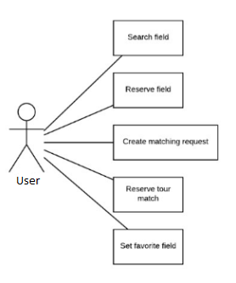

Figure 78: Mobile application communication diagram

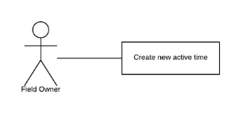

Figure 79: Web application communication

### Test cases

#### <User> Reserve field

|  |  |  |  |  |  |  |  |
| --- | --- | --- | --- | --- | --- | --- | --- |
| ID | Test Case Description | Precondition | Test case procedure | Expected output | Inter-test case dependence | Result | Test Date |
| ReserveF 1 | Test User reserves a field | N/A | 1.User sets time frame  2.User sends reserve command | 1.System shows “Đặt sân thành công” | N/A | Pass | 12/02/17 |
| ReserveF 2 | Test User reserves a field but not enough money | N/A | 1.User sets time frame  2.User sends reserve command | 1.System shows “Tài khoản không đủ tiền”  2.System displays deposit screen | N/A | Pass | 12/02/17 |
| ReserveF  3 | Test User reserves in the busy time frame | There is at least 1 field has free time in database | 1.User 1 and User 2 set the same time frame  2.User 1 sends reserve command  3.User 2 sends reserve command after User 1 | 1.System shows message “Đặt sân thành công” to the User 1  2.System shows mesage “Sân không còn thời gian trống” to other User 2 | N/A | Pass | 12/02/17 |

Table 117: Test case <User> Reserve field

#### <User> Create matching request

|  |  |  |  |  |  |  |  |
| --- | --- | --- | --- | --- | --- | --- | --- |
| ID | Test Case Description | Precondition | Test case procedure | Expected output | Inter-test case dependence | Result | Test Date |
| MatchingR 1 | Test User create matching request is working ok | N/A | 1.User inputs required field  2.User send creates matching request | 1.System shows result: “Đã khởi tạo yêu cầu tìm kiếm” | N/A | Pass | 12/02/16 |
| MatchingR 2 | Test User create matching request without money in account balance | N/A | 1.User inputs required field  2.User send creates matching request | 1.System shows result: “Không đủ tiền”.  2.System displays deposit screen | N/A | Pass | 12/02/16 |

Table 118: Test case <User> Create matching request

#### <User> Reserve tour match

|  |  |  |  |  |  |  |  |
| --- | --- | --- | --- | --- | --- | --- | --- |
| ID | Test Case Description | Precondition | Test case procedure | Expected output | Inter-test case dependence | Result | Test Date |
| ResM 1 | Test user reserve tour match is working fine | Matching request: 15/02/2017, start at 8AM end at 10AM, duration 2 hours, location at “Công viên phần mềm quang trung Q12”, 5km area, rank 2000 was created in database.  User’s rank is 2000 | 1.User inputs “15/02/2017, start at 6AM end at 12AM, duration 2 hours, location at “Chợ cầu Gò vấp”, 5km  2.User sends find matching request command | 1.System shows matching request in database | N/A | Pass | 12/02/17 |
| ResM 2 | Test user reserve tour match with not in range of the matching request in database | Matching request: 15/02/2017, start at 8AM end at 10AM, duration 2 hours, location at “Công viên phần mềm quang trung Q12”, 5km area, rank 2000 was created in database.  User’s rank is 2000 | 1.User inputs “15/02/2017, start at 6AM end at 12AM, duration 2 hours, location at “Chợ bến thành”, 5km  2.User sends find matching request command | 1. System shows message “Không tìm thấy đối thủ phù hợp” | N/A | Pass | 12/02/17 |
| ResM 3 | Test user reserve tour match with not in time frame of the matching request in database | Matching request: 15/02/2017, start at 8AM end at 10AM, duration 2 hours, location at “Công viên phần mềm quang trung Q12”, 5km area, rank 2000 was created in database.  User’s rank is 2000 | 1.User inputs “15/02/2017, start at 16PM end at 21AM, duration 2 hours, location at “Công viên phần mềm quang trung Q12”, 5km  2.User sends find matching request command | 1. System shows message “Không tìm thấy đối thủ phù hợp” | N/A | Pass | 12/02/17 |
| ResM 4 | Test user reserve tour match with not in time frame of the matching request in database | Matching request: 15/02/2017, start at 8AM end at 14PM, duration 2 hours, location at “Công viên phần mềm quang trung Q12”, 5km area, rank 2000 was created in database.  User’s rank is 2000 | 1.User inputs “15/02/2017, start at 8AM end at 14PM, duration 1.5 hours, location at “Công viên phần mềm quang trung Q12”, 5km  2.User sends find matching request command | 1. System shows message “Không tìm thấy đối thủ phù hợp” | N/A | Pass | 12/02/17 |
| ResM 5 | Test user reserve tour match with not the same day as the matching request in database | Matching request: 15/02/2017, start at 8AM end at 10AM, duration 2 hours, location at “Công viên phần mềm quang trung Q12”, 5km area, rank 2000 was created in database.  User’s rank is 2000 | 1.User inputs 16/02/2017, start at 8AM end at 10AM, location at “Công viên phần mềm quang trung Q12”, 5km  2.User sends find matching request command | 1. System shows message “Không tìm thấy đối thủ phù hợp” | N/A | Pass | 12/02/17 |
| ResM 6 | Test user reserve tour match with a higher level rank matching request in database | Matching request: 15/02/2017, start at 8AM end at 10AM, duration 2 hours, location at “Công viên phần mềm quang trung Q12”, 5km area, rank 3000 was created in database.  User’s rank is 2000 | 1.User inputs 16/02/2017, start at 8AM end at 10AM, location at “Công viên phần mềm quang trung Q12”, 5km  2.User sends find matching request command | 1. System shows message “Không tìm thấy đối thủ phù hợp” | N/A | Pass | 12/02/17 |
| ResM 7 | Test user reserve tour match. User was in other user blacklist. | Matching request: 15/02/2017, start at 8AM end at 10AM, duration 2 hours, location at “Công viên phần mềm quang trung Q12”, 5km area, rank 2000  was created in database.  User’s rank is 2000.  User in the blacklist of whom created matching request | 1.User inputs 16/02/2017, start at 8AM end at 10AM, location at “Công viên phần mềm quang trung Q12”, 5km  2.User sends find matching request command | 1. System shows message “Không tìm thấy đối thủ phù hợp” | N/A | Pass | 12/02/17 |
| ResM 8 | Test User find matching request without money in account balance | N/A | 1.User inputs 16/02/2017, start at 8AM end at 10AM, location at “Công viên phần mềm quang trung Q12”, 5km  2.User sends find matching request command | 1.System shows result: “Không đủ tiền”.  2.System displays deposit screen | N/A | Pass | 12/02/16 |
| ResM 9 | Test user reserve tour match, but the request was accepted by other user (user later than other user in accepting request) | Matching request: 15/02/2017, start at 8AM end at 10AM, duration 2 hours, location at “Công viên phần mềm quang trung Q12”, 5km area, rank 2000 was created in database.  User’s rank is 2000 | 1.User inputs “15/02/2017, start at 6AM end at 12AM, duration 2 hours, location at “Chợ cầu Gò vấp”, 5km  2.User sends find command  2.User chooses field, then sends reserve match command | 1.System shows message “Yêu cầu tìm kiếm không còn tồn tại” | N/A | Pass | 12/02/17 |

Table 119: Test case <User> Reserve tour match

#### <Field Owner> Create new active time

|  |  |  |  |  |  |  |  |
| --- | --- | --- | --- | --- | --- | --- | --- |
| ID | Test Case Description | Precondition | Test case procedure | Expected output | Inter-test case dependence | Result | Test Date |
| ActiT 1 | Test create active time is working ok | Field Owner has at least 1 field | 1.Field Owner inputs required information.  2.User sends create new active time. | 1.System shows successfully message. | N/A | Pass | 12/02/17 |
| ActiT 2 | Test create active time with a field has time frame reserved | Field Owner has at least 1 field.  User reserve a field at the next day. | 1.User sends create new active time | 1.System shows “Đã có người đặt sân của bạn” | N/A | Pass | 12/02/17 |

Table 120: Test case <Field Owner> Create new active time

# F. Software User’s Manual

## Installation Guide

N/A

## User Guide

### Mobile Application for Customer

#### Register

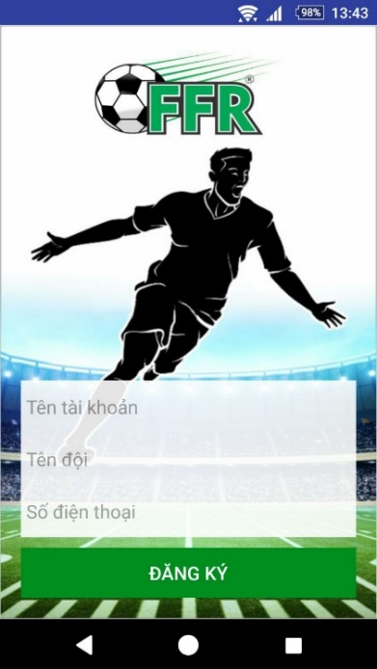

Figure 80: <Guest> Register User UG

|  |  |
| --- | --- |
| **Step** | **Description** |
| 1 | Fill all field information register |
| 2 | Tap “ĐĂNG KÝ” button |

Table 121: <Guest> Register User UG

#### Login

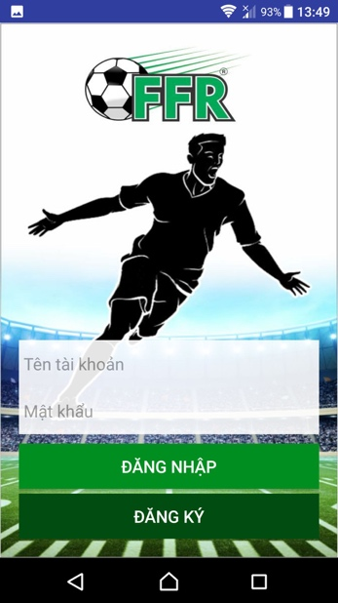

Figure 81: <Guest> Login UG

|  |  |
| --- | --- |
| **Step** | **Description** |
| 1 | Enter username, password |
| 2 | Tap “ĐĂNG NHẬP” button |

Table 122: <Guest> Login UG

#### Search Field

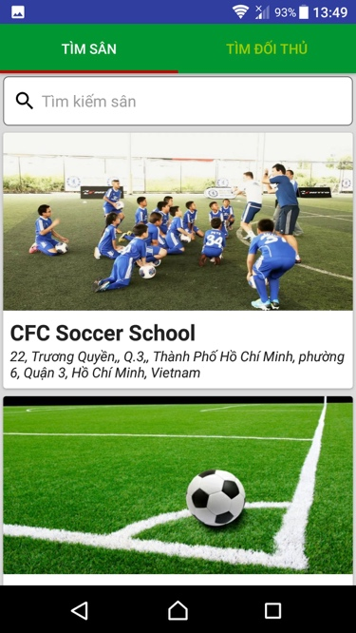

Figure 82: <User> Search field UG

|  |  |
| --- | --- |
| **Step** | **Description** |
| 1 | Tap ‘Tìm kiếm sân’ on textbox |
| 2 | Enter field’s name |
| 3 | Press enter on keyboard |

Table 123: <Field Owner> Search field UG

#### Reserve Match

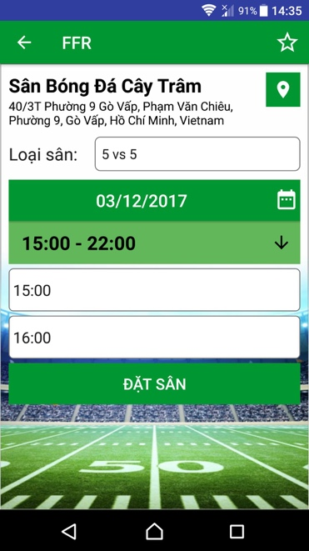 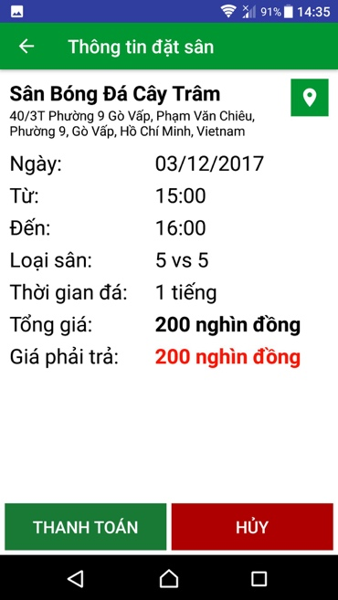

Figure 83: <User> Reserve match UG

|  |  |
| --- | --- |
| **Step** | **Description** |
| 1 | Tap “Loại sân” screen |
| 2 | Choose expected date |
| 3 | Choose expected time to play |
| 4 | Tap ‘ĐẶT SÂN’ |
| 5 | Tap ‘THANH TOÁN’ |

Table 124: <User> Reserve match UG

#### Find Opponent

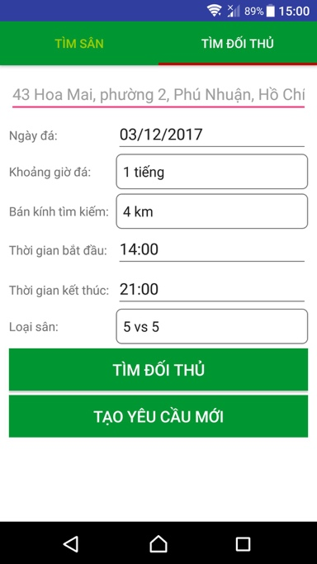 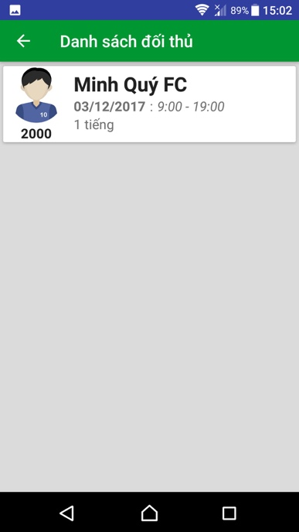

Figure 84: <User> find opponent UG

|  |  |
| --- | --- |
| **Step** | **Description** |
| 1 | Enter address where user want to find |
| 2 | Enter expected time period |
| 3 | Enter radius which user want to find, calculate by km |
| 4 | Enter start time expected |
| 5 | Enter end time expected |
| 6 | Tap ‘loại sân’ |
| 7 | Tap ‘TÌM KIẾM’ |

Table 125: <User> find opponent UG

#### Create new matching request

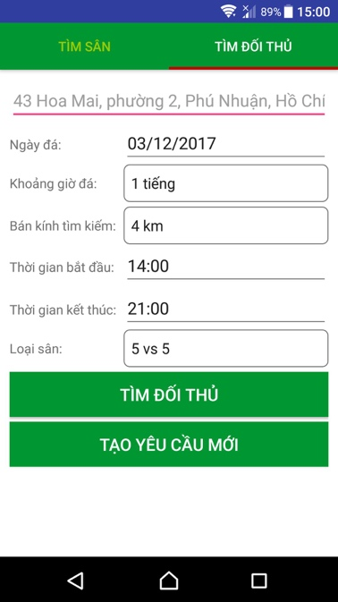

Figure 85: <User> Create new matching request UG

|  |  |
| --- | --- |
| **Step** | **Description** |
| 1 | Enter address where user want to find |
| 2 | Enter expected time period |
| 3 | Enter radius which user want to find, calculate by km |
| 4 | Enter start time expected |
| 5 | Enter end time expected |
| 6 | Tap ‘Loại sân’ |
| 7 | Tap ‘TẠO MỚI YÊU CẦU’ |

Table 126: <Field Owner> Create new matching request UG

#### Choose opponent

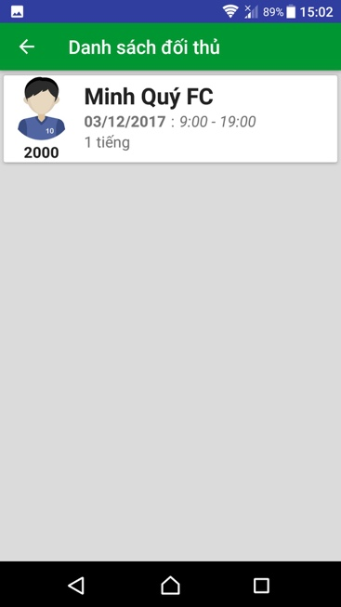 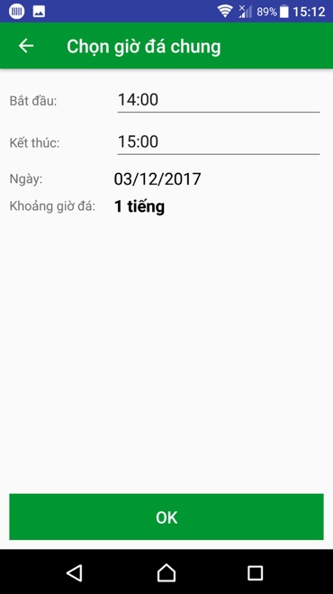 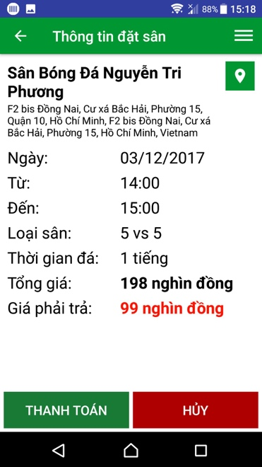

Figure 86: <User> Choose opponent UG

|  |  |
| --- | --- |
| **Step** | **Description** |
| 1 | Tap opponent from list |
| 2 | Enter expected start time |
| 3 | Enter expected end time |
| 4 | Tap ‘OK’ |
| 5 | Tap ‘THANH TOÁN’ |

Table 127: <User> Choose opponent UG

#### Deposit

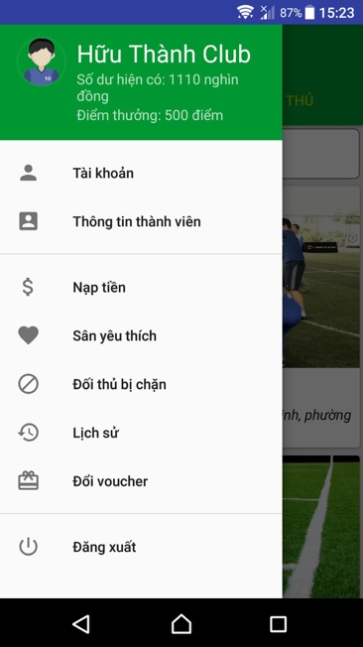 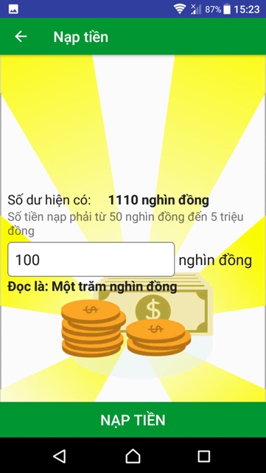 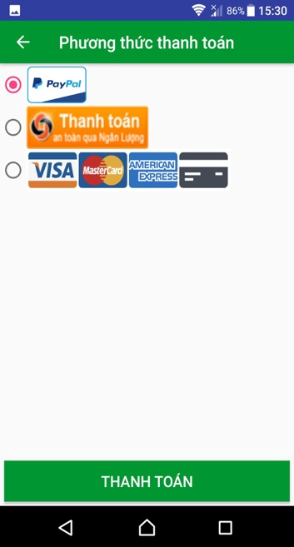

Figure 87: <User> Deposit UG

|  |  |
| --- | --- |
| **Step** | **Description** |
| 1 | Tap opponent from list |
| 2 | Enter expected money |
| 3 | Tap ‘OK’ |
| 4 | Tap ‘THANH TOÁN’ |

Table 128: <User> Deposit UG

### Web application

#### Update active time

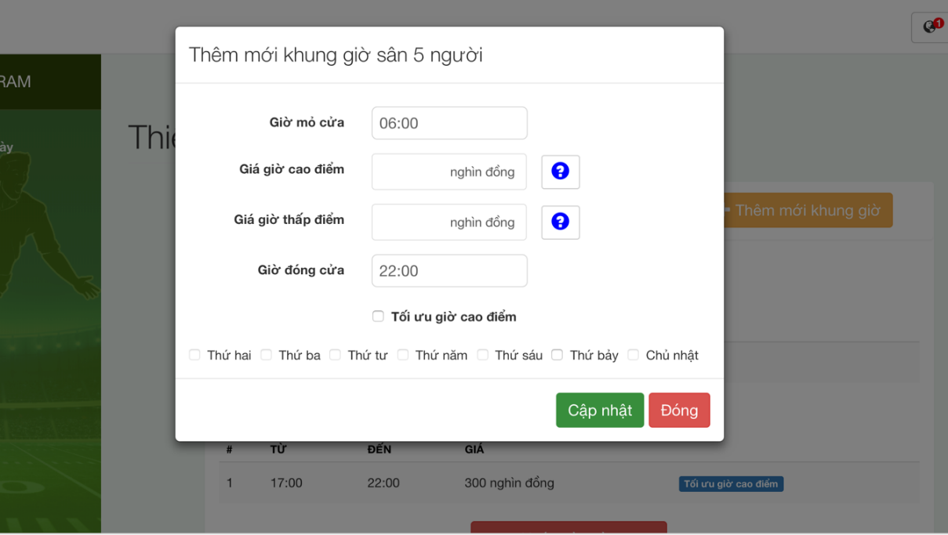

Figure 88: <Field Owner> Update active time UG

|  |  |
| --- | --- |
| **Step** | **Description** |
| 1 | Enter innformation required |
| 2 | Click ‘Cập nhật’ |

Table 129: <Field Owner> Update active time UG

#### Create new promotion

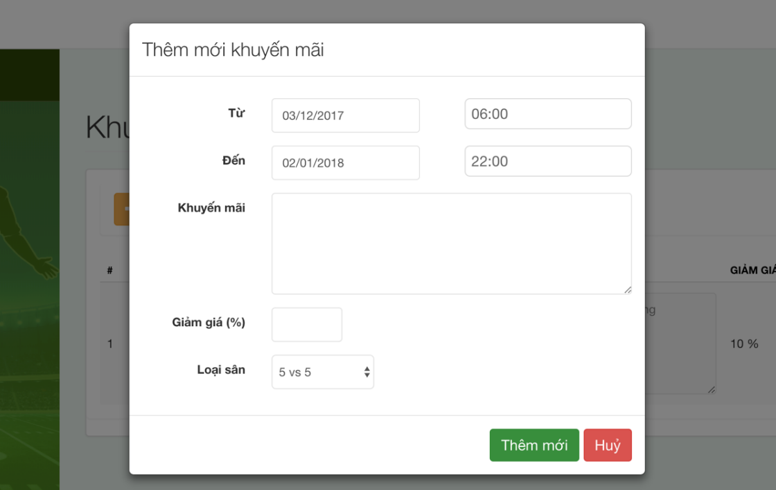

Figure 89: <Field Owner> Create new promotion UG

|  |  |
| --- | --- |
| **Step** | **Description** |
| 1 | Enter information required |
| 2 | Click ‘Thêm mới’ |

Table 130: <Field Owner> Create new promotion UG

#### Reserve Match

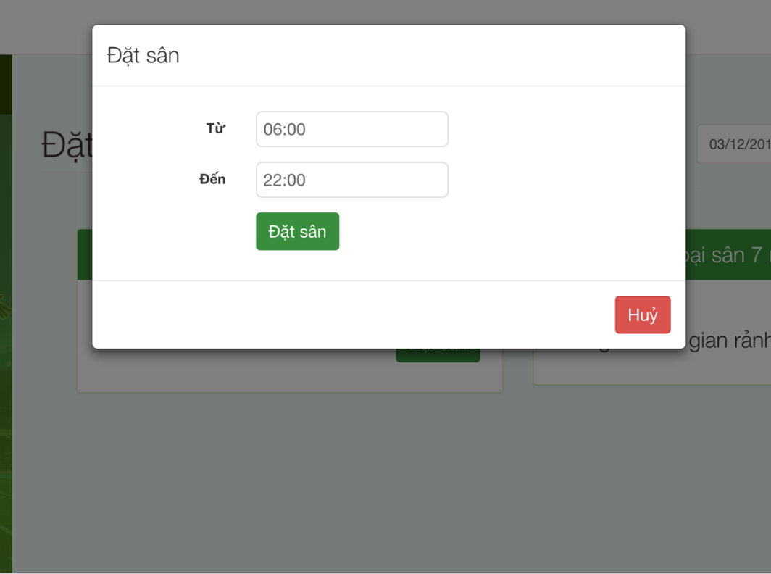

Figure 90: <Field Owner> Reserve match UG

|  |  |
| --- | --- |
| **Step** | **Description** |
| 1 | Choose expected time |
| 2 | Click ‘Đăt sân’ |

Table 131: <Field Owner> Reserve match UG